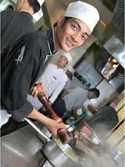

**Food Hygiene**

**Contents**

1. **Food Hygiene**

* **Food poisoning**
* **Bacteria and Food**
* **Contributory Factors in/ and sources**

**of /food Poisoning**

* **Vehicles and routes of bacterial**

**transfer**

* **Prevention of food poisoning**
* **Temperature storage and control of food**
* **Defrosting notes**
* **Food borne/water borne diseases**

1. **Pest control**

* **Introduction**
* **Methods of control**
* **Cleaning practices**

1. **Water Management**

* **Introduction**
* **Potable water**
* **Water sampling**
* **Water treatment**
* **Legionella monitoring**

**4 Management of a food poisoning incident**

* **Definitions**
* **Potential food poisoning outbreaks**
* **Confirmed food poisoning outbreaks**
* **Treatment**

**Introduction**

In this unit we will consider the principles of food hygiene, monitoring and also control under the following headings.

* Food hygiene
* Pest control
* Water management
* Food legislation
* Management of a food poisoning incident

At this moment in time the food legislation in force onshore does not apply offshore, however the HSE (Health and Safety Executive) will apply the principles of the food legislation when carrying out their audits and inspections.

This means that you must be aware of the relevant legislation and its’ implications.

Food Hygiene

1.1 Food Poisoning

Definition

The internationally accepted definition of food poisoning is:

“Any disease of an infectious or toxic nature caused by, or thought to be caused by, the consumption of food or water.”

You may however find the definition used by Professor Noah in the ABC of Nutrition more useful, his definition of food poisoning is:

*“An acute illness, which usually includes one or more gastrointestinal symptoms, caused by the consumption of food or water.”*

The best estimate for the onshore environment is that one person in ten report their experience of food poisoning.

Although the offshore industry suffers from many food poisoning incidents ever year, few of these develop into actual food poisoning outbreaks. We will discuss the distinction between potential and actual outbreaks later in this module. As the case for onshore, it is very likely that most cases of food poisoning are not reported or recognised.

Microbiological food poisoning

Bacteria are the most common cause of food poisoning you will come across. Viruses have been implicated in some forms of food poisoning. However this remains an uncommon cause of food poisoning and won’t be discussed in any more detail.

Question number 1

There are three main types of bacteria which commonly cause food poisoning, the percentages have already been entered but can you place the names of the three types of bacteria in the correct order?

|  |  |
| --- | --- |
| Name of Bacteria | Percentage of cases % |
| ? | 80% |
| ? | 15% |
| ? | 5% |

Now you have named the three different types of bacteria that cause food poisoning we will look at the origins, approximate time of onset and nature of the symptoms of these bacteria.

See the table below:

|  |  |  |  |
| --- | --- | --- | --- |
| Bacteria | Origin | Onset of symptoms | Symptoms |
| Salmonella | Raw meat, eggs, poultry and soil. | 6-72 hrs | Abdominal pains, fever, diarrhoea. Rarely results in more than one episode of vomiting |
| Clostridium perfringens | Raw meat, soil, excreta, insects, stews and sauces. | 8-24hrs | Abdominal pain and diarrhoea, but no fever usually. |
| Staphylococcus aureus | Skin, nose, boils, cuts, raw milk and cooked meats. | 1- 6hrs | Vomiting, abdominal pain, lower than normal temperature. Rarely causes diarrhoea. |

There are some other types of bacteria which are implicated in food poisoning that are much less common, see below:

Listeria Monocitogenes

This organism is often found in soft cheeses and pates and starts to grow at temperatures as low as 3˚c. It has been the cause of a number of food poisoning outbreaks over recent years. This type of food poisoning is usually only a problem in pregnant women, the elderly, and the very young or sick and infirm, none of whom you should expect to find offshore on a regular basis!

Vibrio parahaemolitcus

Not very common

Bacillus cereus

Commonly found in rice and spices. The bacterium causes two different effects.

* Type one results in vomiting only
* Type two which predominantly causes diarrhoea

Both types are normally self-limiting, meaning they only last for 12-24hrs after ingestion of contaminated food and often go unreported.

Escherichia coli

This cause Gastroenteritis and is the usual cause of travellers’ diarrhoea.

Campylobacter

This is found in chickens and seems to be an increasing cause of gastrointestinal symptoms but is rarely food borne. We will discuss food borne diseases later in this section.

Bacterial effects

A bacterium affects the human body by either:

* Attacking the gut wall due to their large numbers, for example **Salmonella**
* Producing toxins as they grow which affect the system directly, for example, Staphylococcus aureus. These are known as exotoxins
* Producing toxins when they die which affect the system directly, for example, Clostridium perfringens. These are known as endotoxins.

**Some bacteria, however, produce toxins both as they grow and as they die! Collectively both types of toxins are known as enterotoxins because they affect the gut much in the same way. The difference is often merely the speed with which they affect the human body. A bacteria that produces toxins as a by-product of growth will have a faster effect on the human body than one that must first grow and then die before producing toxins.**

Here are some group causes of food poisoning

|  |  |
| --- | --- |
| Microbiological: | Bacteria / Viruses  Viruses have been found to be the cause of some outbreaks and they have been identified as being the “small round structured type” often called Norwalk Agent. |
| Chemical: | Heavy metals, pesticides, Unknown heavy metal poisoning is rarely reported today. |
| Vegetable: | Red beans, mushrooms, Solanine (Potatoes)  Red bean poisoning and Solanine poisoning (which comes from eating green potatoes) are rarely reported now. Only 15% of all UK fungi are deadly if eaten, so this is also rare. |
| Fish | Scombrotoxin, Ciguatoxin, Other toxins  Scombrotoxin is a histamine-like substance that occurs in brown fleshed oily fish, such as mackerel, herring and tuna which occasionally cause poisoning. Ciguatoxin comes from a Dinoflagellate eaten by tropical fish. It is uncommon in the UK. Mussels that have been affected by the toxin of the Dinoflagellate Gonyaulax Tamarensis, produce Paralytic shellfish poisoning at certain times of the year (red tides) |

1.2 Bacteria and food

Certain foods may be considered high risk. That is, more likely to lead to food poisoning because they offer conditions that favour the growth of bacteria if the proper hygiene standards are not maintained.

Before you read on have a look at the table below and see if you can write down the four conditions that favour bacterial growth?

*Question 2*

*1. __________________________*

*2.___________________________*

*3.____________________________*

*4.____________________________*

Check your answers on the following page

Answer to question number 2

*Answer Q2*

*Write down the four conditions which favour bacterial growth?*

*Your answer should have included the following but not in any particular order.*

* *Nutrients*
* *Warmth*
* *Moisture*
* *Time*

You will be able to see and understand the importance of these conditions as we work through the programme.

37˚c (the normal body temperature) is the ideal temperature for bacteria to grow.

Warmth

Other bacteria however grow much better in different temperatures, there are three recognised types:

* Pyschrophiles – these grow best at temperatures less than 20˚c
* Mesophiles – these prefer temperatures from 20-45˚c
* Thermophiles – they prefer temperatures ranging from 50-60˚c

Nutrients

Like all cells, bacteria require nutrients for growth. In particular, bacteria need sugars and proteins.

High risk foods

Types of food that provide the best growth conditions are known as high risk and include:

* Cooked Rice
* Gravy and stocks
* Shellfish and seafood
* Cooked eggs and Mayonnaise
* Cooked rice and cold rice
* Milk, cream and artificial diary products

Time

In the correct conditions bacteria can grow rapidly, reproducing by binary fission, which is when one cell divides to produce two; two divide to produce four and so on. This process takes place every ten to fifteen minutes.

There is one important substance that we have not mentioned yet. This substance affects the growth of most cells but which some bacteria do not require, can you think what this substance might be? Have a think now before you read on?

Oxygen should have been your answer. The need for oxygen provides the basis for an important sub division when classifying bacteria:

* Aerobic: these bacteria require oxygen
* Anaerobic: these bacteria do not require oxygen

*Before going to the next page try and write down some contributing factors for the production of bacteria, there are ten main ones*

*1.*

*2.*

*3.*

*4.*

*5.*

*6.*

*7.*

*8.*

*9.*

*10.*

1.3 Contributory factors in food poisoning

There are ten main contributory factors that are identified repeatedly, in the majority of reported cases of food poisoning outbreaks. See the list below, which is in no particular order of importance.

Factors:

* The use of leftover food stuffs
* Infected food handlers
* Cooked food being contaminated by raw food
* Hot food stored below 63˚c
* Inadequate thawing of poultry
* Undercooking food
* Food prepared too far in advance and left at room temperature
* The use of cooked food that is contaminated with bacteria
* Food cooked too slowly before being stored in a refrigerator
* Reheated food not heated thoroughly enough to destroy bacteria

*Now consider some ways which bacteria can be spread?*

*Write these down before you move on to the next page?*

Factors:

More than two of any of these factors are recorded in more

than half of all the outbreaks onshore, and more than three

are recorded in 17% of all outbreaks.

Bacterial contamination is probably the most common form

of contamination and the most dangerous. It results in food

spoilage, ill health and, at worst, death.

1.4 Vehicles and routes of bacterial transfer

The path taken by the bacteria from the source to the food is known as the route. Because most bacteria are incapable of independent motion they require the means of moving about, this is known as the vehicle.

Dust

Bacteria in dust can be disturbed and carried through the air during periods of cleaning; it is your job to ensure that the catering crew and facilities managers take all necessary precautions when cleaning the mess hall and galley areas.

Refuse

All Offshore Installations and Vessels have very strict guidelines for waste control; they can however vary depending on company or country you are working in at that time. There are obviously greater risks if for example the Vessel/Rig was in a hot climate as opposed to somewhere such as Norway. Incorrect food waste storage or protection from pests provides a source of food for rodents and insects. It is also a ready source of infection from food to food and man to food in the handling and storage process.

Animals

Harmful bacteria can often be found on the bodies of pets and other animals. **Salmonella** is often found in the intestines of many animals, in particular, birds, dogs and cats. Ducks, pigeons, geese pet terrapins and goat’s milk have all been implicated in **Salmonella** food poisoning.

Poultry

You might be surprised to know that up to 60,000 of the 31 million eggs eaten each day carry **Salmonella**, even more prevalent in chickens is **Campylobacter**. Most of the chicken flocks in the UK are now vaccinated against **Salmonella**.

Food surfaces and galley utensils may be contaminated by raw food during preparation. If cooked food is then prepared on the same surface then cross contamination will occur. Once again it is part of your job to regularly inspect the food preparation processes and ensure correct cutting boards are used (normally by colour coding) eg different coloured boards for bread, meat, salad, etc.

This form of cross contamination has been found to be a frequent cause of Salmonella food poisoning where the raw meat in question was chicken.

Insects

There are very few insects in the UK that actually cause illness however they can transfer bacteria. Flies and cockroaches (because of their feeding habits) transfer food poisoning bacteria. As you are probably already aware from basic school biology, flies have no biting parts to their mouths and can only deal with liquidised food. They need to vomit acids onto their food in order to liquefy it and then suck it up through a flexible proboscis.

Rodents

Rats and mice can carry Salmonella bacteria in their gut which are then excreted in their faeces and urine. They also pick up bacteria on their own fur and feet. They are capable of contaminating food directly by walking over food preparation areas, storage packages, containers and sacks. Rats can also transmit Weil’s disease and, in the case of the black rat, harbour the flea that carries Bubonic Plague.

People

It is thought that approximately 40% of the population harbour Staphylococcus aureus in the nose and/ or on the skin. This may be spread to food by coughing, sneezing or handling food directly. This organism is however not a common cause of food poisoning. There is evidence that the food handler is not a common source of infection in food poisoning outbreaks. It is usually how the food handler prepares, stores and cooks the food that causes the problem, as the source of the infection is already in the food.



You can see that high risk foods provide nutrients and moisture. The food handler in their preparation period provides the time and warmth factors for bacterial growth. It is often poor hygiene standards that allow the bacteria to come into contact with high risk foods in the first place.

Reflect now for a moment and then see if you can think of ways of breaking the chain of food poisoning.

*Write your answers below:*

*1.*

*2.*

*3.*

There are many ways of breaking the food poisoning chain. Some are listed below:

* Cover the food and keep it covered
* Ensure equipment is clean and serviceable
* Use disposable wipes/cloths
* Keep raw and cooked meat separate at all times
* Avoid handling. Use tongs, plates and trays rather than hands
* Separate preparation boards and utensils for cooked food and raw food
* Keep birds, insects and other animals out of all galley areas, eg mess halls, cooking areas, stores etc
* Store food with correct lids
* Use suitable containers
* Adhere to strict personal hygiene standards for everyone handling food
* Ensure all handlers use clean protective clothing (often T shirts are colour coded for example red for galley staff and blue for cleaning.
* Remove and store unfit waste promptly and away from the galley
* Keep all stores off the deck/floor
* Do not allow defrosting liquids to contaminate cooked foods
* Keep cooked foods above uncooked foods in refrigerators
* Use correct cleaning products and procedures
* Store food at the correct temperature
* Do not use hand wash basins for food prep and vice–versa
* Do not let food cool for longer than 1.5 hours out of a refrigerator
* Keep all hot food above 63˚c
* Keep all cold food below 5˚c
* Make sure all foods, *especially poultry,* are defrosted thoroughly
* Thoroughly cook all foods after defrosting

1. 6 Temperature control and storage of food

Temperature of the stored food on board is frequently implicated in food poisoning incidents. Warmth combined with high risk foods have been mentioned previously and the way which most bacteria respond to varying temperature conditions. See diagram below:

[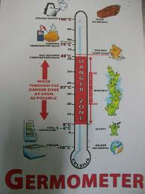](http://www.google.co.uk/imgres?q=germometer&hl=en&biw=1093&bih=502&gbv=2&tbm=isch&tbnid=iExCNUFstik8PM:&imgrefurl=http://cakeandmybread.blogspot.com/2011/03/germmometer.html&docid=6RBqMhv74ZN4SM&imgurl=http://1.bp.blogspot.com/-N4JdoKmrYnk/TX-Sxq3R_wI/AAAAAAAAAHY/jJIsUStWbg8/s1600/Picture+945.jpg&w=1200&h=1600&ei=_3eiT8qzO8eH4gSciZH7CA&zoom=1&iact=hc&vpx=859&vpy=128&dur=2039&hovh=259&hovw=194&tx=104&ty=150&sig=101449519287621197786&page=1&tbnh=142&tbnw=115&start=0&ndsp=15&ved=1t:429,r:7,s:0,i:108)

There is a Code of Practice issued under Section 40 of the Food Safety Act 1990 (the Act), Regulation 24 of the Food Hygiene (England) Regulations 2006 and Regulation 6 of the Official Feed and Food Controls (England)

Regulations 2006 which empower the Secretary of State to issue codes of practice concerning the execution and enforcement of that legislation by Food Authorities. It relates to England only.

|  |  |
| --- | --- |
| Requirement: | Comments: |
| Chilled food must be kept at 8°C or cooler.  Good practice is to keep it below 5°C | Applies only to foods that would become unsafe. Can rise above this for one period only of 4 hours. |
| Various cold foods are exempt: Canned raw materials. Cheese during ripening and others where there is no risk to health | Solid cheeses once ripe and perishable food from opened cans must be kept below 8 °C. |
| Manufacturers may recommend higher  storage temperature/shorter storage life  (provided that safety is verified). | Caterers must use the food within the "Use By" date indicated. (Use by is for perishable food) |
| Cold food on display or for service can be warmer than 8°C Maximum of 4 hours is allowed. | Any item of food can be displayed outside temperature control only once. The burden of proof is on the caterer. |
| Tolerances outside of temperature control are also allowed during transfer or preparation of food and defrost or breakdown of equipment. | No time/temperature limits specified. Both should be minimized consistent with food safety. |
| Hot food should be kept at 63 °C or hotter. | Food may be kept at a temperature cooler than 63 °C for maximum 2 hours if it is for service or on display |

Freezers

Food which is stored in a freezer must be covered to prevent freezer burn. There must also be sufficient space around the packaging for free air movement to allow proper and complete freezing to take place. When you do your inspections, one thing you must check is that you can see visual evidence of stock rotation in freezers, so all food packaging should be marked with use by dates.

Remember when you do your checks; the temperature must be below 18°c. Freezers are usually fitted with sound alarms and visual warning lights in the event of a power failure. They also have panic buttons inside in the event of catering personnel getting themselves trapped inside the unit. Remember to check these during your walkabout inspections with the OIM and/ or Captain. Food, once defrosted must never be refrozen. If this occurs bacteria are given the opportunity to grow and the freezing action on the food can affect both the taste and the quality.

Check the temperature charts on a regular basis and increase in temperature is acceptable for 2 hours only. This time period should be acceptable for both defrost cycles and power failures. Any occurrence outside this should be carefully logged and a report written as to what action was taken

As we said earlier it is your duty to check daily/weekly temperatures of all freezers and chiller rooms. In saying this they should all be fitted with a suitable thermometer that can be read from outside the units. It is also good practice and a recommendation that all freezers and chiller units have stand alone thermometers inside the units as a back up, particularly in case of a power failure.

Ice cream should be stored in conservators (only used for ice cream) at a temperature not exceeding 18˚c. As said earlier, ice cream should never be defrosted then refrozen. Ice and ice cream machines should be defrosted and sterilised weekly - you should ensure the catering staff do this and record everything on a list attached to the unit. This will make your checks must easier to perform.

Typical Galley setting on a Drilling Rig

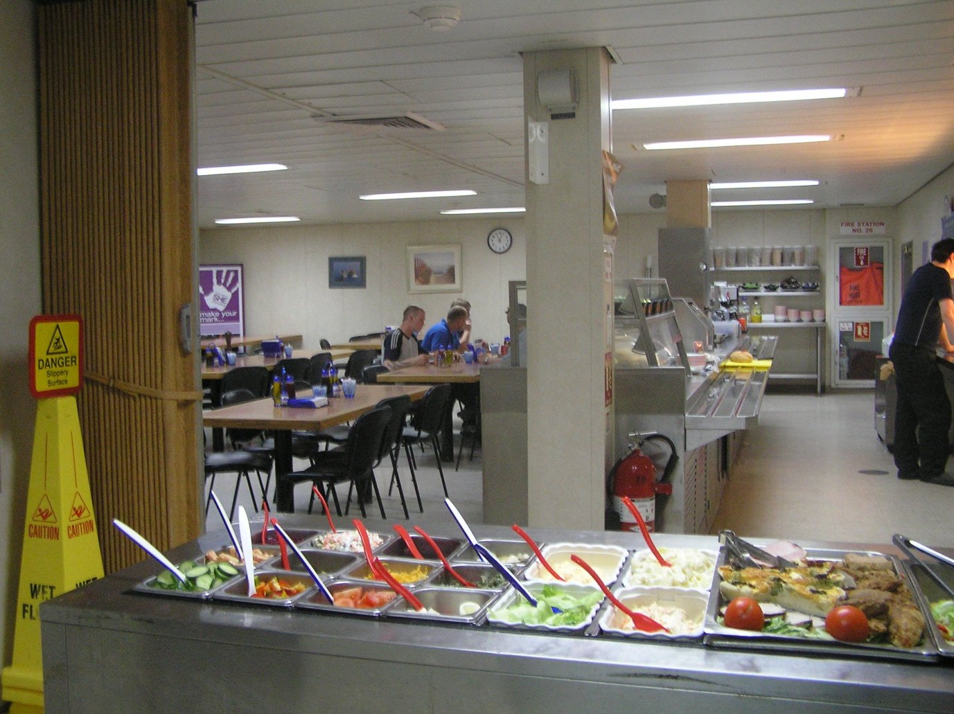

Typical examples of Freezer and Chiller units located on Installations or Vessels

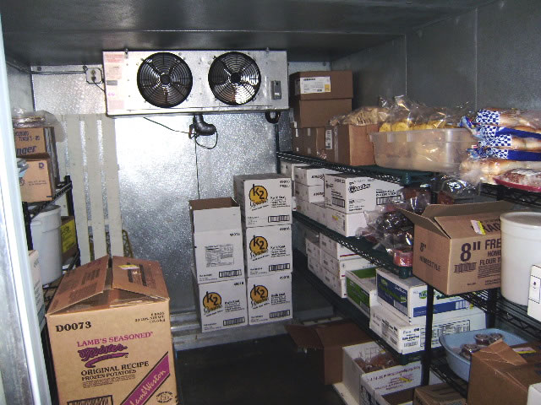

[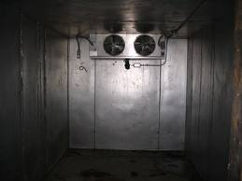](http://www.google.co.uk/imgres?q=walk+in+freezer+units&start=350&hl=en&biw=1680&bih=901&gbv=2&tbm=isch&tbnid=bqrT6m-JSGebrM:&imgrefurl=http://www.bid-on-equipment.com/detail~id~103568.htm&docid=oPxo4PvEsQKD2M&imgurl=http://www.bid-on-equipment.com/uploaded/89000/89344a.jpg&w=600&h=450&ei=7NyjT63yGNGaOsSS2bAI&zoom=1&iact=hc&vpx=208&vpy=503&dur=6281&hovh=194&hovw=259&tx=112&ty=126&sig=105760445343543788967&page=11&tbnh=158&tbnw=239&ndsp=37&ved=1t:429,r:30,s:350,i:221)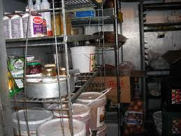

Empty freezer unit

As you can see from both of these photographs, stores have been placed on the deck when actually they should be on a shelf above floor level?

1.7 Defrosting notes

Deep frozen meats, poultry and fish should and must be defrosted in clean containers and be kept at below 10˚c, preferably in the freezer until use. Defrosted food must not be left in water filled sinks after they have adequately defrosted, and they should never be heated to speed up the defrosting process.

Check when you do your first inspection whether the Galley has a proper rapid defrosting cabinet and that it is being used correctly.

Large joints and turkeys should be left in the refrigerator until they defrost. Joints greater than 2.5kg in weight are not recommended as they take too long to defrost and make thorough cooking difficult.

The temperature of food during preparation should not be allowed to exceed 10˚c.

ALL DEFROSTING SHOULD BE PLANNED WELL IN ADVANCE AND FORMS GOOD CATERING PRACTICE

Physical contamination

Food can become contaminated with foreign bodies such as nails, wood, glass, animal droppings, paint flakes, pieces of animals/ insects, knives and human flesh! Physical contamination is more often a nuisance and unpleasant rather than an immediate risk to health. All companies vary on their policies regarding catering staff but a good rule of thumb is for the medic to try and get involved with their toolbox talks and have each catering crew member visit the sickbay at the start of each hitch (trip), to check their hands etc for skin rashes/hygiene issues.

1.8 Foodborne/waterborne Diseases

These differ from food poisoning in that they are diseases that are transmitted by food or on food. Unlike food poisoning organisms, the organisms that cause these diseases do not need to multiply in the food and only small numbers of bacteria are required to cause a problem. Food borne and water borne diseases are much less common than food poisoning (see examples below), they are however much more serious in nature. The bacteria responsible are often in the intestines of man and it is unfortunately man that is the most common cause of the spread of these diseases. There is a well recognised chain of events leading to infection and ill health.

* Dysentery
* Typhoid
* Brucellosis



Human carrier

Mary Mallon, a cook working in New York City in the 1900's became known as 'Typhoid Mary' after directly infecting 51 people (3 died) and indirectly infecting innumerable others with typhoid. Mary did not suffer from the disease but was a carrier

2. Pest control

2.1 Introduction

Firstly please be aware that major food pests are not common offshore because of the location and structure of the Installations. However, transfer does occur and once on board pests can survive and adapt to the environment. Ships are constantly in and out of port often in hot climates such as Egypt, Brazil etc so you always have to be vigilant. Oil rigs can be towed in and out of docks for refit, as can some installations. Others are visited on a daily basis by supply vessels and all of these can allow access to unwanted guests.

Prevention is not easy, food is transported in containers that are sealed after loading but which are not fumigated. There are some containers that are temperature controlled but not many!

Inspection at the point of loading is brief and visual which may not be very effective. For example, it is very difficult to spot small numbers of cockroaches-the person inspecting might be lucky and shake a few out during loading but this is rare - time restrictions mean inspections are often brief or even missed completely. Rats and mice in small numbers are very difficult to spot – even if you only see one there may be many more hiding away.

Reasons for control

There are four good reasons for the control of pests

* To prevent the spread of disease
* To prevent damage to food and property
* To prevent food wastage
* To comply with the law

*Before reading any further in this section, think about what the most common pests might be in the food industry?*

*Make some notes below if you wish.*

That was probably an easy task to do and you should have indentified rodents, insects and birds. See below for a more in-depth description:

Insects

There are many insects which can be called pests as far as food is concerned. They mostly damage food by spoiling it or leaving it exposed to harmful bacteria as opposed to actually causing illness directly in man. Insects often carry harmful bacteria on their body parts.

Common insect pests are:

* Flies
* Cockroaches
* Ants
* Plus stored product pests such as weevils, moths, beetles and their larvae

You can normally see the presence of insects on your inspections by the damage to food and or packaging and also by visually sighting the presence of live specimens, dead bodies, lava and pupa cases.

Common house fly Mustica Muscaria

[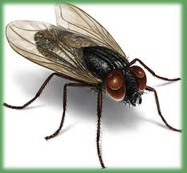](http://www.google.co.uk/imgres?imgurl=http://wakeywakeynews.com/wp-content/uploads/2011/01/housefly.jpg&imgrefurl=http://wakeywakeynews.com/3073/scientists-warn-of-potential-superbugs-spread-by-flies&h=310&w=335&sz=28&tbnid=hbk4HnYZBQ3PsM:&tbnh=104&tbnw=112&prev=/search?q=common+house+fly&tbm=isch&tbo=u&zoom=1&q=common+house+fly&docid=OC7uEIpnRpYbzM&hl=en&sa=X&ei=XaerT9ChA6XQ0QWn_f3VDw&sqi=2&ved=0CIoBEPUBMAM&dur=1979)The common house fly feeds by vomiting onto its food,

then sucking up the dissolved product. It is not particular

where it gets its protein from, in other words it could be

from fresh food or faeces – to the fly it’s all fresh food.

Flies are capable of carrying all kinds of harmful bacteria

on their hairy bodies which they then transfer to any

surface or food that they land on.

***If that surface or food is suitable, the bacteria will survive***

***and grow.***

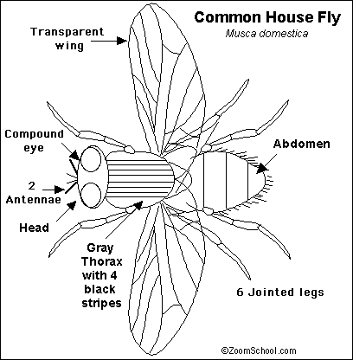

[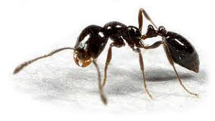](http://www.google.co.uk/imgres?q=common+black+ant&hl=en&biw=1093&bih=502&gbv=2&tbm=isch&tbnid=wHVYs6Lb8lrJRM:&imgrefurl=http://levahnbros.wordpress.com/2011/05/10/how-to-get-rid-of-ants-in-your-home-and-yard/&docid=uZVr6buPyZ-hbM&imgurl=http://levahnbros.files.wordpress.com/2011/05/common-black-ant.jpg&w=500&h=282&ei=yq2rT9PcPKe40QX2vcH3AQ&zoom=1&iact=hc&vpx=76&vpy=88&dur=2243&hovh=168&hovw=299&tx=136&ty=94&sig=101449519287621197786&page=1&tbnh=99&tbnw=175&start=0&ndsp=10&ved=1t:429,r:0,s:0,i:72)

Common Black Ant Lasius Niger

Ants will travel great distances to find a food source

and they will always return to their nest, the black

ant is the most common one seen outdoors and

in the UK.

[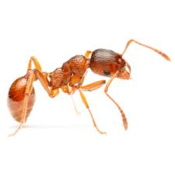](http://www.google.co.uk/imgres?q=red+pharaoh's+ant&hl=en&biw=1093&bih=502&gbv=2&tbm=isch&tbnid=FfQQOet1wNQvbM:&imgrefurl=http://www.frontlinepest.com/pest-library/ants/&docid=mJDVTzL4PiJABM&imgurl=http://www.frontlinepest.com/wp-content/uploads/2011/11/Pharaoh_Ant.jpg&w=360&h=360&ei=bbKrT-yrI8a90QW296WJBA&zoom=1&iact=hc&vpx=115&vpy=152&dur=2854&hovh=225&hovw=225&tx=160&ty=134&sig=101449519287621197786&page=2&tbnh=154&tbnw=179&start=12&ndsp=15&ved=1t:429,r:0,s:12,i:103)Pharaohs Ants Monomorium Pharaosis

The reddish coloured Pharaohs Ant prefers

the warmth and is often found in food

stores. To reproduce, ants require a

breeding female and a suitable

environment for a nest, neither

of which are normally found offshore.

Few of these species are ever found

offshore even though the female black

ant can fly initially.

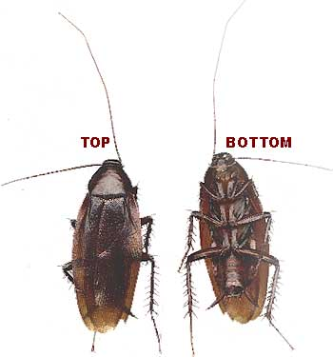 UK Cockroach

Cockroaches are a problem offshore, however

you will rarely find one. You may find an

occasional sample in packaged foods such as

apples and bananas. They would normally

have got there whilst the fruit was in the

warehouse in storage. Cockroaches are from

the family Mantidae, their closest relatives

being mantids, they are thought to have

originated in Africa despite their varied

names.

It is worth noting that these insects

feed on almost anything thus causing

considerable damage. Like many other

insects and pests they carry harmful bacteria

on their legs and feet, consequently they can

contaminate anything they come into contact

with.

There are two main types found in

Europe.

Oriental cockroach Blatta orientalis

This is the larger of the species, dark, almost black in colour with a large rounded head cover. This creature does not require warmth and so can be found outside as well as inside buildings. Its egg cases (ootheca) are tiny semi-circular in shape. The life cycle of egg to nymph is about 40 weeks.

[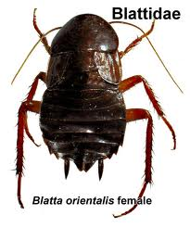](http://www.google.co.uk/imgres?q=blatta+orientalis&hl=en&biw=1680&bih=933&gbv=2&tbm=isch&tbnid=QJDu2mD0u3Z0yM:&imgrefurl=http://www.library.illinois.edu/export/prescons/services/ipm/ipm_photoref.html&docid=nL5ptOIHNlogVM&imgurl=http://www.library.illinois.edu/cms/prescons/services/ipm/images/cockroachx_oriental.jpeg&w=416&h=500&ei=SCetT6LNF8iZ0QWsrJ2RCQ&zoom=1&iact=hc&vpx=174&vpy=589&dur=2519&hovh=246&hovw=205&tx=138&ty=121&sig=105760445343543788967&page=1&tbnh=146&tbnw=117&start=0&ndsp=43&ved=1t:429,r:26,s:0,i:132)

European Cockroach Blattella germanica

This smaller version looks a bit like a cricket; it is reddish-bronze in colour and prefers the warmth. This species is rarely seen outside buildings and normally infests domestic housing. Its egg cases are small and square shaped. The life cycle of the egg to nymphs is approximately 14 weeks.

[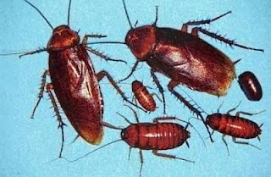](http://2.bp.blogspot.com/_CG5OKqJ6wYQ/TNrHPXa-q7I/AAAAAAAAFO4/qG3sokV66qM/s1600/cockroach.jpg)

Stored product pests such as beetles, weevils, and their larvae

Biscuit beetle Stegobiumpaniceum

This type of beetle is the most common beetle pest in the UK. It affects flour, cereals, biscuits, spices and stored medicines. This particular beetle is small, reddish brown in colour with a covering of dense yellowish hairs. It can cause a great deal of damage to food packaging, and its grub is capable of penetrating tin foil.

[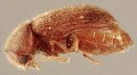](http://www.google.co.uk/imgres?q=biscuit+beetle&hl=en&biw=1680&bih=933&gbv=2&tbm=isch&tbnid=iCVGqhZZugRj0M:&imgrefurl=http://www.knockoutpcs.co.uk/pests/food-beetles-moths.asp&docid=9nim_URVCE0dnM&imgurl=http://www.knockoutpcs.co.uk/pests/biscuit-beetle.jpg&w=200&h=110&ei=A3izT4OVC4io0QWihsDxCA&zoom=1&iact=hc&vpx=423&vpy=504&dur=3200&hovh=88&hovw=160&tx=47&ty=26&sig=105760445343543788967&page=1&tbnh=88&tbnw=160&start=0&ndsp=44&ved=1t:429,r:21,s:0,i:184)

Biscuit Beetle

Flour Beetle Tribolium spp.

This is a flat chestnut- brown coloured beetle which often attacks cereal products, flour, ground nuts and cocoa. The beetle produces a larva, a small elongated meal worm, which leaves a lot of dust and excreta as it feeds.

[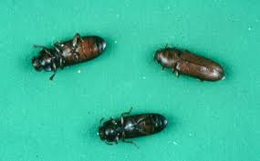](http://www.google.co.uk/imgres?q=flour+beetle&hl=en&gbv=2&biw=1680&bih=933&tbm=isch&tbnid=xezXeH2vYoIMuM:&imgrefurl=http://forums.nasioc.com/forums/showthread.php?t=1539444&docid=kdIMZs-URmgVSM&imgurl=http://www.uidaho.edu/so-id/entomology/Red%20Flour%20Beetle.jpg&w=678&h=421&ei=knmzT6ykKqjB0gWnsOiqCQ&zoom=1&iact=hc&vpx=165&vpy=182&dur=5072&hovh=177&hovw=285&tx=171&ty=97&sig=105760445343543788967&page=1&tbnh=115&tbnw=179&start=0&ndsp=43&ved=1t:429,r:0,s:0,i:110)

Flour Beetle

Weevil Sitophilus spp.

This insect is easily identified by the shape of its snout like projections as you can see in the picture below. At the end of these projections there are mouth parts. Grain weevils attack whole grain, cereals, and products such as dried pasta as they can’t fly. The maize weevil attacks mostly maize, wheat and rice, and again this creature can’t fly in very warm weather. Both the mature weevil and its larvae attack food products.

[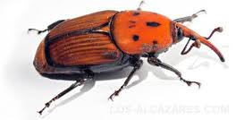](http://www.google.co.uk/imgres?q=palm+weevil&hl=en&gbv=2&biw=1680&bih=933&tbm=isch&tbnid=krhe1ZAX8vqvgM:&imgrefurl=http://www.hondondelasnievestownhall.moonfruit.com/hondon-news/4551904058/Palm-Weevil-Reminder./419957&docid=ky9USUcyMw-yWM&imgurl=http://hondondelasnievestownhall.moonfruit.com/communities/0/004/008/050/850/images/4557546145.jpg&w=330&h=168&ei=2HuzT4HyAqPG0QXH1IiTCQ&zoom=1&iact=hc&vpx=583&vpy=483&dur=2392&hovh=134&hovw=264&tx=154&ty=50&sig=105760445343543788967&page=1&tbnh=96&tbnw=189&start=0&ndsp=39&ved=1t:429,r:18,s:0,i:110)

Palm Weevil

[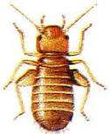](http://www.google.co.uk/imgres?q=booklice&hl=en&gbv=2&biw=1120&bih=385&tbm=isch&tbnid=LGW-kbQMnYi6cM:&imgrefurl=http://www.dover.gov.uk/pest_control/psocids_booklice.aspx&docid=FX1QkJziY4e7iM&imgurl=http://www.dover.gov.uk/images/booklice.jpg&w=188&h=229&ei=0X2zT5nCNIWp0QXsj-GHCQ&zoom=1)Psocids or Book Lice

This insect is commonly but incorrectly known as the book worm. They actually feed on the glue that binds the book, which traditionally was based on animal products. As the glue products have changed to rubber and polymeric based glue, the lice has changed it s lifestyle to adapt. They now attack food packaging which still uses animal product glues.

Birds

In the food safety act of 1990, birds were identified for the first time as being specific food pests which must be controlled. As the Medic and often the Safety Officer on board you must make every effort to ensure birds are prevented from gaining entry into food storage areas. This can be simply achieved by fitting screening devices. It is very important to remember that birds carry salmonella in their guts, this goes for both domestic and wild birds alike. Bird droppings will contaminate anything they land on or in.

Rodents

The most commonly found rats in Europe are the Black and Brown varieties. Both of these originate from Africa or the Far East and made it to our shores probably by getting a ride on board our sailing ships.

Their presence is normally indicated by droppings, smear marks around the edges of bulkheads and damage to pipes, electricity cables, skirting boards, storage cupboards and food packaging by their gnawing. The result of this damage to food and its packaging is the attraction of other pests, the growth of food poisoning bacteria or simply food spoilage. Damage to cables etc can become a fire hazard.

Black rat Ratus rattus

The black rat has been blamed for the spread of the plague throughout Europe in the middle ages. It is however in fact the flea (*Xenopsylla cheopsis)* living on the rat that carries and transmits the disease, the black rat is now rare compared with the brown variety.

[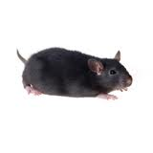](http://www.google.co.uk/imgres?q=Black+rat&hl=en&biw=1120&bih=385&gbv=2&tbm=isch&tbnid=OsswHW_YZDYAOM:&imgrefurl=http://shieldpestcontrol.co.uk/services/rats-mice/&docid=XY0d8_PSuDEKnM&imgurl=http://www.shieldpestcontrol.co.uk/wp-content/uploads/2011/12/black_rat_200.jpg&w=200&h=200&ei=sIOzT9C_HsSP0AWcv7SICQ&zoom=1&iact=hc&vpx=913&vpy=2&dur=3051&hovh=160&hovw=160&tx=80&ty=51&sig=105760445343543788967&page=2&tbnh=111&tbnw=160&start=5&ndsp=18&ved=1t:429,r:11,s:5,i:174)Black rat

Brown Rat Rattus norwegicus

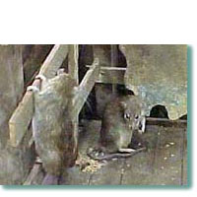The brown rat is better known for its ability to damage food and property rather than produce disease. However, it is a host for Leptospira which is a sprochaetal organism causing acute and potentially fatal, febrile disease also commonly known as Weils Disease. This disease is spread to man if the rat’s urine contaminates water or food.

Brown Rat

Common House Mouse Mus musculus (also the nickname for the

Odd job man on board).

This small creature is less adventurous than the rat, preferring

the warmth and security of a building and seldom ventures

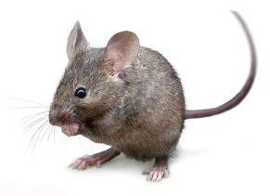outside. This small rodent causes more damage to food and

property than it does spread disease.

Common House Mouse

Pigeons

Every year Pigeons are raced over the North Sea to Germany and Holland and back, they often land on Offshore Installation and remain there. Pigeons are a pest offshore as well as onshore

*Q.3*

*List the obvious things that you might observe offshore that will lead you to believe that pests have caused the damage.*

*You can check your answers on the next page*

2.2 methods of control

Pest requires three essential things to grow and survive:

* Food
* Shelter
* Security

Denial of theses conditions and the use of physical control measures are the most effective ways of controlling pests. Some of these will be available to you offshore, they are:

* Deny entry. Ensure all doors, windows and fly screens are secured and kept shut. Check all deliveries for pests before they are accepted on board.
* Deny food. This can be achieved by ensuring all food waste is disposed of and kept secure. Remind the catering crews about correct disposal of waste and good cleaning practices and store food in sealable, pest resistant containers.
* Deny security. This can be achieved by filling in all holes and gaps in concrete or bulkheads so as to not allow pests a safe, warm, dry place to live and reproduce.
* Physical control. Use devices such as electric fly traps and rodent traps. Avoid chemical ‘knock down’ agents that kill insects in flight as they may fall into the food. If you suspect that the insects have become well established then you must seek outside specialist help.

2.3 Cleaning particles

The best and most effective way of preventing contamination and further growth of bacteria is to have good cleaning practices on board. For the best hygiene practice you should ensure clean:

* Surfaces
* Equipment
* Hands
* Clothing

Every galley should have a strict cleaning schedule backed up with written records identifying the following:

* What must be cleaned
* Who should carry out the cleaning
* What substance and equipment should be used
* When cleaning should take place, and the frequency

This schedule should be signed and dated by the person, persons carrying out the task, and be audited by the medic, OIM, Company Man, Safety Officer and Master of the Vessel, on a weekly basis.

*Answer to Q 3*

*List the obvious things that you might observe offshore that will lead you to believe that pests have caused the damage.*

*You should have recognised and listed most of the signs listed below:*

* *Live and /or dead bodies*
* *Smear marks on bulkheads and around pipes left by rats*
* *Signs of gnawing and damage to property and packaging*
* *Egg cases*
* *Skin Cases*
* *Pest Droppings*
* *Pupa*
* *Larvae*

Water Management

3.1 Introduction

Water may be the source of ill health both onshore and on offshore installations.

Contaminated water can be the cause of:

* Serious food borne diseases
* Food poisoning
* Other diseases such as Legionnaires Disease

Depending on the type of Installation you are on or the company protocol and procedures for that particular company, it might be the Offshore Medics Job to check and maintain the purity of water to ensure it is fit for human consumption.

Depending on company policies the Medic may or may not be nominated to actually carry out water dosing and/ or testing. Whatever the circumstances you must be aware of the results and document them. You must also be prepared to intervene if you feel the water quality is not adequate.

We will discus techniques on your residential 5 day unit.

3.2. Potable Water

The term ‘potable’ comes from the Latin ‘potare’ meaning ‘to drink’ and it refers to all water used for human consumption.

Regulation 25(1) and (2) of the *Offshore Installations (Operational Safety, Health and Welfare) Regulations SI 1976/1019* cover the requirement to supply:

Regulation 17 of the *Offshore Installations* and *Pipeline works (management & Administration Regulations 1995* requires that "an adequate supply of clean, wholesome drinking water is available at suitable locations and those supplies should be tested regularly.”

Regulation 18 requires that "the duty holder shall ensure that all provisions for consumption by persons on the offshore installation are fit for human consumption, palatable and of good quality".

Samples must be collected every 3 months for bacteriological and chemical analyses. Samples for bacteriology must be sent to shore to arrive at the analytical laboratory with the minimum of delay. In order to ensure that this happens, arrangements for the collection and delivery of samples must be made well in advance.

Most companies with a Medical Department will have set procedures for this and samples will usually be tested at a private laboratory or by arrangement with the Public Health Laboratory Service.

The results of water samples are required to conform with the criteria laid down in EEC *Directive 80/778 - The Quality of Water for Human Consumption.*

3.3 Water sampling

Chemical analysis

Samples for chemical analysis must be collected in clean 5litre containers. They should be clearly labelled showing the following information on each container:

* Name of the Installation/Vessel
* Point of sampling on the installation
* Source of supply, that is the onshore source (port authority etc)
* Method of purification used such as chlorination, ultraviolet etc
* Reasons for sampling: for example routine 3 monthly checks or investigation of a problem
* Date and time of collection
* Hot or cold water sample
* Name of the Person/Medic collecting the sample

You must be sure you then complete the required company specific request form giving all the required information we have just mentioned and the relevant details concerning the reasons for testing. You must also ensure that your information mirrors the information on the bottles and each sample bottle is given a specific ID number and this number appears on the request form beside the relevant sample request. If you do not do this then the samples will not be tested and you will have wasted time taking the samples and the cost of sending them by helicopter.

If you are on a Vessel then the process is slightly different, you will have to arrange with the shipping agent for the collection and testing of the water samples after speaking to the Captain, you will still have to ensure all the details are carefully added as above.

Self adhesive labels should not be used as they may come of during transit. You must also make sure you send the samples in a sturdy box with added protection to prevent contamination and damage whilst in transit. Many companies supply a cooler box for this purpose to keep the water samples cool and safe.

Bacteriological testing

Samples for bacterial testing must be kept in sterile bottles, with a capacity of between 240-400mls. These samples must be taken from the cold water supply. The areas used can be varied, however, the sampling point must be representative of the installation/vessel supply and be in good repair.

All parts of the outlet tap must be sterilised by ‘flaming’ and the tap should be run for 10 minutes prior to collecting the sample. ‘Flaming’ is where a naked flame is held underneath the tap outlet for at least 3-4 minutes before the sample is collected. Be sure to check that the tap does not have a plastic insert (which is now common practice). Many companies do not require you to flame the tap but they still wish you to run the supply for ten minutes.

In some areas ‘flaming’ would require a hot work permit so you must check local protocols before you do this. Where this technique is impractical you should thoroughly clean the outlet with alcohol swabs, their use should be noted on the request form as spurious results will be more likely.

Sample bottles must be completely filled and great care must be taken not to contaminate the cap or neck of the bottle. The bottles must again be clearly labelled stating:

* Name of Installation
* Site of sampling
* Date and time of collection
* Examination requested

The samples must be sent without delay, you need to work your times out with ETA of routine Helicopters and Port call for Vessels. If there is an unforeseen delay then the samples must be discarded and re taken at a convenient time - never freeze samples and then submit for testing at a later date.

Results

No *E. coli* or other coliform organisms should be detectable in any 100 ml sample of drinking water.

When any coliforms are detected, a repeat sample should be taken from the outlet which yielded the unsatisfactory result and the water supply heated immediately to make sure it is safe to use. You cannot allow a suspect supply to be used whilst awaiting the return of results.

Where an unsatisfactory result is confirmed as a problem you should seek the expert advice of your Supervising Physician. Acting on his advice, you should take the appropriate action to determine the source of the contamination as a matter of urgency.

REMEMBER:

THE PRESENCE OF E COLI IS ALWAYS AN INDICATOR OF FAECAL CONTAMINATION

The presence of colonies of non coliform bacteria, if greater than 10 colonies per 100ml of water, indicates a low level contamination which requires investigation.

Satisfactory results obtained after a re screen should not be regarded with complacency. Although the absolute count of organisms is important, the trend of results over a period of one year can be of equal importance. The examination of a single sample only gives you an indication of the conditions prevailing at that particular time and point of sampling. It is the regular testing, recording and retention of results that forms an important part of monitoring.

REMEMBER

ANY RESULTS THAT DIFFER FROM THE EXPECTED NORM SHOULD BE REPORTED IMMEDIATELY TO YOUR SUPERVISING PHYSICIAN

3.4 Water Treatment

Potable water is drawn from the mains source onshore, it is then transferred to supply boats and then shipped to the offshore installation. However, it may become contaminated during this process often at the point of transfer. Vessels on the other hand will often bunker water direct from the mains at the port of call; once again contamination can occur at the point of transfer. Because of the risks during transfer all water taken on board should be treated immediately after it has been loaded into the installation/vessel water tanks.

Some Vessels/Installations have ultra violet treatment facilities for all water prior to entering the drinking water system. The problem is that ultra violet does not destroy Legionella bacteria and automatic systems can fail. Chlorination is therefore recommended for all bunkered water used offshore.

This system is simple, cheap and an effective way of treating water supplies.

For chlorination to be at its most effective, all suspended matters and solids must be removed. This is normally done onshore at the collection point by using filters. If a suspect offshore water tank is to be treated it must first be drained and flushed free of sediment.

The most effective way of liberating chlorine into water is the use of a solution of sodium hypochlorite which is available under the trade name of Milton and Chloros.

Treatment of water on board requires that a sufficient quantity of chlorine be added to destroy any bacteria present in the system/tanks. If contamination is suspected, emergency treatment must be carried out. All this means is that you need to ensure enough chlorine is added to ‘shock the system’ and you can measure the result by checking the free chlorine levels which should read free chlorine of 0.15 to 0.2 parts per million (ppm) remaining after a 30 minute contact time.

Contact time

**Chlorine must remain in contact with water for at least 30 minutes to render it safe to drink**

This emergency treatment described above will make your water supply safe at that moment in time. However the effects are not long lasting and so you must ensure that there remains a residual amount of chlorine in the water tanks to keep the free chlorine levels at a level between 0.3-0.5 ppm, after the 30 minute contact time.

As a guide only, normally the addition of 100 ml of stock solution to one ton of water will give a residual chlorine level of 0.1 ppm.

Treatment method

If you are given the Job of adding the chlorine or if you are only monitoring the system, you must ensure that the dose is given to the supply during the tank filling (bunkering) procedure to ensure that there is adequate circulation within the tank during the process. If this has not been possible then a method of agitation will be required to complete the process and this will require you to contact the Engineer or Barge Engineer.

Successful treatment depends on the following:

* Quality of the water being treated
* Correct dose of chlorine agent added
* Correct mixing method (during bunkering, or agitation by Engineering dept)
* Contact time of at least 30 minutes

Dosage rates

It is very important to stress that freshly opened Chloros or Milton must be used and therefore a stock supply must be kept on board.

The solutions must be stored:

* In a cool place
* They must be tightly sealed
* Away from direct light

Sodium hypochlorite solutions degrade in the presence of sunlight and air.

If the level of chlorine exceeds 0.5 ppm then the whole tank supply might require de-tasting. The standard agent for this is sodium thiosulphate which is available in tablet or granular form. The dosage is 2-3 mgs per litre, after the 30 minute contact time. Although the removal of excess chlorine is instantaneous on contact with the sodium thiosulphate, it is important that it is added after the 30 minute contact time of the chlorine/Milton otherwise the sterilisation will have been incomplete.

On completion of the process the water supply should be free from any strong taste or odour, however you will often have comments from crew stating that the water tastes a little unpleasant and they will have concerns about their health and the fact that they have to shower in it. You can reassure them that any small quantities of chlorine left in the water are harmless.

Chlorine testing

On some ships and barges this might be the job of the barge engineer/ engineering dept, however, it is normally the job of the offshore medic to carry out the daily chlorine testing. There are many methods available and one of the most common used offshore is the Lovibond 2000 Comparator.

Lovibond comparator

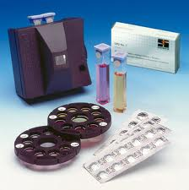

3.5 Legionella monitoring

Legionella pnuemophila was first recognised in 1976 and occurs widely in the environment, commonly, in mud, soil, lakes, rivers and streams. Even though it is widespread it seems clear that its presence rarely causes infection and even then it is normally the elderly and sick who suffer.

The main route of infection is by inhalation of droplets, this can cause two very distinct conditions:

* Legionnaires Disease – which is characterised by a pneumonia –like illness with a fever and cough
* Pontiac Fever - which is less serious but similar to the above

The organism frequently colonises hot and cold water system and humidifiers, calorifiers and shower heads have all been implicated as sources of infection. Some cooling packs for air-conditioning units provide an ideal condition for growth of these organisms as they contain stagnant water at a temperature of 20-45˚C.

Air conditioning units and other water cooling units should be cleaned bi-annually and the water sterilised with chlorine as follows:

**Initial sterilisation –** Uses a chlorine level of 15 ppm with a 2 hour contact time and then flush the system

**Second sterilisation –** Use a chlorine level of 4-10 ppm with a 2 hour contact period, this should be followed by a final flushing and refilling of the system.

Cold water storage systems are less affected and so only require that the water should not be allowed to rise above 20˚C. Hot water systems should be maintained at an output temperature of 55-60˚C. Warning notices about water temperature should be placed in the bathrooms to avoid accidents to unwary users such as new joiners/green hats etc.

4 Management of a food poisoning incident

4.1 Definitions

There are two definitions concerning food poisoning outbreaks that you need to distinguish between:

Potential food poisoning outbreaks

This is when 3 non-food handlers or food handler suffer abdominal symptoms, etc, in any 24hr period.

Confirmed food poisoning outbreak

This exists when 6 non-food handlers, or 3 food handlers, suffer symptoms in any 72 hr period.

The following management techniques are based on the UKOOA Environmental Health Guidelines.

4.2 Potential food poisoning outbreak:

|  |  |
| --- | --- |
| Action | Guidelines |
| Notification | Inform the OIM and the ODD/Supervising Physician |
| Isolation | **Non-Food handler**  Admit the patient to the sick bay or designated cabin and give strict instructions on personal hygiene. Use disposable cutlery or wash the utensils separately in dishwater using water over 80 C  **Food Handler**  You will be required to remove the patients from duty and isolate them as above, pending evacuation and subsequent clearance of stool specimens. If it is possible, obtain a stool specimen prior to the patients’ departure. Patients will only be allowed to handle food again once they are asymptomatic and have provided three clear stool specimens. |
| Investigation | Cary out the following:   * Collect stool/vomit specimens * Identify all food consumed by patient * Follow any further instructions from the ODD * Collect samples of food |

4.3 Confirmed food poisoning outbreak

|  |  |
| --- | --- |
| Action | Guidelines |
| Notification | As for potential outbreak. |
| Isolation | As for potential outbreak. |
| Investigation | Carry out the following:   * Collect stool/vomitus specimens. * Identify all food consumed by the patient. * Collect food samples of: * Remnants of left over food. * Foodstuffs (defrosted and frozen) from the same delivery batch as the suspected foodstuffs consumed within the previous 48 hours. * Gravy, sauces, mayonnaise, creams and custards. * Collect stool samples from all food handlers. * Examine food handlers for superficial infections. * Check food handler’s recent history – specifically holidays abroad, gastroenteritis, respiratory infections andcontact with infectious diseases in family. * Check defrosting procedures. * Check temperature control records of refrigerators and freezers. * Check use-by and/or best before dates of foods used. * Obtain menus for period from Camp Boss/ Chef Manager now called Facilities Manager as Camp Boss is deemed to be politically incorrect. |
| Make safe food and water supplies | **Food**  Inspect the galley and, after samples have been obtained, dispose of:   * All leftover or recycled food (pasta or rice salads) or reheated sauces, gravy, stews, stock pots. * Any suspect thawed food, for example, same batch delivery of poultry, offal and dairy produce. * All ice cream and milk, juices in dispensers or ice making machines.   Ensure all containers and machines are sterilised.  **Water**  Carry out the following:  Collect samples of water for bacteriological testing from the galley and soft drinks machines. Do not forget water taps at tea points and water fountains in the accommodation and recreation area.  If the Installation uses a bunkered water supply, make this safe by chlorination and de-tasting. |

|  |  |
| --- | --- |
| Action | Guidelines |
| Documentation | 1. Notification  You should complete a Notification Proforma and a Primary Notification Form (illustrated below). You should convey the information to the ODD and send the forms to the appropriate authorities.  2. Food consumed  A full list of all foods consumed over the past 48 hours should be compiled for each patient.  3. Nominal roll  A complete list of all persons presenting with the symptoms must be compiled, allocating a unique case number to each patient and stating job and employer. All further personal details including home address and GP information should also be documented on the personal medical card for each individual. |



|  |  |
| --- | --- |
| Action | Guidelines |
| Documentation (cont) | 4. Schedule of specimens  This form is a specific requirement for food Poisoning see page 37. Patient specimens should always have: The Name and unique case number entered onto the form as each specimen is collected. Individual specimen containers must also have the patient’s name and code number printed on the container label.  Food and water specimens: These should also be allocated a unique number and details entered on the form as and when collected.  5. Specimen storage and dispatch.  Specimens should be placed in a double seal Polythene bag and stored under refrigeration until dispatch.  Specimens should be hand – carried whenever possible. They must be manifested as hand carried in order to ensure immediate Customs clearance. Arrangements must be made for immediate collection from the heliport or port for onward travel to the laboratory. Whilst awaiting the return of the results, samples of food from every meal prepared after an outbreak must be collected and stored, pending further investigation or repeat outbreak. These samples should be stored, refrigerated and kept for 48 hours. |

Remember to list the following and send with every sample:

Date of collection:

Incubation period (if known):

Name of patient:

Employing company:

Age:

Details of specimen:

Nature of food specimen:

Code number:

Expiry date:

Submitted by (Offshore Medic):

Objectives

|  |  |
| --- | --- |
| What you should now be able to answer | Test |
| 1. List all the common causes of food poisoning with particular reference to the main bacteria and the foods they affect. | Q. 1 - 3 |
| 2. State the common causes of bacterial infection in food. | Q. 4 |
| 3. Describe the common food pests, the reasons why there must be a control policy and the principles of their management. | Q. 5-7 |
| 4. Outline the factors involved in safe water management with particular reference to the substances used for sterilisation and the frequency of testing and dosing. | Q. 8-11 |
| 5. Identify the main acts and regulations governing food hygiene. | Q. 12 |
| 6. Define food poisoning and distinguish between a potential and confirmed outbreak. | Q. 13 |

Q.1

List the common causes of food poisoning?

|  |  |
| --- | --- |
| Microbiological |  |
| Chemical |  |
| Vegetable |  |
| Fish |  |
| Others |  |

Q. 2

List the three main bacterial causes of food poisoning

1.

2.

3.

Q.3

List the foods commonly affected by the 3 main food poisoning bacteria you identified above? We have provided a table below to help you

|  |  |
| --- | --- |
| Bacteria | Food Affected |
|  |  |
|  |  |
|  |  |

Q. 4

List the seven common causes of bacterial infection of food?

|  |
| --- |
| 1. |
| 2. |
| 3. |
| 4. |
| 5. |
| 6. |
| 7. |

Q.5

List the common food pests, with examples, you are likely to encounter in the food industry in general?

|  |  |
| --- | --- |
| Pest | Examples |
|  |  |
|  |  |
|  |  |

Q.6

State four succinct reasons why a pest control policy is required offshore?

1.

2.

3.

4.

Q.7

Pest control is based on the needs of pests to grow and survive. What are these needs?

Q.8

Complete the following statements by filling in the correct details:

Temperature control Regulations state that cold/chilled foods must be kept at -------------------------- or cooler.

Good practice recommends keeping cold food at -----------------------------or cooler.

Q.9

Chloros and Milton are its trade names, what is the correct name for the recommended water purification substance?

Q.10

Water will be sterilised by the addition of chlorine at levels between 0.15-0.2 ppm. What concentration level is required to protect against further contamination?

Q.11

Apart from tests for chlorine, what other water tests are carried out by law?

Q.12

What is the main Act concerning food?

Q.13

Take a look at the written account of a suspected food poisoning outbreak.

A Chef, roustabout and a driller all suffer from diarrhoea and vomiting for 36hrs.

Is this a potential or confirmed outbreak? Or is it merely a suspected outbreak?

Answers

Q.1

List the common causes of food poisoning?

|  |  |
| --- | --- |
| Microbiological | Bacteria  Viruses |
| Chemical |  |
| Vegetable | Red Beans  Mushrooms  Solaninine  (potatoes) |
| Fish | Scrombrotoxin  Ciguatoxin  Other Toxins |
| Others | Heavy metals  Pesticides  Unknown |

Q. 2

List the three main bacterial causes of food poisoning

1. Salmonella

2. Clostridium perfringens

3. Staphylococcus aureus

Q.3

List the foods commonly affected by the 3 main food poisoning bacteria you identified above? We have provided a table below to help you

|  |  |
| --- | --- |
| Bacteria | Food Affected |
| Salmonella | Raw meat, eggs, poultry |
| Clostridium perfringens | Raw meat, stews, sauces. |
| Staphylococcus aureus | Raw milk, cooked meats. |

Q. 4

List the seven common causes of bacterial infection of food?

|  |
| --- |
| 1. People |
| 2. Raw foods |
| 3. Insects |
| 4. Rodents |
| 5. Animals/Birds |
| 6. Dust |
| 7. Refuse |

Q.5

List the common food pests, with examples, you are likely to encounter in the food industry in general?

|  |  |
| --- | --- |
| Pest | Examples |
| Rodents | Rats and Mice |
| Insects | Flies, ants, cockroaches, beetles, weavils, moths, book worms |
| Birds | Pigeons, seagulls, sparrows |

Q.6

State four succinct reasons why a pest control policy is required offshore?

1. Prevent the spread of disease

2. Prevent damage to food and property

3. Prevent food wastage

4. To comply with the law

Q.7

Pest control is based on the needs of pests to grow and survive. What are these needs?

Basic needs for pests are:

* Food
* Shelter
* Security

Therefore the denial of these, combined with the physical control methods available to you provides an effective control system.

Q.8

Complete the following statements by filling in the correct details:

Temperature control Regulations state that cold/chilled foods must be kept at 8°C or cooler.

Good practice recommends keeping cold food at 5°C or cooler.

Q.9

Chloros and Milton are its trade names, what is the correct name for the recommended water purification substance?

Sodium hypochlorite

Q.10

Water will be sterilised by the addition of chlorine at levels between 0.15-0.2 ppm. What concentration level is required to protect against further contamination?

0.3-0.5 ppm of chlorine

Q.11

Apart from tests for chlorine, what other water tests are carried out by law?

There are two further tests required:

* Bacteriological testing
* Chemical analysis

Q.12

What is the main Act concerning food?

Food safety Act 1990

Q.13

Take a look at the written account of a suspected food poisoning outbreak.

A Chef, roustabout and a driller all suffer from diarrhoea and vomiting for 36hrs.

Is this a potential or confirmed outbreak? Or is it merely a suspected outbreak?

This is a potential food poisoning outbreak.

Notes