Objectives

|  |  |
| --- | --- |
| You should now be able to: | Test |
| 1. State the causes of burns | SAQ 1 |
| 2. State the classification of burns | SAQ 2 |
| 3. Assess the extent of a burn | SAQ 3 |
| 4. State the first aid principle in the management of a burn | SAQ 4 |
| 5.Describe the hazards to an airway which may be involved with a burns injury | SAQ 5 |
| 6. Calculate the replacement needs for a patient following severe burns | SAQ 6 |
| 7. Describe the management strategy for a case involving severe burns | SAQ 7 |

Self-Assessment Questions

SAQ 1

List at least 6 causes of burns?

SAQ 2

There are three classifications of burns, each with characteristic signs and symptom. Describe the classifications and signs and symptoms below:

|  |  |
| --- | --- |
| Classification | Sings and Symptoms |
|  |  |
|  |  |
|  |  |

SAQ 3.

Using the rule of nines, calculate the total area of the burns within the shaded area:

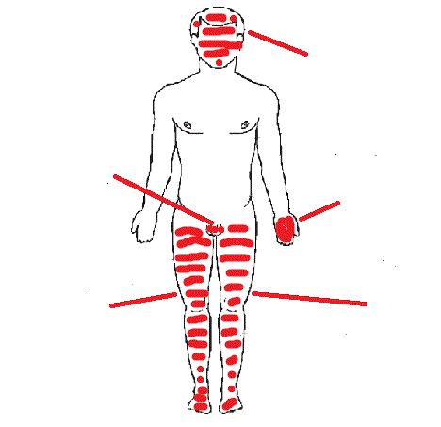

Burn to front and back of head

Private parts



Front of left leg

Whole of left leg front and back

Answer TOTAL AREA IS =

SAQ 4

Using example of SAQ 3 what would be your immediate first aid action?

SAQ 5

What would you expect to find if you suspected your patient had inhaled hot smoke?

What might develop as a result of smoke inhalation?

SAQ 6

Calculate the fluid replacement required in the first 4 hours for a male patient who weighs 98kg and has a full thickness burn of 40% of his body? Ignore the daily requirement. What must you be aware of in terms of the time of the injury?

SAQ 7

Using the patient in SAQ 3 list the urgent actions you would carry out once you are back in the sickbay/hospital.

**Answers**

**SAQ Answer 1**

*List at least 6 causes of a burn.*

Your list should include 6 from the following:

* Dry heat
* Wet heat
* Cold
* Friction
* Chemical
* Electricity
* Radiation

**SAQ Answer 2**

*There are 3 classifications of burns, each with characteristic sign sand symptoms. Describe the classifications and signs and symptoms.*

Your answer should include the following:

**Classification**

* Superficial
* Partial thickness
* Full thickness

**Signs and symptoms**

* Redness of the skin, pain
* Redness, blistering, pain
* Tenderness, blanching of the skin with applied pressure
* Dull red or grey white. Painless, insensitive, does not blanch with pressure

**SAQ Answer 3**

*Using the Rule of nines, calculate the total area of the burns within the dotted lines.*

Answer = Approx. 47%

**SAQ Answer 4**

*Using the patient illustrated in SAQ 3, list the immediate First Aid action you would take.*

Your answer should include all of the following:

* Ensure the safety of yourself and the casualty
* Neutralise cause of burn, for example, extinguish flames, wash off chemicals
* Cool the burn, if appropriate
* Ensure the on-going safety of the casualty and yourself
* Lie the patient down
* Protect the patient's airway
* Protect the patient from the environment

**SAQ Answer 5**

*What would you look for if you suspected a patient had inhaled smoke and what may develop as a result of smoke inhalation?*

Your answers may look like these.

On inhalation of smoke, a patient may exhibit:

* Altered consciousness
* Direct burns to the face or oropharynx
* Hoarseness, stridor
* Soot in nostrils or sputum
* Expiratory rhonchi
* Dysphagia, that is difficulty in swallowing

As a result of inhalation:

* Smoke inhalation may lead to pneumonitis within the following 24 hours. This may be a serious risk to survival and means that **all** victims suffering suspected or confirmed smoke inhalation must be Medevaced.

**SAQ Answer 6**

*Calculate the fluid replacement required in the first four hours for a male patient who has a weight of 98kg and a full thickness burn covering 40% of his body. For this calculation, ignore the daily requirement. What must you be aware of in terms of the time of the injury?* If the injury was already an hour old, you would have to infuse the 1960 ml in the next 3 hours. The calculation gives the fluid replacement requirements in the first 4 hours.

**Calculation = (98x40) % 2 = 1960 ml**

**SAQ Answer 7**

*Using the patient illustrated in SAQ* ***3*,** *list the urgent action you would carry out once you are back in the sick bay.*

Your answer should include all or most of the following:

* Contact the Topside Doctor
* Continue with the patient recumbent and legs raised.
* Control any pain the patient has.
* Remove clothing except any adhering to the burns.
* Administer oxygen. If using Entonox, no additional oxygen is necessary.
* Assess the severity of the burn, that is, area and depth.

Initiate vital signs monitoring:

* Pulse
* Temperature
* Blood pressure
* Weight
* Respiration
* Fluid balance
* Set up two or more IV lines.
* Calculate fluid needs for the next four hours.