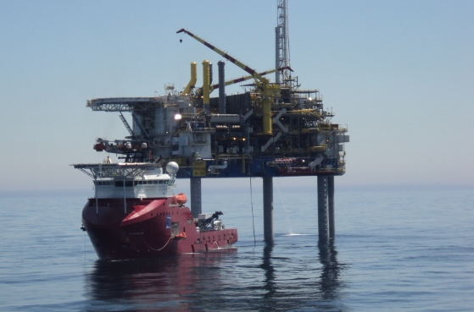
Burns Assessment and Management

Contents
- Causes

- Classifications, signs and symptoms
3. Initial Management
4. Specific Management
- Airway management
- Assessment of burns
- Fluid replacement and requirements
- Analgesia
- Dressings
- Control of Shock
- Medical back-up and evacuation
- Additional considerations
5. Action Checklists

Introduction
Burns are the probably the most serious of the acute trauma conditions you will come across whilst working offshore or in remote areas whether it be on a platform, drilling rig, Flotel or support vessel. Even quite small burns can become lethal when they involve smoke inhalation. As an Offshore Medic you must be able to manage both minor and major burns in:

- The initial first aid phase
- The following four hour period
We will cover different causes and the treatments of burns in the following unit; we will concentrate on thermal burns as they are by far the most common offshore. Cold injuries such as frost bite, frostnip and dry ice burns will be only mentioned briefly within the unit. It is up to the offshore medic to prepare themselves for whatever environment they will be working in and so further reading is always recommended before going on to a deployment.

Preparation
Before reading further please ensure you familiarise yourself with the first aid treatment of burns and do some further reading in the section on skin in your selected Anatomy and Physiology textbook.
Ensure that you also have a calculator to hand before you commence the rest of this unit.

Warm up
Please take time to try the following activity as a simple reminder and preparation for the study materials that will follow.

Draw a diagram of a cross section of the skin in this box?

1. Causes
Damage is caused to the layers of the skin by the following:

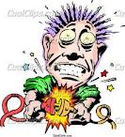
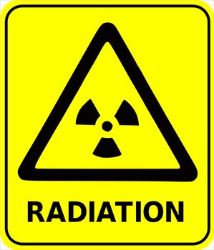

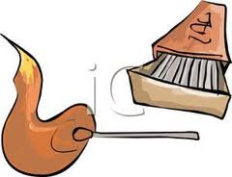
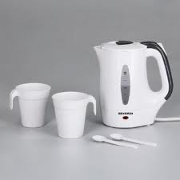

Causes

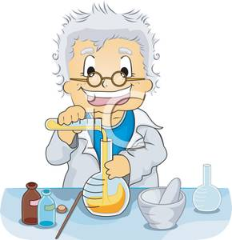
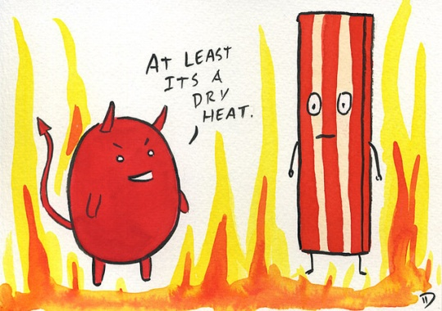

2. Classification, signs and symptoms
For ease of management, burns may be grouped into three categories according to the depth of burn. These categories, together with the signs and symptoms of the types of burn, are shown in the table below. See photographs 1-3 below table:

Classification | Skin layers | Signs and Symptoms
Superficial | Involving epidermis | Redness of the skin, pain
Partial thickness | Involving epidermis and superficial dermis | Redness, blistering, pain, tenderness, blanching of the skin with applied pressure
Full thickness | Damage extending through the dermis to the subcutaneous tissues | Dull red or grey white, Painless, Insensitive, does not blanch with pressure
Classification, signs and symptoms of burns

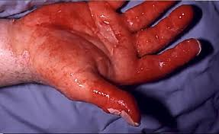
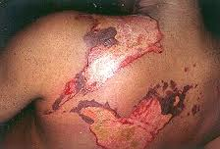
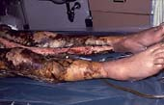

Superficial burn to hand Partial thickness burns Full thickness burns

3. Initial management
Management of burns can be separated into initial management and specific management phases. The initial management being the first aid phase given to any injured person suffering from a burn, in order to preserve life and prevent further injury or harm. Have a look at the table below which shows the initial management of the injured person for each type of burn injury.

Causes | Initial treatment
Dry Heat | Remove the IP from the initial source of danger. Lie IP down and carefully smother any flames taking care not to injure yourself. Remember flames and smoke travel upwards and may cause damage to the IP’s upper body and airway and have an effect on the rescuer. Remove IP to fresh air as soon as possible. Douse any smouldering clothes with copious amounts of water. Remember don’t remove any clothing that is stuck to the skin.
Wet Heat | Immerse in cold running water immediately. If any clothing is saturated with hot liquid remove it quickly and carefully and or cool with copious amounts of water.
Friction | Friction burns are considered as being caused by dry heat and therefore are treated as above.
Radiation | Radiation burns are extremely rare and require expert help and Topside Specialist advice ASAP.
Chemical | Remove the chemical with copious amounts of water especially around the face, mouth and eyes. Wear protective clothing including gloves and mask and safety glasses whilst removing any contaminated clothing. Make a note of the identity chemical using the DATA sheet at the site. If the burn is from Hydrofluoric acid (which is used offshore), calcium gluconate solution should be used to neutralise.
Electrical | First of all ensure that the power is shut off, the area is safely isolated and a lock out tag has been fitted if possible as there is a danger of arcing from high voltage power supplies. Remove the IP from danger. Check the airway (ABC) - if the injured person is in cardiac arrest commence CPR and transfer to the Sickbay as soon as you can, once they are stable.

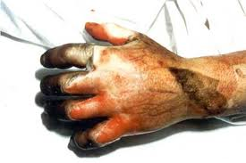

Electrical burn

Question 1:
List 4 -5 signs of thermal injury
Answer on next page

4. Specific management
The specific management phase is what you would do as a medic to ensure the ongoing wellbeing and safety of the injured person, leading up to and including evacuation by SARS, routine in field flight or by sea. The management of severe burns should be seen as an ongoing process which requires constant review and revision by yourself and your Topside Doctor.

To simplify this phase we have dealt with the specific management as a series of phases or steps. Remember the priority of treatment could alter depending on the severity of the burn.

- Airway assessment
- Assessment of burns
- Fluid replacement and requirements
- Analgesia
- Dressings
- Control of shock
- Medical back-up and evacuation
- Additional considerations
4.1 Airway assessment
Administer oxygen at the highest concentration available, give humidified if you can. Check for smoke or thermal injury to the respiratory tract and record all findings and observations. Smoke inhalation may lead to pneumonitis within the following 24 hour period. This may be a risk to the victim’s survival and so all burns victims should be Medevaced as a matter of course.

4.2 Assessment of burns
The severity of the burn is usually indicated by its depth and the surface area. There is a poor prognosis for full thickness burns greater that 70% of the body area. Shortly after the burn, plasma starts to pool beneath the damaged area, due to altered capillary permeability, resulting in a fluid (plasma) shift from the intravascular space. If more than 15% of the body is burnt, this progressive fluid loss will result in Hypovalaemic shock. Note the critical % of burn for an adult is 20% or more.

How would you go about assessing the area of burn?

The usual method is using the Rule of Nines in an Adult

(see diagram below)
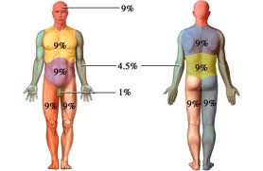

The surface area of a patient’s hand is roughly equivalent to 1% of their body surface area. So you can either use the rule of nines as above or estimate the area burnt or use the patients hand size to make an estimate. You should record your findings on a suitable chart. In the case of extensive burns it is much easier to deduct the burnt area from 100. To get a correct analysis be sure not to include area of redness and erythema.
Answer Q1
What signs of smoke or thermal injury might you expect to see?
Your list should include most of the following
- Altered consciousness
- Hoarseness stridor
- Sputum or soot in the nostrils
- Expiratory ronchi
- Dysphagia, difficulty in swallowing
- Direct burn to face of oropharynx

4.3 Fluid replacement and other requirements
Fluid replacement for minor burns can be oral fluids, however for burns of 10% or more or where the burn affects the oral/pharyngeal areas, an IV infusion is required. In order to calculate the fluid requirements, you must assess or ask the patient’s body weight and record it. Commence 2-3 IV lines. Cannulate with large bore cannula, 14 or 16 French Gauge. See table below for a guide as to flow rates of each cannulae.

French Gauge | Flow Rate
14 | 1 litre in 4 minutes
16 | 1 litre in 5 minutes

It is recommended that you use the largest accessible vein available. Remember that ankle veins are prone to rapid thrombosis. Fix the cannulae securely to prevent dislodging when moving the IP, remember however that burnt skin sloughs.

Remember that small veins in the back of the hand have very little use in this situation as they have a very slow infusion rate.

Fluid requirements
The amount of fluid required following a burn can be calculated using the following formula:

Fluid required Weight of patient, kg x % area burn
In the first 4 hours = _____________________________
2

This formula gives the patient’s requirements for the first four hours following the initial injury. This will not cover the fluids lost as a result of the burn. The calculation for loss of fluid from the initial burn injury will be discussed in the next section.

Question 2
Calculate the fluid replacement required in the first four hours for male patient who weighs 90 kg and a full thickness burn covering 40% of his body?

Then try calculating the normal daily requirement to give you the TOTAL amount of replacement fluid needed.

Now check your answer on the next page

Normal intake
You must always remember to include the body’s normal requirement for any fluid replacement requirements. Have a look below at the following information this should help you estimate these requirements.

The minimum normal intake is considered to be 50ml an hour (1200 ml per day). This figure does not take into account compensation for sweating in hot weather of hot environments. Remember if the patient sweats profusely then you will need to add a further 300ml to the total daily figure.

Fluid type
The first 500ml should be 0.9% saline and the remainder should be colloid. If you are in a position where you can only use a crystalline solution then you must double the fluid replacement figure.

Check with the unit ‘Shock: Mechanisms and Management’ and clarify why the volume of crystalline solution needs to be doubled.
Answer Q2
Calculate the fluid replacement required in the first four hours for male patient who weighs 90 kg and a full thickness burn covering 40% of his body?
Then try calculating the normal daily requirement to give you the TOTAL amount of replacement fluid needed.

Calculation:

Volume of fluid required in the first four hours after the burn = (90x40) % ÷ 2 = 1800ml

Normal requirements = 4hrs at 50ml per hour = 200ml so total fluid replacement requirements for this man for the first 4 hours = 1800+200ml = 2000ml

Chart input and output
Commence an input/output chart to record the amount of fluid passing in and out of the body, make sure you record all fluids given IV and orally and measure the urine output.

If you have time prior to Medivac you should catheterise the patient after obtaining their consent, this will allow you to monitor urine output more accurately. You should also note hourly volume output, colour and consistency.

4.4 Analgesia
Superficial and partial thickness burs can be very painful therefore adequate analgesia is required. Remember pain relief is one of the major factors in the treatment for shock. Use Entinox unless other injuries contraindicate this such as maxillo-facial injuries, suspected Pneumothorax or the patient is a diver and decompression injury is another factor in the equation

Reassurance is very important. Patients with quite sever burns are often fully alert and aware of their surrounding and they need comforting. Patients with full thickness burns which give very little pain will also be frightened and distressed and will require some pastoral care.

Remember!
Other personnel present such as your first aid team may also be distressed and thus require reassurance and counselling. In offshore environments it is more likely that the injured person is a close friend or colleague and this will have an impact on everyone on board including yourself.

4.5 Dressings
Don’t use creams or lotions on burns.
Don’t transfer patients with wet dressings as hypothermia is a real danger, with possible lethal consequences.
Don’t burst blisters.
Cover the burn area with Clingfilm, a clean sheet and a blanket or anti - hypothermia bag. If the transfer is likely to take over an hour then you should consider using a Roehampton burn dressing. This will absorb exudate and is more comfortable and warmer for the patient.

4.6 Control of shock

In addition to fluid replacement, lay the injured person down, raise their legs and monitor their body temperature. Continue to give reassurance to them, check their Tetanus status if possible and administer a vaccine if required. There is no reason for using antibiotics as a prophylaxis measure at this stage.

4.7 Medical back-up and evacuation

Contact Topside at the earliest convenience to arrange a medivac. If you are too busy then request assistance from the OIM and or Company man on board.

You should give as much information as possible at this stage, in particular:
- Area and depth of burn
- Involvement of airway or special areas such as eyes, face and perineum
- History of event, for example patient was burnt due to an explosion, patient was a diver etc
- Time patient exposed to heat and smoke fumes
- Any noticeable respiratory problems
- Time elapsed from the time of injury
- Treatment commenced

If the injured person’s airway is compromised then you must consider having a Doctor to escort them from the platform or vessel. In cases of evacuation you must ensure the patient has enough analgesia and fluids for the trip. A helicopter flight could take anywhere up to 2 hours and may be diverted due to weather conditions.

Note: all severely burned victims must be escorted by a competent medical person and not a First Aider.

4.8 Additional considerations

When dealing with specific management of burns you should consider all of the following conditions:

- Laryngeal oedema: this might require crichothyroidotomy.
- Bronchospam: This may require the administration of Ventolin (Salbutamol) via a nebuliser.Remember don’t use water in the nebuliser to humidify the oxygen as this may lead to a condition called “soggy “lung.
- Circumferential burns: These may require escharotomy (by a burns specialist) in severe cases of swelling.

For all of the above you must first contact the Topside Doctor.
Crichothyroidotomy and escharotomy have their own dangers and the medic should not attempt these procedures. Only attempt emergency crichothyroidotomy if the patient is in dire straits and after discussion with your Topside cover. If however you are unable to communicate with Topside and it is a life saving procedure then discuss with the OIM and/or Master of the Vessel and proceed with caution.

5. Action checklists
Immediate action
Urgent action

- Remove injured person to the sickbay
- Contact Topside
- Continue with patient recumbent and legs raised
- Control pain
- Remove clothing except any adhered to the burns
- Administer oxygen, if using Entinox that will suffice
- Assess the severity of the burn
Ensure the safety of yourself and injured person

Neutralise cause of the burn, for example
extinguish flames - wash off chemicals.

Cool the burn, if appropriate.

Ensure the ongoing safety of yourself,
your first aid team and the injured person.

Lay the person down.

Protect patient’s airway, protect them from
the environment.

Initiate baseline observations

- Pulse
- Temperature
- Blood pressure
- Weight
- Respiration
- Fluid balance
- Set up two or more IV’s
- Calculate fluid requirements for the next four hours as discussed on page 9 of this module.

On-going Management
- Reassess the injured person’s airway regularly. The effects of smoke inhalation are often delayed and change may occur rapidly
- Administer necessary oxygen therapy
- Monitor and record clinical signs
- Apply any dressings required to keep area free from contamination

Administration
- Keep the OIM, Ships Master or both informed of the patients status and requirements
- After you have discussed logistics with your Topside cover, arrange medivac following company guidelines and procedures
- Arrange suitable patient escort
- Provide adequate supplies such as drugs, IV fluids etc. for the journey
- Send detailed copies of patient’s records including drug administration and details of incident etc. with the patient
- Complete accident reports etc. when you have time and forward to relevant personnel
- Send notification of medivac as per company procedures.

Be aware that all companies have their own guidelines and you must keep up to date with individual policies and stick to them.

Key points
There are many causes of burns offshore.

You might have someone come offshore already suffering from a burn either very recently or being treated by their Doctor.

Always be aware of smoke and thermal injury to the respiratory tract and carry out appropriate airway management.

Arrange medical back-up and early medivac as soon as possible

Burns are classified by depth into:
- Superficial
- Partial thickness
- Full thickness
Remember the severity of the burn(s) is proportional to depth and surface area.

Additional considerations include:
- Laryngeal oedema
- Bronchospam
- Circumferential burns
Remember to consult your Topside cover in all of these circumstances.

Fluid replacement for minor burns can be oral fluids, but for burns greater than 10%, IV infusion is normally required. Keep a strict input and output chart at all times.

Superficial and partial thickness burns can be very painfully and require good pain management.

Reassurance is vital for both the possibly distressed patient and other personnel present such as rescuers, first aiders and bystanders. Also remember that relationships are built offshore so don’t ignore the partner that might be on a different shift or working in another area.

Notes from Student

Notes fro tutor

