Diving Aspects: Assessment and Management (part 2)

3. Diving related disorders

Diving disorders can occur when divers ascend and descend to and from the sea bed or place of work.

There are four main causes of diving disorders.



3.1 Pressure volume changes descending

During descent the middle ear pressure must be equalised by the methods described earlier in this module. If this is carried out incorrectly the diver will experience intense pain in the affected ear. There are two things that can happen to relieve the pressure.

* The diver could ascend and thus decrease the pressure
* The ear drum could rupture and release the pressure

The sinus cavity could also be affected causing severe pain and a nose bleed, although this is more uncommon.

Remember

Both conditions normally occur when a diver that has not respected the old saying (never dive with a common cold): this is often a problem for the medic on board a DSV because they are responsible for conducting pre-dive and post-dive medicals. Often sat divers will not want to disclose the fact that they have a cold because that could result in them failing the pre-dive medical losing 28 days work.

There are other implications to this. For example, they have paid for travel to work and don’t want to waste the money and they also won’t want to be seen to be causing problems for the company. A sick diver could mean not enough men to work in a team which can have a huge effect on productivity. You must bear this in mind if you ever have to conduct pre-dive medicals offshore.

3.2 Pressure volume changes: Ascending

Consider the lungs as two air filled bags

Remember that the air in the lungs will expand as the ambient pressure is reduced.

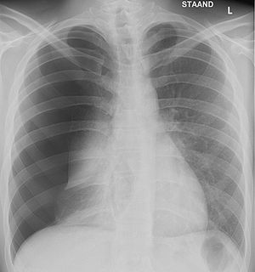Have a go at answering the following question

*A diver breathing air from a tank is diving at 10 meters. He becomes snagged in netting and panic. He suddenly inflates his buoyancy compensator and shoots to the surface.*

*His lung volume at 10 metres was 5.5 litres.*

*What will his lung volume be at the surface? And what do you think might happen?*

*Check your answer on page18*

X-Ray showing a Pneumothorax

Pulmonary Barotrauma

This term is used to describe the over inflation of the lungs that is caused by a sudden decrease in pressure. The air in the lungs expands too quickly and cannot be expelled through the mouth. This can also happen if a diver ascends to the surface whilst holding their breath. Submariners are also at risk from this type of injury as they have to go through a submarine escape procedure. They are trained to ascend from a great depth, breathing out slowly as they rise to the surface. However, there have been occasions when some crewmembers have not adhered to the procedure and subsequently died. In these circumstances air breaks out of the lungs, leading to various effects.

* Air might burst through the pleura, entering the chest cavity causing a collapse of the lungs which is called a Pneumothorax.
* Air may rupture the Pulmonary Vein, and then enter the blood that is circulating back to the heart, and so enter the general circulatory system. This can then enter the cerebral circulation, blocking the circulation to the brain resulting in a stroke. This is called an air embolism.
* Air might rupture the vessels in the neck causing a condition known as interstitial emphysema.

Please note that diagnosis of this type of injury will have to be derived from the circumstances leading up to the incident.

The patient’s symptoms may present almost immediately during ascent or on reaching the surface. Symptoms might include:

* Chest Pain
* Breathing difficulty
* Cough
* Bloody sputum (indication of Pneumothorax)
* Sudden collapse
* Loss of consciousness (indication of cerebral

embolism)

3.3 Effects of breathing gas when descending:

Oxygen is required to sustain life, however, if Oxygen is breathed at an ambient pressure above atmospheric pressure it can be harmful. This effect is known as Oxygen Toxicity.

There are many toxic effects noted during animal studies into the effects of Oxygen toxicity, however in man there are two main clinical effects.

* Chronic pulmonary toxicity where the breathing becomes difficult
* Acute central nervous system toxicity, where the oxygen can cause a grand mal convulsion

**The crucial factor is of course the pressure at which oxygen is being breathed**

Acute central necroses system toxicity

It is worth noting that any healthy individual, who breathes oxygen at a pressure greater than 2 ATA, is liable to suffer a grand mal convulsion. This is identical to a fit experienced by an epileptic but is caused by oxygen. We don’t need to be too concerned about the reasons for this, in fact the precise Aetiology of CNS toxicity is unknown. It is obvious however, that it could be fatal to suffer a grand mal fit whilst underwater.

Oxygen at this pressure may be breathed in a mixture or as pure gas. Pure oxygen breathing is used to hasten decompression during routine diving operations, and is usually the treatment for decompression sickness. In these circumstances care has to be taken to ensure oxygen is at a safe level of pressure. It is worth mentioning that most individuals can tolerate a higher oxygen pressure in a dry chamber than they can when diving. For this reason decompression sickness is carried out at 2.8 ATA.

Chronic Pulmonary Toxicity

This is the second of the oxygen toxicity clinical effects. Here the effects are proportional to the partial pressure of oxygen and the duration of exposure. It can commence at pressure between 0.5 and 0.8 ATA. Clinical effects can range from:

* Mild chest soreness with a persistent cough
* Increasingly severe breathlessness with reduction of lung vital capacity

When oxygen is used to treat a diver suffering from decompression sickness the diver may have to breathe oxygen at 2.8 ATA for many hours. The duration of therapy is determined by a treatment table. To lessen the effects of pulmonary oxygen toxicity the oxygen breathing periods are broken up into sections by periods of air breaks (or air breathing cycles).

Nitrogen

Nitrogen is the main constituent of air, with increasing underwater depth and therefore pressure, nitrogen in the tissues distorts motor and intellectual functions. This effect is solely depth related and can be reversed once the pressure is reduced, that is on ascent.

*Question 4*

*See if you can work out the depth of which a diver breathing air could suffer with central nervous system toxicity*

*Question 3*

*A diver breathing air from a tank is diving at 10 meters. He becomes snagged in netting and panic. He suddenly inflates his buoyancy compensator and shoots to the surface,*

*His lung volume at 10 metres was 5.5 litres.*

*Answer:*

*The pressure changes from 2 ATA to 1 ATA on ascent. Using Boyles law this means the pressure is halved and the volume is doubled. The diver’s lung volume would therefore increase to 11 litres; this would result in a ruptured lung which could well have fatal consequences.*

Check answer on next page

The clinical effects appear at about 50 meters, although this depends on each individual’s susceptibility to the condition. The severity of the symptoms is also depth related, including:

* Mild Euphoria
* Loss of Inhibitions
* Sense of feeling woolly-headed
* Inability to concentrate thought (especially dangerous for commercial divers)
* Loss of reason power (again dangerous when working at depth)
* Confusion
* Stupor
* Unconsciousness

Many aspects of diving illnesses are not fully understood but it is believed that the so called “narcotic” effect of nitrogen overcomes the convulsive effects of oxygen at depths of 90 metres or more.

Therefore to allow diving to take place at depths greater than 50 metres, an alternative gas to nitrogen has to be used. Helium was discovered to be the best substitute for nitrogen. The divers breathing mix is artificially made up from compressed oxygen and helium gases. Helium can only be obtained from natural sources, therefore it is very expensive to use. In modern commercial diving system Helium is reclaimed and recycled.

*Answer 4*

See if you can calculate the depth of which a diver breathing air could suffer with central nervous system oxygen toxicity?

Answer:

The partial pressure of oxygen in air at a surface pressure of 1 ATA = 20% x 1 = 0.2 ATA

CNS toxicity occurs at 2 ATA or greater. Thus a partial pressure of oxygen in air representing 2 ATA occurs in 10 ATA (2 ATA is 20% of 10 ATA).

An underwater pressure of 10 ATA =

1 ATA surface pressure + 9 ATA water pressure

The depth equivalent of 9 ATA = 9 x 10 metres = 90 metres

Answer = 90 metres

Therefore if a diver descends to 90 metres or more he could, in theory, suffer an oxygen induced convulsion. However this does not happen for reasons that will be discussed later – the “Narcotic” Effects of Nitrogen.

3.4 Effects of breathing gas: Ascending

Using Henrys law, it is clear that more gas dissolves in a liquid as its partial pressure increases. So, as nitrogen gas it not used by the body it will be in a steady state for any given ambient pressure.

Diving whilst breathing air causes more nitrogen to dissolve in the tissues, the longer and deeper the dive the more nitrogen is taken up by the tissues.

With ascent, the pressure of the body decreases and the solubility of the nitrogen decreases. So, the nitrogen leaves the tissues. Provided the ascent and the pressure drop is slow enough, the excess nitrogen will leave the body as it entered, through the lungs.

Decompression Sickness (the bends)

If a diver’s ascent is too fast, they can be struck down by a disorder known as decompression sickness. Because the lungs can’t get rid of the excess nitrogen fast enough, the tissues become saturated with nitrogen. It is at this point that the bubbles of nitrogen form within the tissues and veins. As the bubbles can form anywhere in the body it must be anticipated that the effects will be wide spread. Some of the clinical effects and there comparative frequency are shown in the table below.

|  |  |  |
| --- | --- | --- |
| Symptoms | No. of Cases | % of cases |
| ‘Bends’ (joint pains) | 3278 | 88.78 |
| ‘Bends’ with local manifestations | 9 | 0.26 |
| Pain with prostration | 47 | 1.26 |
| Central nervous system symptoms:  1. Hemiplegia  2. Spinal cord | 4  80 | 0.11  2.16 |
| Vertigo (‘staggers’) | 197 | 5.33 |
| Dyspnoea (‘chokes’) | 60 | 1.62 |
| Partial or complete unconsciousness | 17 | 0.46 |

Clinical effects of Decompression Sickness

Decompression sickness has been recognised for over 100 years. Experiments showed that decompression sickness was an inevitable consequence of diving but that it could be controlled with ascent. The reduction of pressure or decompression can now be determined by tables, see example of US Navy Standard Air Decompression Table below on page 25.

Tables come in large manuals. They have been derived from calculation and experimentation. For each ten feet increment of depth and ten minute period of bottom time there is a depth/time profile. The diver follows the profile as he ascends hence avoiding decompression sickness. The table below is for diving at 80 feet. It remains standard practice in the USA and UK to keep to the non-metric system. You can see both imperial and metric measurements on the table provided.



*Figure 1*

Should the diver be at a depth or time that falls between the given values on the table, he will follow the next higher value. For example if he dives 76ft for 78 minutes he will follow the 80ft/80 min table. Have a look at figure two on the next page, this shows a different representation of the data given in table 3.

Please also note that for each depth and time spent at that depth there is a staged ascent. The times at the “stops get longer the nearer to the surface the diver ascends. In practice, this is carried out by a weighted rope that is marked with depths and which hangs below the dive boat.

*Figure 2*

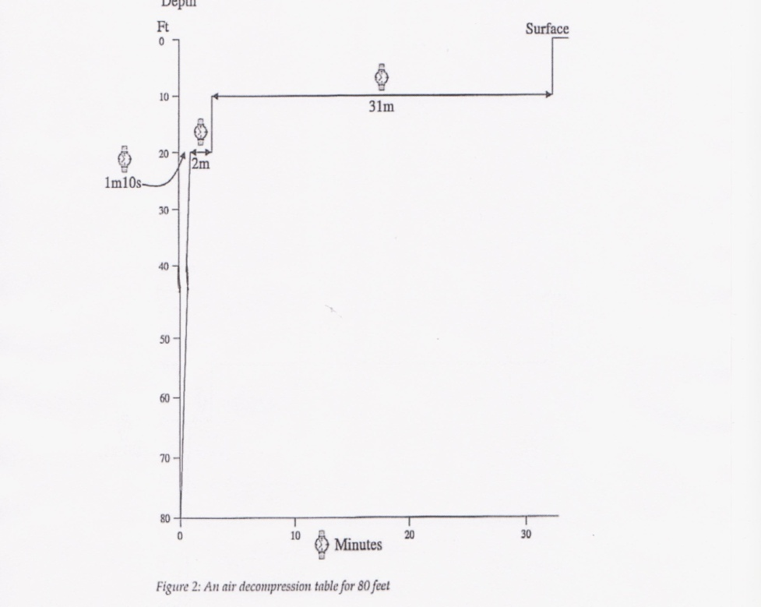Recompression techniques

Question 5:

What particular problems do you think might be associated with the technique of surface decompression?

Check answer on page 29

A dive should always be pre planned so the diver knows how long they can spend at each stop on their ascent. For deeper and longer dives the diver might be required to wait at a level in the water for an hour or more.

This method was found to be unsatisfactory and non cost effective in commercial diving as no useful work could be carried out during the waiting periods. Also, the weather could change and the diver could get very cold and hungry. Once commercial diving began, often in deep and dangerous waters, a faster way of retrieving divers was required.

There are two basic techniques:

* Surface recompression
* Use of a diving bell

Surface recompression

Very rarely used today, the technique utilises oxygen and is only suitable in waters up to 40 metres in depth – it is sometimes known as a form of aborted decompression sickness. The technique requires that the diver can return to the surface and enter a recompression chamber on the support vessel and be recompressed all within the space of 5 minutes. You can see a photograph of a typical decompression chamber on page 26. Once the diver is inside the chamber, the pressure is increased to a pre determined depth equivalent.

The diver breathes 100% oxygen from a mask over times cycles, whilst pressure in the chamber is slowly brought back to atmospheric pressure.

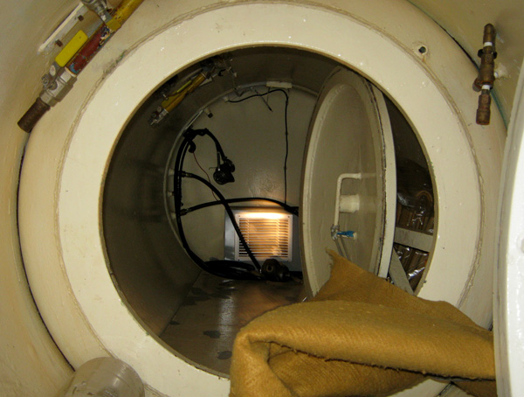

*A typical decompression chamber*

Use of a diving bell

The bell is lowered to the diver and the pressure in the bell is increased until it is equivalent to the pressure at which the diver is working. The diver then enters the bell, shuts the door and both diver and bell are returned to the surface. The pressure in the bell is slowly reduced so the diver does not suffer from decompression sickness.

The advantage of this system is that it is an extremely safe way of diving and is used routinely in the commercial diving sector; however it is very expensive and requires a large support network of dive supervisors, sat supervisors and dive technicians.

The recreational diver will not normally have any access to such facilities, however if they plan the dive correctly, they should have no problems. In the past, most recreational divers did not dive deep enough or long enough to need to worry about decompression sickness. Accidents happened due to too rapid ascent or from drowning. With the introduction of more sophisticated equipment the recreational diver now has to take into account their nitrogen load. This means following the old staged ascent system.

Case histories

The following case histories show how dives do not always go as planned.

Case One

1. Situation

3rd of June @ 19.15 hours. The North Sea medical centre was contacted about a 23 year old diver carrying out commercial air diving of the coast of the UK.

2. Patients Symptoms

Severe abdominal pain, colicky in nature, located in right iliac fossa radiating to the right hypochondrium. Exacerbated by movement and deep inspiration. No nausea or vomiting reported and no diarrhoea.

3. Diving History

Last dive 0800hrs, 30 metres of sea water (msw) for 22 mins. ‘No stop dive’ One before on the 21st of June at 12.00 hrs, 40 msw for 11 mins.

4. Further history

Pain commenced at approx, 0600hrs, 2 hours before last dive, and 42hrs after previous dive.

5. On examination

*Answer 5*

*What particular problems do you think might be associated with surface recompression?*

*Answer:*

*Decompression and Oxygen Toxicity*

Pyrexia of 38.4c Nil of significance discovered.

6. Management

Surgical registrar flown out from local hospital.

7. Conclusion

Acute abdominal pain

8. Action

Registrar arranges to admit the patient to hospital

9. Conclusion reached at hospital

Either a slow leak from a perforated ulcer or biliary colic with peritonism

10. Outcome

Patient treated conservatively with a ‘drip and suck’ regime. Made a rapid recovery.

On the 17th of July - elective surgery, non functioning gall-bladder removed; diseased

and full of small stones.

Discussion

Divers who fall ill always present difficult problems as one always has to think of diving related illness, especially if the disorder arises after a dive. In the North Sea Medical Centre series of cases, 35% of divers who presented with some sort of abdominal pain, in fact had decompression sickness affecting the spinal cord. The pain experienced by the diver is thought to be from a focus of decompression sickness in the spinal cord. The treatment is invariably recompression, which needs to be carried out as soon a possible. The most available chamber is the one on the work site.

***REMEMBER***

To remove a diver who is unwell from their work site is to remove him/her from the very facility that they might need for recovery.

In the case history, the diver reported that his symptoms began 2 hours before his last dive and some 42 hours after his previous dive.

Furthermore, clinical signs indicated an acute abdomen which was indeed the case. It should also be noted that it is fairly unusual for a 23yr old man to suffer from gallstones.

Case Two

The SCUBA diver

A 36 year old SCUBA diver dived to 50 meters (165ft) for 43 minutes, ran out of air, returned to the surface for a fresh cylinder, performed inadequate in water decompression and vomited 10 minutes after surfacing. He was examined two hours later and was found to be disorientated and suffering from memory loss. He also complained of soreness in his scapula area, pain in his neck and weakness in his arms. He was unable to sit up and had swelling of the left leg and a loss of sensation to pinprick and temperature of the left leg.

The right leg was completely anaesthetised; he had no reflexes in his knees or ankles.

He had acute retention of urine and then became quadriplegic and unconscious.

He was compressed to 18m (60ft) initially then 50m (165ft) for more than one hour without any improvement. He was treated for 42 hours with 9 hours of intermittent oxygen breathing.

He recovered consciousness, recovered movement in his arms and trunk, and on decompression his general condition was excellent on reaching the surface.

He suffered a degree of paraplegia which was treated with alternate day 9m (30ft) oxygen surface tables.

The patient was able to walk without the aid of a stick – excellent result.

Symptom Management

We need to consider the following

* Key personnel
* Communications
* Special Advice
* The Medics role offshore

It is important that you understand the roles and responsibilities of the following key personnel:

|  |  |
| --- | --- |
| Diving Supervisor | He is in charge of all diving operations and activities related to diving, including therapeutic recompression in a chamber.  He is the pivot around which all activities concerning the treatment of a sick diver will revolve. He will liaise with the diving medical specialist. He will give instruction to the Diver Medic and/ or the Offshore Medic. |
| Diver | The patient. |
| Diver Tender | A fit diver who can care for the sick diver in the chamber. |
| Diver Medic | A diver who has received special training in diving medicine and the management of diving related illnesses. It is unlikely that he will have any medical knowledge prior to this special training, so his competence will be at a fairly rudimentary level. He will be able to move in and out of the chamber to examine the diver and provide medical attention, unless he is in a saturation environment in which case he is stuck in with the diver. |

|  |  |
| --- | --- |
| Diving Medical Specialist | A physician who has specialist knowledge and experience of the management of diving related Medical Specialist illnesses. He will be located onshore and will have access to a shore based recompression chamber. He will generally provide advice over telephone but may need to travel offshore if the problem is a difficult one to resolve. |

Every diving company will have planned for the possibility of having to treat a case of decompression sickness and will have a well-established treatment regime available. The regime may have developed in-house or may make use of standard treatment tables developed by a civilian or military research unit.

A commonly used treatment schedule is one developed by the US Navy. The diver is introduced into a decompression chamber and repressurised to a depth equivalent of 18 metres of sea water (2.8 ATA). He breathes 100% oxygen by mask on a cyclical basis, for example 20 minutes oxygen, 5 minutes chamber air, 20 minutes oxygen and so on. The pressure is reduced gradually over a period of hours until atmospheric pressure is regained.

Because treatment has to be instituted rapidly, the diver is usually recompressed prior to full assessment having taken place.

The Diving Medical Specialist is generally called once the diver has been compressed to treatment depth.

**Remember:**

* Throughout the treatment period the Diving Supervisor is ultimately in control.
* The role of the Diver Medic is to enter the chamber and carry out an assessment of the diver's condition. He will report his findings to the Diving Supervisor.
* The Diving Supervisor will maintain regular contact with the diving Medical Specialist throughout the treatment.
* The Diving Medical Specialist will advise the Diving Supervisor of any need for special medical treatment. This may take the form of an intravenous infusion, catheterisation and drugs.
* The Diver Medic will administer these inside the chamber.
* The Diving Medical Specialist may also advise the Diving Supervisor of an alternative scheme for decompression, should the conventional treatment scheme not be working.
* The Diving Medical specialist may also give advice to either the Diver Medic or the Offshore Medic.
* In the absence of a Diver Medic, you as the Offshore Medic, may have to fulfil a similar role. For reasons given shortly, the Offshore Medic should avoid entering the chamber.
* Should additional medical treatment be required, the Offshore Medic may have to instruct the Diver Tender how to perform the task. This is not ideal.

**5.2 Communications**

In many countries commercial diving practice is regulated. There is an onus upon the diving company to make arrangements with a Diving Medical Specialist to provide an advisory service for the diving operations. The Diving Supervisor should have the means to contact the Specialist at any time. If this is not possible, then any of the following could be carried out:

* Telephone the ODD
* Telephone the local hospital
* Obtain a copy of Diving Regulations which contain a list of treatment centres. Telephone the nearest centre.

As an Offshore Medic, you are unlikely to have much regular contact with diving operations unless you enjoy recreational diving. It is useful to have an aide-memoire at hand for emergencies. The Aide Memoire for Recording and Transmission of Medical Data to Shore pro-forma was developed by a group of diving specialists (document DMAC 1). It could form the basis of your aide-memoire. If you need to use the form, complete it as fully as you can before making contact with the diving

specialist. You will be able to see a copy of this on the Practical Course.

5.3 Specialist advice

It is very important that you can work effectively with the diver and/or his team and provide advice from a Diving Medical Specialist in the management of a diving related illness.

Any illness occurring after diving, particularly within the first hour, should be treated as an illness specific to diving. For example, an ache around the chest after a dive may feel like a pulled muscle, a pain in the shoulder may be an aggravated old injury - both should be treated as decompression sickness.

**Remember:**

Over 50% of decompression sickness cases develop symptoms within one hour post dive, and 90% within 6 hours.

Most commercial divers recognise the dangers of decompression sickness and will report any symptoms to their supervisor.

Sometimes divers collapse with a major illness and in this case the diver should be immediately recompressed. Diving medicine differs from conventional medical practice here, in that treatment is often initiated before a full history and examination have taken place. Instead, the Diver Medic Recompression will reverse the acute effects of pressure/ volume changes, the movement of nitrogen out of solution, and compress the bubbles that have formed in the tissues and bloodstream. As the diver is once again under pressure, in order to reduce the uptake of further nitrogen and to encourage the elimination of nitrogen from the body, the diver is provided with 100% oxygen to breathe through a mask (hyperbaric oxygen).

This procedure forms the mainstay of decompression sickness treatment, although treatment plans vary from one centre to the next. Most treatment plans have been devised in Naval Medical Departments.

**5.4 Your role as the Offshore Medic**

Your role in diving medicine can be summarised as follows:

* Information gathering using the pro-forma
* Communication with the onshore Diving Medical Specialist
* Liaison officer between the Diving Supervisor and the Diving Medical Specialist
* Instruction to the Diver Tender concerning the examination of the patient
* Supply of medication to the Diver Tender as instructed by the Diving Medical Specialist
* Instruction to the Diver Tender concerning the administration of medication

**Do not administer any treatment without prior consultation with the onshore Diving Medical Specialist**

**Avoid entering the decompression chamber at all costs**

The reasons for avoiding entry to the chamber are as follows:

* Everyone should have a special medical examination prior to going under pressure
* You may not be able to relieve the extreme discomfort in your ears as you go under pressure
* You may be unable to think clearly, and you should make no decisions whilst under pressure
* You may suffer with claustrophobia
* You are exposing yourself to the risk of developing a diving related illness
* You cease to be of use where you are most needed, that is, outside the chamber

**6. Flying after diving**

Ascent in an aircraft produces a fall in ambient pressure. Hence all the effects of pressure/volume changes already considered will apply to any diver who flies after diving. The following recommendations for flying after diving have been produced by the Diving Medical Advisory Committee and cover:

* Air diving
* Mixed gas diving
* Following therapy for dysbaric illness
* Decompression illness in flight

**6.1 Air diving**

The reasons why the altitudes shown in the tables have been chosen is because 2,000 feet (600 metres) is the maximum height to which the diver should ascend following a dive, when travelling in a non-pressurised aircraft, and 8,000 feet (2,400 metres) refers to a normal aircraft with a pressurised cabin.

|  |  |  |
| --- | --- | --- |
|  | 200 ft  600 meters | 8000ft  2400 meters |
| 1. Non - stop dives  Total time under pressure less than 60 minutes within previous 12 hours  2. All air diving (less than 4 hours under pressure) | 2 hours  12 hours | 4 hours  12 hours |
| 3. Air or Nitrox saturation (More than 4 hours under pressure) | 24 hours | 48 hours* |

* Experience in this range is extremely limited, and this recommendation should be interpreted with caution

6.2 Mixed Gas diving (Diver on air at sea level)

No flying at all for at least 12 hours following return to atmospheric pressure following diving involving the use of specialised gases.

6.3 Following diving from Dysbaric illness

|  |  |  |
| --- | --- | --- |
|  | 2000ft  600 metres | 8000ft  24000 metres |
| 1. Successfully treated | 24 hours | 48 hours |
| 2. Cases with residual symptoms must be decided on an individual case by case basis by a Diving Medical Specialist | ..... | ...... |

6.4 Decompression Sickness in flight

Where the diver’s symptoms consist of only pain in a limb, they should be treated with analgesics, oxygen if it is at hand and the plane can continue to its destination without any change of plans or adjustment to altitude.

When the diver has other symptoms advice should be sought immediately from a Diving Medical Specialist. It might be necessary to reduce the altitude of the plane and or divert it to the nearest airport. In the meantime the patient should be given Oxygen if available.

All of the information provided in this section is for your information only and any decisions regarding flying after a diving incident should be first of all referred immediately to a Diving Medical Specialist.

Key points

Diving and diving medicine is a specialist subject with its own team of key personnel. You might however become involved at some stages or indeed you might even decide to complete the DMT course and work full time on a DSV.

* Oxygen can be used in the treatment of decompression sickness, but brings with it its own medical problems.
* There are three laws of physics that relate to pressure and gas in the underwater environment.
* It is useful to carry an aid memoir relating to diving emergency protocols and keep it readily at hand.
* Diving related disorders usually occur on descent and ascent from the workplace.
* Divers use a mixture of gases to overcome the physiological effects of individual gases.
* The usual immediate response to a suspected diving disorder is to recompress the diver.
* There are strict guidelines for flying after diving.
* As the Offshore Medic you should avoid entering the decompression chamber at all costs

Glossary of terms

|  |  |
| --- | --- |
| ABLJ | Adjustable Buoyancy Life Jacket. |
| Ambient | Surrounding, as in ambient temperature and ambient pressure. |
| ATA | Atmosphere Absolute. The pressure upon object immersed in water equal to the pressure of the water plus the pressure of the atmosphere above the water. |
| Barotrauma | Damage to the tissues induced by change in ambient pressure. |
| BC | Buoyancy Compensator. |
| Bell | A hyperbaric transport chamber. |
| Chamber | A hollow steel cylinder large enough to accommodate one or more men, capable of retaining an internal pressure greater than atmospheric. |
| DCS | Decompression sickness |
| Decompression sickness | An illness produced by a fall in the ambient pressure. |
| Dysbarism | Any medical disorder induced by a change in ambient pressure |
| FSW | Feet of sea water. |
| Hyperbaric | At a pressure greater than atmospheric. |
| MSW | Metres of sea water |
| N2 | Nitrogen |
| O2 | Oxygen |
| PP | Partial pressure. |
| Saturation diving | A type of diving system in which the diving team remain at the pressure of the working depth for up to a month. |
| SCUBA | Self Contained Underwater Breathing Apparatus. |

**Notes and questions for tutor**