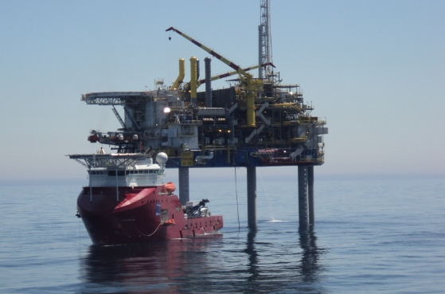Diving Aspects: Assessment and Management (part 1)

**Contents**

1. Diving

Commercial

Recreational

Personal equipment

Commercial diving systems

Recreational diving systems

1. The underwater environment

Physical effects

Physical effects: The gas laws

Physiological effects

**3**. Diving related disorders

Pressure/volume changes: Descending

Pressure /volume changes: Ascending

Effects of breathing gas: Descending

Effects of breathing gas: Ascending

**4**. Case Histories

Case History 1: Galls Stones

Case History 2: Scuba Diver

**5.** System of management

Key personnel

Communications

Specialist Advice

Your role as the Offshore Medic

**6**. Flying after diving

Air diving page

Mixed gas diving

Following therapy for dysbaric illness

Decompression sickness in flight

**7**. Glossary of terms

Introduction

Much of the content in this particular module will be unfamiliar or indeed new to you therefore this is based at a more basic level. You should consider this as being no more than an introduction to the subject, if you are required to work with Divers you will be required to complete the 2 week Diver Medic Technician Course.

As an Offshore Medic you might be required to treat a sick or injured Diver however this would be unlikely unless you are employed to work on a DSV as regulation dictate that:

*For bell* diving operations at a depth exceeding 50 metres and for diving operations involving the use of a mixed gas there should, as from 29 April 1991 be present and not diving at least one person who has successfully completed an approved course as a Diver medic. \*\**

* See glossary *Section 7*

** See *5.1* key personnel

For all types of commercial diving the contractor must decide whether to employ a diver medic, in fact on Sat Vessels it is the norm to have at least one diver medic in each team if not more and also have an HSE Offshore Medic on board who also holds the DMT Certificate.

Preparation

Before you read any further you should ensure that you are failure with the basic physics of gasses and liquids. Please also refresh your knowledge on the respiratory system using your chosen Anatomy and Physiology textbook.

The recommended books on diving medicine are:

*Diving and subaquatic Medicine* by *Edmonds, Lowry and Pennefather.* Published by the Diving Medical Centre, sold and distributed by Biomedical Marine Services, *25* Battle Byde, Seaforth, *2092,* Australia.

Or Bove and Davis Diving Medicine

1. Diving

There are five types of diving that you need to consider these are:

* Recreational
* Commercial
* PPE Personal Protective Equipment
* Commercial Diving Systems
* Recreational Diving Systems

1.1 Commercial Diving

Offshore diving work takes place on rig supports, pipelines and underwater well heads, jackets, this list is not exhaustive. Dive Support Vessels working for the Offshore Industry are in great demand at this time and many more are in the process of being built.

Commercial diving takes place wherever work has to carried out underwater for example in tunnels, on bridge supports, in outflow pipes from sewage, bomb disposal by the military clearance divers and police divers searching for bodies or other evidence.

Divers may be working at depths between 3.3 and 330 metres of water (10-1000 feet) in reservoirs, rivers dams, lakes and of course the North Sea. We have listed below some of the tasks they might be expected to complete in very difficult conditions.

* Carry out non destructive testing, measurements, surveys etc
* Clean metal using high powered water jets or shot blasting
* Cut and weld using welding gear, hydraulic shears or high pressure water cutters (used to cut pipes).
* Dismantle and reassemble flanges and clamps
* Lay heavy concrete mats to protect pipelines
* Work with slings and lifts

1.2 Recreational diving

To give you some idea of the numbers, there are about 2 million recreational divers in the US and about 70 thousand in the UK. This is a very popular sport but not without its hazards, there are about 150 diving related injuries/illnesses per year and on average 15 deaths are attributed to recreational diving each year.

This sort of diving mostly takes place in places of interest on shipwreck sites, close to the rocky shore line where colourful fish and interesting marine life is in abundance. Tropical seas are a popular destination for such sights but there are also a lot of wrecks in UK waters.

Recreational Diving: Case History

Two men were working off the Norwich coast, water depth approximately 33 meters (100ft). One diver was working alongside a shipwreck the other was in a boat. The unconscious diver suddenly appeared on the surface and was quickly pulled back into the boat. There was a Dive Support Vessel nearby working alongside a Gas Production Platform.

The injured diver was taken alongside and placed in one of the Sat Decompression Chambers alongside his diver who rescued him. Soon after entry the unconscious diver suffered a grand mal convulsion. The Offshore Medic was called from the Platform and instructed to enter the Chamber in order to treat the diver.

Because of the serious condition of the diver it was necessary for the Offshore Medic and the other diver to remain in the chamber for three days. With support from a Doctor who was later flown out to the Vessel, the medic monitored the patient, introduced an intravenous Cannula so IV fluids could be given to rehydrate the diver and inserted a urinary catheter to monitor the divers urine output.



The chamber was less than 1.5 metres in diameter and 2 metres long, with nothing more than two bunks.

This case history illustrates a very rare case where an HSE Offshore Medic has been committed to enter a chamber to treat a patient. Under normal circumstances today the diver would be treated by another qualified diver medic and the medic on board would relay information into the chamber from a Topside Diving Doctor Specialist onshore.

1.3 PPE

We should now consider four aspects:

* Breathing
* Diving Suits
* Buoyancy
* Equipment

Breathing

To survive and work under water, the diver needs to either use portable tanks to give him an air supply or take air from a hose, which is supplied by a surface supply on board a boat or pontoon. There are two basic methods he can receive the air supply:

Method 1: To allow the diver to breathe naturally the air is piped into a helmet which encloses his head. The air fills the helmet and slowly escapes from the helmet through a valve set along with his exhaled breaths, this in turn passes directly into the water. This method prevents a build up of carbon dioxide inside the helmet.

Method 2: A much more common system used today is where the inlet of air is controlled by a regulator that only provides air when the diver inhales. The exhaled air again passes directly into the water. This type of regulator is called a demand valve; this is particularly advantageous for the diver who breathes from a tank as the supply can be rationed allowing the diver to stay in the water working for longer periods.

Diving Suits

Divers need to be protected from the cold and elements and there are two types of suit available today.

1. Neoprene wet suit - the type and thickness used depends on the depth and length of the dive. As the dive deepens, the protection from the Neoprene is lost as it is compressed thus making the protective layer thinner. A wet suit becomes wet inside, however the thin layer of water quickly warms up to insulate the diver from the cold for a limited time.
2. Dry suit - these are made of a thin membrane which is itself not compressed. The membrane keeps the diver dry and allows the diver to wear warm clothing underneath.

If the divers are working at depth or in very cold waters they may use dry suits that are called hot water suits, this is like being inside a hot water bottle, and the supply of hot water is regulated from a surface supplied hot water set-up

Buoyancy

Because divers are naturally buoyant they may have to wear weights in the form of a belt to allow them to dive. You might remember the very old diver set up, their suits were very buoyant so the diver had to wear a heavy plate around the neck and heavy boots on their feet.

Old Fashioned

The Diver of yesterday wears a large copper helmet that is bolted to his rubberised canvas suit. The diver would then wear thick warm clothing underneath the suit. He would receive his air supply freely into the helmet; the air would also enter the suit and act as an insulator. As you can see by the photograph he is also heavily weighted.

Modern

The modern diver wears a lighter helmet made out of metal or fibreglass which is weighted and sealed around the neck giving them much more mobility. The suit is made from thick Neoprene and is separate from the helmet. He breathes air through a demand valve; he wears fins or yellow boots, and has a reserve tank of air on his back in case the surface/Vessel air supply fails.

Equipment

Have a look at the pictures below, these show the difference between the old fashioned and modern diver.

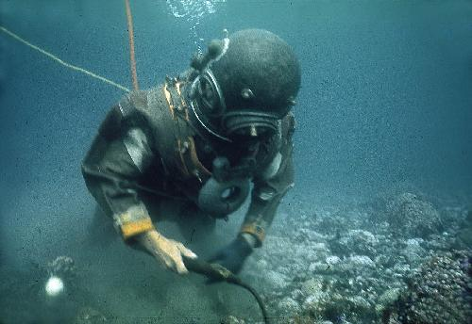

Standard Diving Dress (old fashioned)

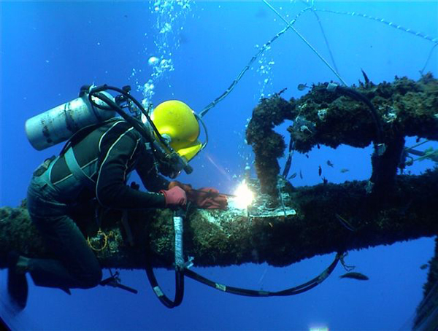

*Commercial Divers (Modern)*

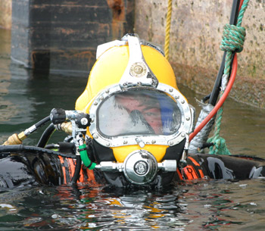

*Commercial Divers Helmet (Modern)*

The recreational diver also used Neoprene but he/she does not wear a helmet. Instead they wear a face mask which enables them to see and breathe through a demand valve retained by a special mouthpiece gripped between the teeth.

The recreational diver will also wear buoyancy Compensator (BC) or adjustable lifejacket (ABLJ), this is normally in the form of a vest with bags that can be inflated from a direct feed or an alternative small cylinder. The BC or ABLJ are rescue devices – should the diver get into difficulties they can return to the surface rapidly by inflating the BC.

1.4 Commercial Diving Systems

Simple Systems

In the Simplest form a diving system comprises of the diver with his air supply being provided by a pump in a boat, the boat would have one or more attendants. This is known as surface supplied diving.

Diving support vessels

These systems tend to be a lot more elaborate, for example there could be 18 Saturation Divers on board in Sat at any time, with two diving bells working in eight hour shifts. Often these types of operations would see teams of technicians, gas men, sat supervisors and dive supervisors working 24 hours a day to look after the divers, the divers themselves often spend 28 days under pressure.

The photograph below shows one of many dive support vessels working in the North Sea and around the world. This particular one is in St Johns harbour New Foundland.

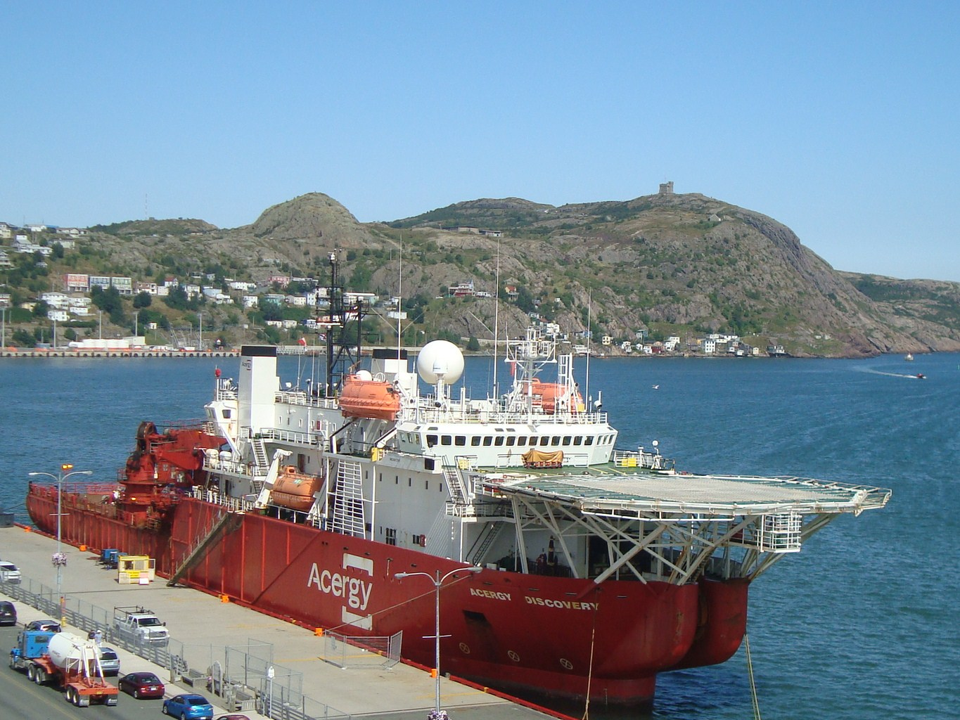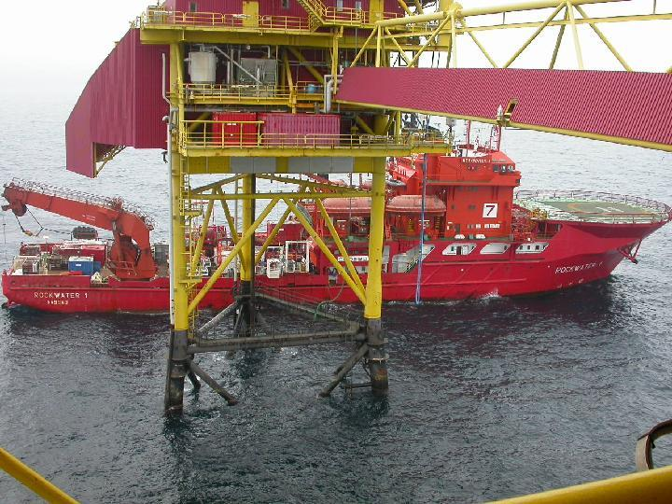

*Dive support Vessel alongside a jacket*

In the next picture you can see Saturation Divers from the commercial world working on a Jacket, the jacket is the legs that support the platform/Rig. The diver will be dressed as in the photograph and the long hose attached to the diver is known as an umbilical.

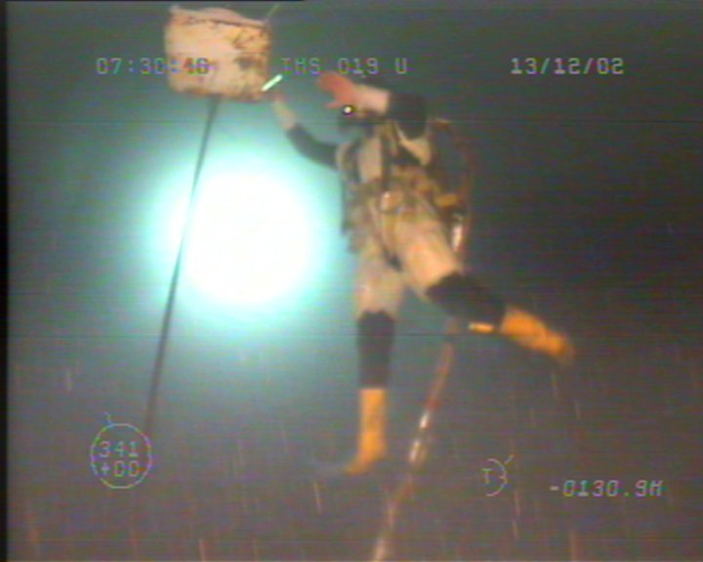

The umbilical carries a:

* Communication cable linking the diver to the dive supervisor who works Topside on the Vessel. The operation is normally talked through move by move and everything is recorded on CD. The dive supervisor would also be in contact with the DPO (Dynamic Positioning Officer) /Ships Captain and Offshore Manager. The DPO sits on the FWD/Aft Bridge and keeps the Vessel in a fixed position and only moves it if and when requested by the Dive Supervisor. The operations are normally followed very closely by the Vessels ROV (Remote Operated Vehicle) Pilot and team.
* hose for air
* supply of water from a boiler on the Ship to the divers suit to keep them warm
* depth measuring device which is monitored by the Dive Supervisor

Note that the diving systems operating from support vessels are limited by the weather, currents and tides.

Diving Bells

To make diving operations on diving vessels more cost effective most of them are equipped with dive bells. Some of these are lowered overboard and moved on trolley traces. Others have forward and aft bells that are lowered directly to the sea bed or work station through the moon pools on the Vessel.

The Diving Bell has a number of advantages as it provides:

* a refuge for the diver
* 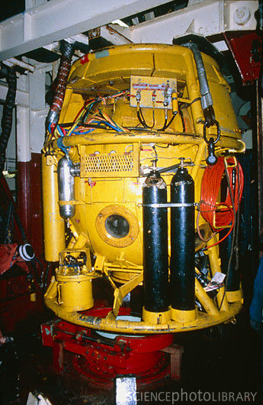a decompression chamber
* an umbilical connection to the surface vessel which is safer
* a transport device. The diver can be transported quickly and with ease to his work station , this is especially beneficial when the weather is bad with rough seas and treacherous conditions

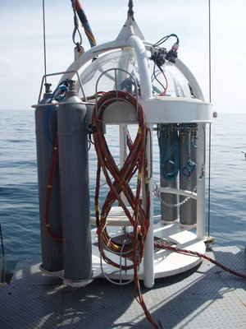

*Examples of diving bells*

Saturation Diving Systems

The principle here is that a team of saturation divers (between 6 and 18 depending on the size of the set up) will spend 28 days at a constant pressure which is equivalent to the working depth - this is known as the *storage depth*. They are closed up in an enclosed system of connecting steel cylinders called *Chambers*.

The area is quite cramped, especially in the older chambers, however there is sufficient space for the divers to eat, sleep and rest in relative comfort, although humidity is quite high. For divers over the height of 5ft 11inches it can be quite cramped as chambers are never that high - some sat divers have been known to be 6ft 7inches or taller!

The divers normally work in three teams doing eight hour shifts and travel to work via the bell, which can connect to the system without a change in the ambient pressure. This means that by the end of the 4 weeks the divers only have to go through one slow decompression phase in order to get back to the surface - decompression is normally about one metre per hour (a slow process) so divers working at great depth often take 3-4 days to decompress.

Saturation Diving Spread on board a DSV (DIVE SUPPORT VESSEL)

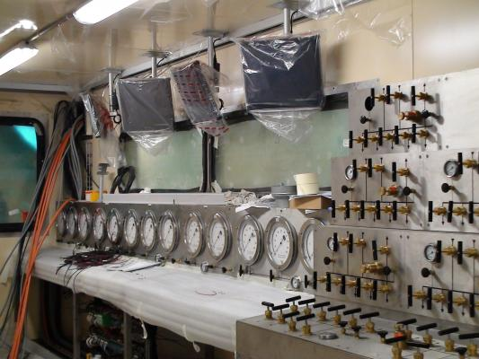

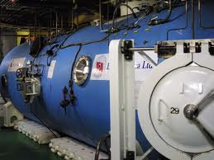

*Divers living area*

*Sat Control consol for the team who constantly monitor the divers*

1.5 Recreational Diving Systems

The sport diver is well contained as he carries his supply with him – a self contained underwater breathing apparatus or (SCUBA). All the Scuba diver requires is a boat to get them to the dive site and a buddy to dive with them. They should never dive below 50 meters (165ft). In open water the diver is always more vulnerable to weather and changing conditions so they should take adequate precautions.

**2. The underwater environment**

2.1Physical effects: Pressure

Air and water have mass and therefore are acted upon by gravity. They therefore have weight. This means that both of them can exert pressure on objects placed in them.

Air pressure

At sea level, the atmosphere presses down with a mass of approximately one kilogramme for each square centimetre of the earth’s surface. This pressure is called atmospheric pressure and is the pressure of the air around us (that is 1kg/cm2). In Imperial units this is 14.7 pounds per square inch. Remember at sea level is approximately equivalent to 1bar.



You can look at this in a different way; atmospheric pressure represents the height of a column of mercury that exactly balances the weight of a column of the atmosphere. At sea level the height of the column is about 760mm (29.92 inches). There are a number of ways of expressing atmospheric pressure but as scientific units are expressed in metric units we will use these measurements throughout the rest of the unit.

Water pressure

The layers of water pressing down on the sea bed have weight. At a depth of 10 metres, the pressure is equal to 1 atmosphere. So, an object at the

surface is subject to a pressure of 1 atmosphere, and at 10metres

below the surface a pressure of 2 atmospheres. Or every

10metres in depth, there is an

additional increase of 1 atmosphere pressure. The total

pressure on an object under water is the atmospheric

pressure plus the water pressure. This is called the

absolute atmospheric pressure, ATA (Atmospheres Absolute).



*What do you think the pressure in ATA will be on an object or diver at a depth of 100 meters?*

*See answer on page 16*

Water pressure will have an effect on a submerged air filled container. If the container has rigid walls or bulkheads it will be able to retain its shape as long as long as it in shallow depths where the Absolute Air Pressure (measured in ATAs) is not great enough to affect the containers rigidity and thus crush it.

However, the deeper the depth of the container the greater the ATA’s. The challenge for the Subsea engineers is to create a bell that can withstand the ATA’s experienced at the depths required to complete the work.

2.2 Gas Laws

**Boyle's law (1660)**

This is a very simple law which is very important in diving:

**P x V = Constant** The volume of a fixed mass of gas is inversely proportional to the pressure applied to it.

Look at this example. If 1000 ml of gas is taken from the surface to a depth of 10 metres, it will be subjected to a pressure of 2 ATAs. Its volume will decrease to 500 ml. So, while the pressure has increased from 1 to 2 ATA - that is doubled, the volume has decreased from 1000 - 500 ml that is halved. A simple way to remember Boyle's law is to use the following equation:

**Pressure X Volume = constant**

For diving, it is important to remember that when you are surfacing, the pressure reduces and the volume of gas increases. You will see why this is a problem shortly

**Dalton's law of partial pressures (1801)**

Air is a mixture of gases: oxygen, nitrogen and small amounts of carbon dioxide, water vapour and rare gases.

At the earth's surface, the air pressure is 1 atmosphere. Each of the constituent gases in air exerts its own pressure according to its physical properties. The amount of pressure exerted by each gas in the mixture is proportional to the percentage of the gas in the mixture. This is the pressure that the gas would exert if it alone occupied the same volume as the mixture. It is called the partial pressure.

So, Dalton's law of partial pressures states:

**P = p1 + p2 + …..**

The pressure of a mixture of gases is the sum of the partial pressures of its constituents.

The two main constituents of air are oxygen 20% and nitrogen 80%. For simplicity, air is regarded as this mixture. Therefore, for an air pressure of 1 atmosphere, the partial pressure of oxygen (ppO2) is 0.2 atmospheres, and that of nitrogen (ppN2) is 0.8 atmospheres.

*Question 2*

*What do you think the partial pressure of oxygen and nitrogen will be at a sea depth of 100 meters?*

*REMEMBER TO USE ATAs*

*Check your answer on the next page*

*Answer1:*

*What do you think the pressure will be in ATA on an object or diver at 100 meters?*

*Answer:*

*10+1 = 11 ATA*

**Henry's law (1803)**

This is another law which is very important in diving:

**V = constant X p1**

For diving, the most important consequence of this law is the amount of nitrogen which can be forced into the blood supply at depth. This, of course, is directly related to decompression sickness as we shall see shortly.

2.3 Physiological effects

Vision

When water comes in direct contact with the cornea the divers vision is distorted (you will probably know this from your own experiences of swimming underwater). Divers therefore require protection to make a safe barrier between their eyes and the water; this is achieved by way of providing them with a glass fronted mask or full helmet.

Because of optical distortion caused by the glass or Perspex cover, all objects become magnified. At depths of 10 meters or more, most objects look blue or green, there is also a problem with silt and debris floating in the water and this is often made worse when commercial divers are clearing the sea bed.

Sound

Sound waves are carried much better in water than in air but it is very difficult for divers to communicate with their supervisors on the Vessel because voice production is distorted by pressure. It can be very difficult to understand conversations with the diver and there are many systems developed now to try and overcome this. You can imagine how stressful it can therefore be for a Dive Supervisor sitting in his control room talking to a team of divers for an eight hour shift, explaining every move they have to make, looking out for their safety on the visual screens whilst writing an ongoing report as they go.

Pressure volume changes

There are a number of air filled cavities within the human body, the intestines, the lungs, the sinuses, and the middle ear. Pressure from diving will therefore compress the air in these spaces. Pressure in the middle ear can be equalised with external pressure by opening the Eustachian tube and this is done by:

* Pinching the nose, closing the mouth and blowing gently, repeatedly, and briefly

Answer 2

*What do you think the partial pressures of oxygen and nitrogen will be at a sea depth of 50 meters? You should remember to use ATAs.*

*Pressure at 100 meters =10+1 = 11 ATA*

*Therefore pp02 = 20% of 11 = 2.2*

*Therefore ppn2 = 80% 0f 11 = 8.8*

* Yawning
* Swallowing
* Moving the Jaw from side to side

The sinuses will clear automatically

if they are not blocked.

The lungs are equalised because they are supplied with air at or above the ambient pressure – otherwise it would prove impossible for the diver to breathe.

Pressure decrease with ascent to the surface doesn’t usually present a problem because the cavities usually equalise themselves naturally.

Nitrogen

Nitrogen is described as an inert gas, it passes into the body during inspiration and is dissolved in the tissues. At any given environmental pressure the amount of nitrogen dissolved in the body’s tissues will reach equilibrium with the ambient pressure. An increase of environmental pressure, as a result of diving, will cause an increase in dissolved nitrogen and so a decrease in pressure will cause nitrogen to leave the tissues.

The deeper and longer the dive lasts the more nitrogen will be absorbed by the tissues. The illustration below shows how nitrogen moves from the lungs to the blood stream to the tissues.



When the diver ascends this process is reversed. The nitrogen moves from the tissues to the lungs. If the pressure is lowered too fast the lungs can’t exhale the nitrogen fast enough. Nitrogen builds up in the bloodstream and tissues causing effects commonly known as decompression sickness, or the bends. We will discuss this further in a moment.