Cold Water Immersion:

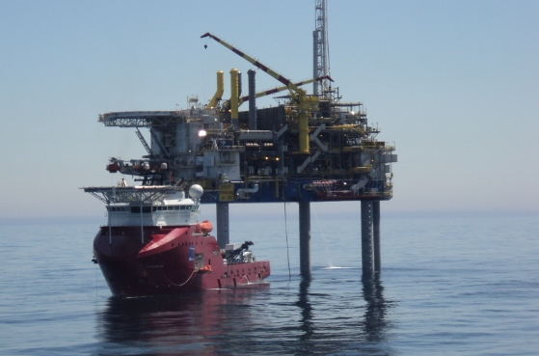

**Contents**

1. Definition
2. Classification
3. The effects of cold on the body

* Temperature changes
* Cooling rates

**4**. Immersion

* Dry drowning
* Secondary drowning
* Cold Shock
* Complications

**5.** System of management

* Mild hypothermia
* Moderate hypothermia
* Severe hypothermia
* General considerations

Introduction

Anyone falling overboard into the North Sea is very likely to suffer from Immersion as well as Hypothermia. These are two very separate conditions, each one requiring its own specific management. In practice however you could have to deal with both conditions simultaneously, with this in mind we will deal with each condition separately but the management of these conditions will be combined.

The work of Golden, Hervey, and Tipton of the institute of Naval Medicine, Gosport, Hampshire, has been used in the preparation of this module.

Preparation

Although a great deal of research has been carried out in this field, there will be limited reading material readily available to you. Therefore there is no pre reading material required prior to commencement of this module.

Warm up

Perhaps you would like to take at look at the measurements on this thermometer. Then try this simple exercise.

Mark on the thermometer the core temperature or range in centigrade for the following listed below:

* Normal temperature
* Hypothermia
* The temperature below which death from Hypothermia is inevitable

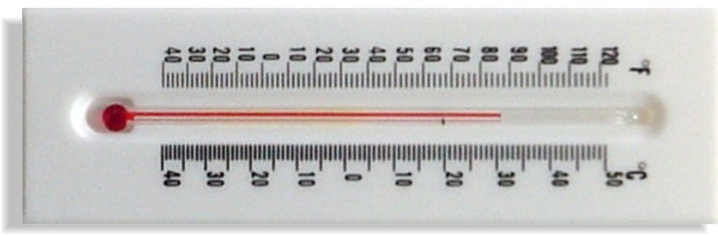

You will be able to check your answers as you work your way through the unit.

1. Definition

Man is a temperate animal who must maintain a temperature within a very small range to sustain life.

The body can compensate for small variations by increasing blood flow to the surface and sweating to cool the body when it heats up and shivering if the temperature drops to warm the body up.

Hypothermia means a lowering of the body’s core temperature below that which is considered normal, the normal being 37°c in a healthy person.

Clinically, hypothermia exists when the body’s core temperature drops below 35°c.

All core temperatures should be taken rectally.

2. Classification

There are three classes of hypothermia summarised below:

*Class of Hypothermia Core Temperature °c*

Mild 35-34

Moderate 33-31

Severe less than 30

3. The effects of cold on the body

There are two factors we need to consider: temperature changes and cooling rates.

3.1 Temperature changes

As the body cools the first sensation that occurs is that of feeling cold. The body’s reaction is to start shivering; this can raise the body’s temperature by 1°c. Combined with shivering there are other bodily reactions eg “vasoconstriction”. After a short while the effects of shivering and vasoconstriction fade and the body temperature starts to fall once again. The various effects of the cold on the body are described in the table below:

|  |  |
| --- | --- |
| Core Temperature, °c | Effects |
| 36°c | Distinct feeling of cold, skin may become pale, waxy, and numb. Weakness and fatigue might ensue. |
| 35 | Clinical hypothermia, intense uncontrolled shivering commences, patient remains alert, however movement become uncoordinated. |
| 34 | Mild confusion, introversion, disorientation, increased pulse and respiration, signs of losing interest in the surroundings. |
| 33 | Semi consciousness, shivering ceases and is replaced by muscular rigidity. Drowning will now occur without a buoyancy aid. Speech becomes slurred and strange behaviour might occur, breathing becomes slower and more shallow. |
| 33-30 | Drifting in and out of consciousness. |
| Below 30 | Bradycardia followed by arrhythmias of any type, but atrial fibrillation and ventricular arrhythmias most common, may be little or no pulse / breathing, and patient may appear dead. |
| 26-25 | From 26°c and below there is little chance of recovery. Death inevitably occurs at 25°c. |

Cooling Rates

The rate that the body cools itself depends on factors, such as:

* The amount of fat that the body carries
* The temperature of the water that the body is immersed in
* The layers of clothing worn, such as PPE, Immersion suits etc

The amount of clothing worn and the body’s fat content act as insulators and so will reduce heat loss.

The chart below gives you some idea of the body’s cooling time when a person is dressed in normal clothing and immersed in water at 10°C:

|  |  |
| --- | --- |
| Time to cool in hrs | Core temperature, °C |
| 1.5-2.0 | 35 - 34 |
| 2.0-3.0 | 33 - 29 |
| 3.0-3.5 | Less than 29 |

*Q1*

*You may have heard of ‘tog’ or ‘clo’ in relation to bedding or some types of clothing.*

*Have a go at finding out what these ratings mean?*

*Check your answers on page 6*

4. Immersion

Immersion might follow a simple course of drowning followed then by death. However, as the chart below shows, immersion may also result in a full recovery by the casualty. It might also be complicated by hypothermia or secondary drowning. In an uninterrupted course of events, immersion leads to:

* First of all the injured person swallowing water which in turn prevents inhalation
* Secondly, they inhale water
* Finally, death occurs due to hypoxia

The effect of immersion on the body

There are four effects which may result from immersion that you should be aware of:

* Dry drowning
* Secondary drowning
* Cold shock
* Complications

4.1 Dry Drowning

It is possible to drown without inhaling water into the lungs. It is a well known fact that 20-25% of immersion victims show less than 150 mls of water in their lungs. The cause of death is Laryngeal spasm – dry drowning. When water below 15°C enters the throat, the epiglottis clamps shut and goes into spasm. As long as water remains over the epiglottis, the spasm is maintained.

4.3 Secondary Drowning

Secondary drowning occurs from 24 – 96 hrs after initial recovery from the water. The presence of matter in the water such as algae, zoo plankton, sand in suspension, and surface contaminants such as oil, cause a local reaction within the lungs – pneumonitis. The lungs flood with exudate and the alveolar exchange is reduced leading to hypoxia and death, if untreated.

This same condition/effect can occur due to any insult to the lungs, in particular, smoke inhalation. Please remember any casualty suffering from either immersion or smoke inhalation must be Medivaced when it is safe to do so.

4.4 Complications

There are two important factors which can complicate the management of an immersion injury.

* After-drop, this is associated with hypothermia
* The effects of water on the body

After – Drop

This is a phenomenon that occurs with any ‘body’ that generates its own heat within an insulating shell. As the body cools, the core temperature falls at a slower rate than that of the outer shell. Then when the re heating takes place, the core temperature still lags behind that of the shell therefore cooling persists. The core temperature often falls by as much as 1 – 2 °C in the first hour following rescue – this is after-drop.

If the core temperature at rescue is within 2°C of 28°C, after drop can reduce it to a critical level and the injured person’s heart might start to fibrillate.

After-drop does take time to occur and this cannot explain the sudden collapse of some recorded rescues. A possible explanation for this following some recorded cases of post – rescue collapse is:

* A drastic drop in blood pressure
* Associated hypoxia
* A reduction in circulatory blood volume due in part to pooling of blood in paralysed, dilated peripheral veins.

The effects of water on the body

Water has a density similar to that of the human body. Therefore a body immersed in water become weightless and the resulting effect of gravity on the system is reduced. The pressure exerted by water increases with depth, and for a body floating vertically in water, there will be a pressure gradient exerted on it.

Research shows that the blood in the lower limbs is forced upwards, increasing the volume of blood returning to the heart and, therefore the cardiac output. This increase is also added to by the effects of the peripheral shutdown caused by the cold. Although this increased cardiac output and venous return is initially beneficial, it is ultimately perceived by the body as an excess of fluid.

This excess is removed in the usual way by increasing the urine output; the volume involved can exceed 350 ml per hour, and can result in hypovalemia and severe shock.

**It is very important for the Medic to remember this next part when dealing with an initial rescue from the water.**

On recovery from the water, the hydrostatic pressure on the lower limbs is removed, and in vertical lifting, the blood drops suddenly to pool in the legs. This mimics the effects of a sudden loss of a litre or more of blood from the system, further worsening the hypovolaemia. This in turn will lead to cerebral and myocardial hypoxia. The myocardial ischemia which results may lead to irreversible ventricular fibrillation

***Answer to Q1***

***You will probably know that duvets and some items of protective clothing use these measures. In both cases the ratings give an indication of how warm the item will keep the body.***

***One ‘clo’ = the thermal insulation required to keep a sedentary person comfortable at 21°C***

***One ‘tog’ = 0.645 clo.***

How would this affect Helicopter rescues?

The outcome of research has resulted in the rescue services adopting a method of retrieval using a double helicopter strop allowing a horizontal lift.

The effects of a cool wind blowing over a warm body can cool it dramatically. In cold weather the effects of wind speed must be taken into account, along with the air temperature. The wind chill temperature for various wind speeds can be seen in the chart below:

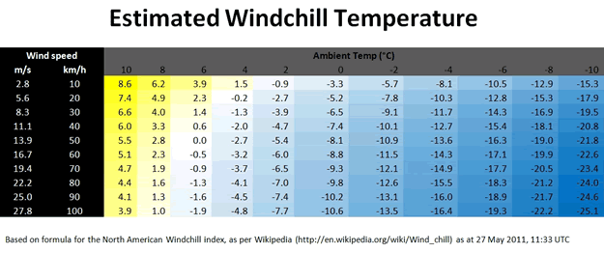

5. Management of Hypothermia

Remember this saying and keep it imprinted in your memory **“no one is dead until they are warm and dead”**

A severely hypothermic patient may have no apparent pulse, BP or be breathing but they may still be successfully resuscitated with the correct management.

The management of immersion casualties depends on their core temperature and is summarised in the table below. The only way of measuring the body’s core temperature is by using a low grade reading rectal thermometer.

|  |  |
| --- | --- |
| Management following immersion |  |
| Mild and Moderate Hypothermia | Severe Hypothermia |
| Temperature °C 35 -31 | Temperature °C <30 |
| Remove wet clothing  Prevent further heat loss with blankets and dry clothing  Active re-warming with hot drinks  Medivac | Remove wet clothing  Use rescuers body heat as well as blankets  Exhaled air near nose and mouth  No active re – warming  CPR  Oxygen  Medivac |

5.1 Mild Hypothermia

As the medic offshore you should prevent further heat loss. Keep the casualty horizontal at all times, and raise the legs as you would for shock. Remove all wet clothing and pat the skin dry, taking great care as cold skin is easily damaged.

Remember the effects of wind chill, especially on someone who is still soaked.

A foil blanket only prevents heat loss; it will not warm the injured person up. Once the casualty is dry and in warm clothing and blankets it will then be a useful idea to cover these in a foil blanket to prevent heat escaping.

As soon as possible start warming from the inside by giving hot drinks.

Remember the use of a bath for re-warming patients is no longer accepted practice. Rapid re warming has been associated with Cardiac Arrhythmias.

5.2 Moderate Hypothermia

Once again it is important to remove wet clothing and cover the patient with blankets. You can apply mild heat to the head, neck, chest, armpits, and groin using wrapped thermal pads, hot water bottles or warm towels.

Give warm sweetened drinks if the patient is conscious and able to swallow.

5.3 Severe Hypothermia

Remove injured person/crewmember from the cold and wet environment and use whatever means are available to reduce a further drop in temperature.

* Remove wet clothing
* Replace with dry clothing and or blankets
* Use the rescuers body heat - skin to skin is the best contact. (There are some who would argue this practice is not a good idea if the person doing the warming is the medic or only other person to hand as they might put themselves at risk.) There is also a gender issue.
* Use exhaled warm air near the patients nose and mouth
* Avoid active external warming to prevent metabolic release

Remember to avoid unnecessary movement to reduce the risk of precipitating cardiac arrhythmia.

Only commence CPR if the patient is in full cardiac arrest and has no evidence of a carotid pulse after a two minute check.

Baseline measurements of rectal temperature, pulse and blood pressure are essential as soon as possible.

**“It may be difficult to detect a pulse as extreme Bradycardia could be present in these circumstances. A pulse should be felt for a full two minutes at least, before deciding it is absent.**

5.4 General considerations

**As for any case of shock, give Oxygen at the highest concentration possible for all immersion casualties as soon as possible.**

At this point it is worth mentioning that you should think initial first aid (complete a secondary survey), check for any other injuries. For example you might not know why they fell overboard and remember falls from height into the sea can cause extensive injuries which might complicate management. For example a person with fractured ribs resulting from the fall might have difficulty in breathing due to the pain.

Pain control using intramuscular injections should be avoided due to the peripheral shutdown which will impair absorption of the drug. Entonox (50% oxygen 50% nitrous oxide mixture is preferred in these situations, as it also provides an additional 50% oxygen.

**Be aware that the person you are treating might be a diver in which case you must not use Entonox at any cost”**

**Finally, all immersion victims must be Medivaced for further care due to the risk of secondary drowning. If they are a diver then care must be taken to fly them below 2000 metres and you must discuss first with a diving Doctor.**

Key Points

Your notes

Questions for tutor