Medical Record Keeping Offshore on Ships and Installations

Contents:
- Medical Records
- Paper based records
- Computer Based records

- Confidentiality
- Definition
- Contract

- Disclosure of Medical Information
- OIM and Ships Master
- Patient access

- Communication
- Legal Requirements
- Equipment
- Procedures
- Communication checklist

Introduction
This unit covers:
- The need for recording and retaining medical records
- Legal requirements regarding medical records
- The use of computerised documentation on board
- The reasons for confidentiality
- The type of information which can be disclosed to your OIM or Ships Master

The unit also covers the necessity for clear and concise information when working and communicating with your Topside service and Medical Officers.

Please note that a lot of the guidance you are given throughout this module is recommendation only as many of the procedures discussed are based on best practice rather than legal requirement.

1. Medical Records
With today’s heightened awareness of medical litigation and claims for compensation for injuries sustained at work, the requirement for accurate documentation of medical information is paramount.

It is very important that you record the patients details methodically, noting the time they presented, their symptoms, what treatment you prescribed and any medications given. It is also worth mentioning at this juncture that you should enter the Topside Doctors name in your notes along with a brief description of the conversation you had, the time it was carried out and any advice given. Make sure you also document the Doctor’s name. This is not only to protect the patient but also yourself and the company. Poor record keeping could mean that patients present on more than one occasion with a recurring problem but, because it has not been recorded, no action is taken to investigate further.

Claim for compensation might not be made for many years after the initial illness/injury, and by this time it is very difficult to remember all the intricate details of the case. The person or persons involved with the treatment may not be available anymore so it is imperative that the details are recorded correctly. The claim process is not always straight forward and is open to abuse.

Now we have confirmed meticulous record keeping is vital, how do we go about this in the offshore environment?

1.1 Computerised systems

In this age almost very Installation, Ship, Drilling rig, and Floatel have computerised systems on board for recording medical attendances and treatments in the sickbay.

The use of such systems onboard allow for:

- Better collation of information
- The recording of statistics which can then identify problem areas rapidly. These systems can help prevent repeated accidents and illness offshore. It has been confirmed that there is no reason to keep paper copies as well as electronic, however you must follow local protocol and procedures. Some companies still require you to use patient’s notes, similar to those used in hospitals, as well as documenting everything electronically.

1.2 Paper based record

Most companies will require you to complete some sort of record of your activities which you will be required to e mail or post every week or monthly. This information is then monitored by medical personnel on shore to ensure the medic is following local protocols and procedures.

There are two forms of records.

i)

This is normally known as the “medic log” wherever you work
The medic log provides a chronological record of all the attendances to the sickbay. This is either a hard copy or a computer based spread-sheet where details of each patient’s attendances are recorded. Most companies have their own spreadsheet templates, however others may use templates provided by one of the Occupational Health companies such as Capita or Abermed. The forms are all very similar and typically ask for:

- Name of patient
- DOB
- Job Title
- Company
- Brief notes on the presenting complaint including history, examinations, allergies, medications and treatment given.

Copies of these should be sent to the Supervising Doctor on the beach (onshore) at the end of each medic’s tour of duty or on a weekly basis, depending on local protocols. Remember- these documents contain substantial confidential medical information and so should not be made available to anyone without clearance. You should only send the information to your Supervising Doctor, his/her Secretary or your Medical Health Team Leader. There are some companies that require you to send this information to various other departments, such as the Health and Safety department, and for this purpose you must remove all information that might allow someone to recognise the patient. (You are normally required to remove the patients name and DOB.) It is recommended that you also remove the patient’s Job Title from the spread sheet as this can often make it very easy to breach medical confidentiality, especially if the person is the OIM, Company Man, Head Chef etc.

ii)

Patient’s records.
These are normally either computer or hard copy based records for each individual patient. Unfortunately some companies want both which means entering the data twice. If they are in hard copy format they are usually in A4 folders which are kept locked in a secure cabinet within a locked Sickbay/Hospital. If the records are computer based they should be on a stand-alone computer or be kept on an external hard drive which can only be accessed by the Medics. Special care must be taken when working on vessels, as often the Captain, Chief Officer, and Chief Steward may have extended duties and be expected to be the Medic when no Offshore Medic is on board.

There is normally a front sheet to these documents where the patient’s personal details are recorded, along with details of the patient’s medical history, past medical history, allergies, regular medication, etc. Notes are then kept of each individual visit /consultation at the sickbay. These are expected to be in greater detail than those on the Medical Log.
Question 1:
In completing the accident form, you are maintaining the record system, but why the emphasis on processing the form? Note your thoughts below.

Check your answer on the following page.

This kind of Medical note can normally only be used for core crew as it would be logistically impossible to do this for all third party personnel. There are some Installations and some Floatels that require hand written notes and computer based notes for everyone.

Example of a daily medical report form.
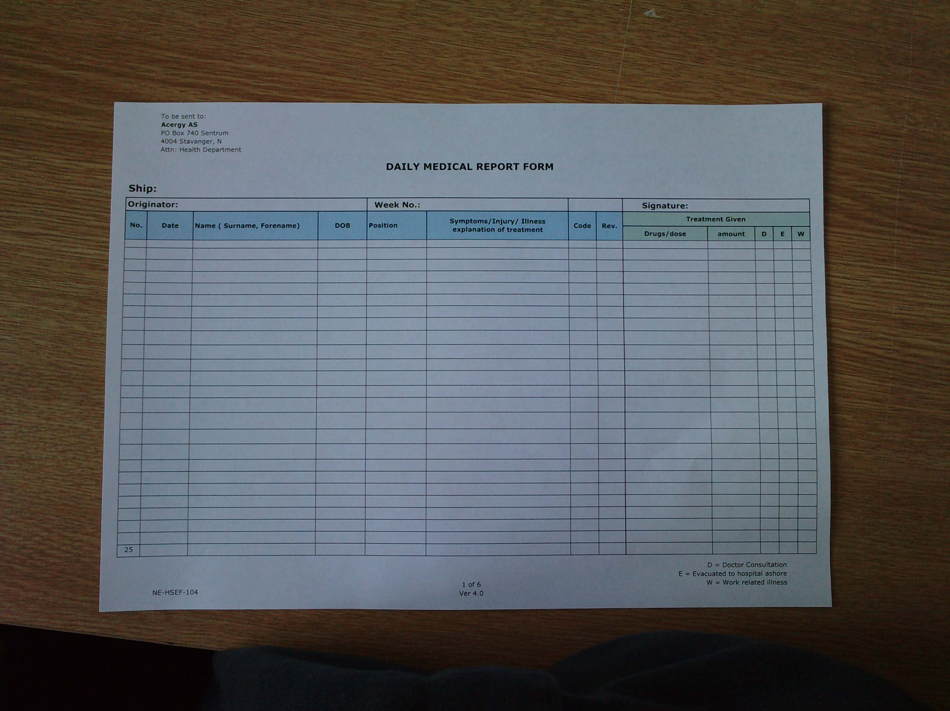

Answer to question 1:
In completing the accident form you are maintaining the record system, but why the emphasis on processing the forms? Note your thoughts below.
Prompt processing allows for early investigation of the cause and prevention of recurrence, or a more serious accident occurring. Some serious occurrences must be reported to the HSE immediately e.g. major fractures, risk to ‘life and limb’. (This is the OIM’s or company’s responsibility.)

2. Confidentiality

Confidentiality promotes confidence between yourself, your patient and other members of your team. If your patient lacks confidence in you, or in your use of the system, they could feel tempted to withhold information from you. What affects might this have? Think about this now before you go any further?

If vital information is withheld, there is a potential risk to the patient’s safety, that of their work team and even the whole Installation/Vessel.

Question 2
Bearing in mind the need to keep medical records, how would you go about getting informed consent?

You can check your answer on the next page.

2.1 Contract

As the medical person on board you must ensure that such information is not passed on to a third party without the patient’s informed and understanding consent. Therefore whenever a patient discusses their personal information with you, it must be understood that there is an implied contract of confidentiality.

It is important to ensure the patient is fully aware that, at the beginning of any consultation, any medical details disclosed are confidential (medical in confidence). You should not reveal any medical details (other than detailed shortly-see question 3) unless the patient understands the need and has freely given informed consent.
Question 3
Take time to consider the situations where you would have to release a patient’s medical information without their consent? Note you thoughts below

You can check your answer later or have a look further down this section now.

Answer to question number 2
Bearing in mind the need to keep records, how would you go about getting informed consent?

The best way is in writing - this same rule also applies to seemingly innocent requests such as those from legal and /or insurance officers from outside or inside the company. Any requests for access to records from any source should be passed to the company’s Medical Advisor first.

3. Disclosure of medical information

Circumstances may arise when you have to disclose some medical information to support the effectiveness of the management of the Installation/Rig or Vessel. Each and every situation is unique.

3.1 OIM (Offshore Installation Manager) and or (Offshore Manager/Master)

Because of his/her role on the Installation/Vessel, we must consider the special rights of the OIM, OM and/or the Ships Master.
Question 4:
Can you think of a situation where the OIM needs to be given more information about your patient’s condition?

Check your answer further on in this module.

Because of his/her role on the Installation, we must consider the special rights of the OIM, Offshore Manager and or Master of the Vessel.

In keeping with the trust we have already discussed between yourselves and your patient, you should make them aware that the OIM, OM or Master has the right to request information about:

- The patients whereabouts
- The patient’s fitness to work
- Likely duration of any period of unfitness
- Suitability for light duties inside the Installation/ Vessel
- Suitability to remain on board the Installation
- Mental State

The OIM and or OM/Vessel Master is entitled to be informed of any medical condition of anyone on board which materially affects the daily running of the Installation/Vessel. This also goes for any condition that might put the patient, the vessel, or anyone else on the Vessel/ Platform at risk.

As the HSE medic you may need to supply the OIM/Master/OM with additional background information that you would normally not consider offering except to your Topside Doctor, to allow a management decision to be made. Whilst respecting your patient’s confidentiality you have an obligation to respond to the rightful requests of the management for such information.

There will definitely be some situations whereby you need to give the OM/OIM/Master more information to support your request for the logistical management of the patient. For example, Medical Evacuation, the requirement for a stretcher and / or Escort, the need for a Topside Doctor to come to the Installation etc

As an Offshore Medic, you must appreciate that any information you supply to the senior management may affect your patient’s relationship with their employer, therefore you must ensure your patient is fully aware and understands this.

3.2 Patient’s access

As we discussed earlier, all of your patient’s medical records are confidential, with right of access only to the Topside Doctor and other members of the Medical team, such as your back to back and the Health team leaders on the Beach.

The DATA PROTECTION ACT 1998 gives the patient access to his/ her own Medical Records - the access to Health Records Regulations 1990 now only applies to the medical records of a deceased person.

Although the regulations do not impinge directly on the role of the Offshore Medic, there are certain conditions attached to these regulations of which you must be aware.

The patient must apply to the supervising or company Doctor, who must in turn, be aware of the content of the records. In certain circumstances, the regulations allow the Doctor to omit information he feels may be harmful to the individual patient or which covers third parties.

Remember
You do not have the authority to allow individuals to see their own records, and you should always consult company policy and the supervising Physician.

If the information in the record has been changed within the past 40 days; the patient may see it free of charge. But, where the record has been unchanged for the past 40 days; the company may make a charge not exceeding £10 (Although a charge for copying and processing may be made up to a maximum of £50)

Answer to Question 3
Take time to consider the situations where you would have to release a patient’s medical information without consent?

It is very unlikely you will have come up with all of the following and the list itself is not exhaustive. Your answers should have, however, covered similar areas.

- Where required by statue, for example, the Public Health Contagious Diseases regulations
- Where ordered by a court of Law
- Where a complaint has been lodged against a Health Authority or Individual Health Professional
- Where serious crime might be prevented or detected by the disclosure of health Data to the Police
- Where required in the interests of National Security
- Where required in the interests of Public Health

Answer to Question 4
Can you think of a situation where the OIM, OM, or Master needs to be given more information about your patient’s condition?

Here are some answers:

- To assist in the arrangement of a Medivac
- A psychiatric emergency
- When you suspect substance abuse
- A food poisoning outbreak. The OIM has a legal responsibility to report this

C

4. Communications

What we mean by communications in this section is the logistics and mechanics of communicating with your shore based providers. Bearing that in mind there are also the interpersonal skills required and other aspects which you should keep in mind, it is all part and parcel of communications.

4.1 Legal requirements

The table below shows the responsibilities and duties of the designated person in charge of the Installation, Oil Rig, or Vessel. It also gives reference to where this information is documented.

Duty /Responsibility | Documentation
‘Make, or ensure that there are made, such arrangements as will enable the advice or presence, as appropriate, of a suitably qualified registered medical practitioner to be obtained when needed.’ | Offshore Installations and Pipeline Works (First-Aid) Regulations 1989 (SI1671), Regulation 5(1)(c)(ii).
‘The sick bay should have facilities for effective two way communication with onshore medical services’. | Approved Code of Practice (ACOP), Paragraph 6(g).
‘A link to the barge/installation shore line is essential. This phone link should also have the capacity for use internally on the installation or barge. | Approved Code of Practice (ACOP), Part 5 - Furnishings &Equipment.

What this all means is that there should always be suitable advice available to you 24 hrs a day seven days a week. That advice should be from a Topside Doctor or Diving Doctor and, if this is not sufficient, there should also be a line of communication available to a suitably qualified registered practitioner.

4.2 Equipment

There are at least eight different methods of communication available to the Offshore Medic who works on an Installation. Most Platforms have a direct telephone system in place. However there can still be difficulties on some drilling rigs, especially when they are on tow to and from a new location. This problem can often apply to vessels when they are in transit or deep sea.

4.3 Procedures

Whatever systems are in place on your installation it is up to you (the medic) to know how to contact your Topside Doctor at all times. Companies are required to have written procedures and contact details for contacting Topside posted in the Sickbay/Hospital and at least one other location on the Installation/Vessel. One place where you may find information posted other than your Sickbay would be the Radio room or on the Bridge of a Vessel.

There will also be operating procedures laid down concerning who to contact for advice on routine matters and procedures and in place for emergencies - that is for situations whereby you might require a Medivac or Medrescue. These terms have begun to be used differently over the years and you must be sure that you and the person you are communicating with understand the term the same way you do.

Medivac

For some this term means the routine medical evacuation of a crewmember where they is no particular urgency.
For others this term means any situation where the patient is returning onshore for medical reasons with no reference to urgency.

Medrescue

This may be meant as a medical rescue situation with some degree of urgency, which is usually life threatening.
For others this term is only used for a situation where the Topside Doctor has to be flown out to the Installation/Vessel to escort the patient back, once their condition has been stabilised.

Remember to check your company’s emergency procedures manual where you will find their definition of these terms. You must stick to the procedures at all times when dealing with any such emergency.

Question 5

Write down below how many methods of communication you think might be available to you to contact the shore base, as the HSE Offshore Medic?

You can check your answer at the end of section 4

Remember when speaking to your Topside Doctor you must liaise directly where possible to avoid any breach of confidentiality. There might be occasions where you will have to relay messages and, in these circumstances, you must endeavour to keep the information to a minimum and if possible have the OIM or Ships Master relay messages - not the radio operator.

These procedures are carefully detailed to ensure that the right people are informed and the correct assistance is made available at the correct place and time. These may differ from company to company so make sure you keep yourself up to date with the procedures on your Installation. The individual procedures must be followed exactly for everything to run smoothly.

Failure to follow procedures can result in delays and confusion which in turn could be potentially expensive and put your patient in danger.

Communications must be clear and concise to avoid confusion and misleading information being given to the Doctor. He or she has to make their decisions given on the information you have supplied.

It is for this reason that the information is passed direct from you to your Topside Doctor rather than it being relayed through a third party such as the Radio Operator, unless due to the situation this is unavoidable.

When you communicate with the Doctor you might like to use the checklist below. Always check in your sickbay when you first arrive as you should find a similar checklist posted on the bulkhead by the outside phone line. This is usually posted alongside all the relevant emergency numbers.

4.4 Communication checklist

Use the lists below as a guide to check that you have all the information required to hand before you speak to the Doctor.

When you first speak to the operator give them your contact number and the Installations /Rig/Vessels position

Your name and the name of the Installation/Rig/Vessel

Your patients name, age, and date of birth

The company the patient works for and his/her occupation/position

The patient’s condition/symptoms/signs
- Presenting signs and symptoms, time of onset, duration of illness
- Findings on physical examination
- Relevant part or present medical history
- Any known allergies
- Any medications/treatments already given
- Base line observations, BP, Pulse, Respiration, SP02, Temperature

In the event of an accident you would need to add:
- A brief account of the accident
- Time injury sustained
- Nature and extent of the injury
- Baseline signs/present condition
- Treatment started and medications given

In the event of a Medivac/ Mederescue being required
- Is the presence of a Doctor required?
- Prevailing weather conditions?
- Is the patient fit for evacuation?
- Degree of urgency to Medivac?

Once evacuation has been agreed
- Time of arrival of helicopter onshore
(ETA)
- Availability of escort
- Ability of escort
- Transport required once ashore, for
example, do they require an ambulance,
company car or taxi?

“Make sure you have all the logistics arranged prior to the injured party leaving your installation as there has been an instance whereby a communication breakdown has led to a casualty having to wait at the heliport for an Ambulance.”

(There are specific regulations regarding diving emergencies and specialist consultation is required in these circumstances. There are more specific guidelines for dealing with these emergencies, in particular who to contact, for more information refer to the Module “Aspects of Diving Medicine”.)

Question number 6
Write below where you think the written instruction for contacting Topside etc should be posted

You can check your answer on the following page

Answer to Question 5

Write down below how many methods of communication you think might be available to you to contact the shore base, as the HSE Offshore Medic?

Telephone microwave transmission – this is the most common method of communication.

Radio-telephone link with the public telephone service.

Via the company’s radio telephone link between its local office and the onshore Installation

High frequency (HF) radio transmission between an Installation and shore based communication centre.

Telex link – rarely used now, superseded by fax which again is becoming obsolete.

Satellite communications - very expensive £10-£15 per minute, but a viable backup.

Facsimile mostly superseded by e mail.

Air band transmissions- ship to shore, and aviation band radio.

Cellular – phones - usually only on drilling rigs during rig moves. However they can be adversely affected by poor weather conditions.

Answer to Question 6
Write below where you think these instruction would be posted

Answer:
In the Sickbay/Hospital
In the Radio Room
On the Bridge
Captain’s Office
Administrator’s office on board a Vessel

Key points:

Notes:

Questions for Tutor:

