The Diving Medical Advisory Committee

DMAC, Third Floor, 5 Lower Belgrave Street, London SW1W 0NR, UK www.dmac-diving.org
Tel: +44 (0) 20 7824 5520 · Fax: +44 (0) 20 7824 5521 info@dmac-diving.org

Aide Mémoire for Recording and
Transmission of Medical Data to Shore

DMAC 01 – 1984

C O N F I D E N T I A L

This form has been designed in three parts to make it easier to use.

Part 1 is an aide mémoire to obtain essential information for transmission ashore in event of a medical emergency. This information will enable the onshore doctor to advise on immediate management of the casualty.

Part 2 collects more detailed information to provide a permanent record of the incident and to assist in accident analysis. Obviously in urgent cases there must be no delay in contacting medical assistance with the information in Part 1. Part 2 should be completed later.

The onshore doctor will frequently ask for some further examination to be carried out.

Part 3 provides a form for recording this information.

It is recognised that it will not be necessary to complete the form fully in most cases, and where a question (or section) is not applicable, ‘N/A’ should be entered. If you are uncertain of the meaning of a question, do not attempt to answer it, but ring the question number.

The views expressed in any guidance given are of a general nature and are volunteered without recourse or responsibility upon the part of the Diving Medical Advisory
Committee, its members or officers. Any person who considers that such opinions are relevant to his circumstances should immediately consult his own advisers.

Page 2 1984 DMAC 01
Part 1

Essential Information For Transmission Ashore
In Event Of An Emergency

Part 1 – Section A
GENERAL INFORMATION

1 Patient surname:................................................................. Christian name:......................................................................................

2 Company:...................................................................................................................................................................................................

3 Worksite:...................................................................................................................................................................................................

4 Date of incident:................................................................. Time: ........................................................................................................

5 Type of incident:.......................................................................................................................................................................................

6 Is the general condition of the patient: Good
Fair

Critical

DMAC 01 1984 Page 3
Part 1 – Section B
INFORMATION ABOUT THE DIVE RELATED TO THE INCIDENT
(If the illness is not related to diving, skip to Section E)

7 | Method: | Scuba | Bell bounce
 |  | Surface supplied | Saturation
 |  | Wet bell
8 | Air mixture: | Air | Nitrox
 |  | Heliox | Trimix
9 | Job: | Diver | Other
 |  | Bellman | Specify ............................................................................
10 | Working depth: |  | ..................metres
11 | Bell depth: |  | ..................metres
12 | Storage depth (where relevant): |  | ..................metres
13 | Time spent at working depth: |  | ................ minutes
14 Decompression table selected: .............................................................................................................................................................
Depth selected: Bottom time selected:  Surface interval selected (repetitive dives): |  |  | .................... hours | ..................metres  ..................metres  ................ minutes

15 Type of work performed: .....................................................................................................................................................................

.....................................................................................................................................................................................................................

.....................................................................................................................................................................................................................

.....................................................................................................................................................................................................................

16 Adverse conditions, if any (e.g. sea state, tidal stream, temperature, fouling, disorderly ascent, hard work, etc.):

.....................................................................................................................................................................................................................

.....................................................................................................................................................................................................................

.....................................................................................................................................................................................................................

17 Did the incident begin: in the water in the deck chamber in the bell other?
Specify? .............................................................

18 At the onset of symptoms, was the patient:
descending ascending

on the bottom on the surface
Part 1 – Section C COMPRESSION/DECOMPRESSION INCIDENT (If the illness is not related to diving, skip to Section E)

19 | Incident during or immediately following compression: |  |  |  |  | YES | NO
20 | Incident during normal decompression: |  |  |  |  | YES | NO
21 | Incident after surfacing following normal decompression: |  |  |  |  | YES | NO
 | End of decompression at: |  |  |  | .................... hours |  | ................ minutes
22 | Incident following excursion from saturation: |  |  |  |  | YES | NO
 | Time of outset after decompression: |  |  |  | .................... hours |  | ................ minutes
23 | Incident following blow-up/drop in pressure |  |  |  |  | YES | NO
From: |  | depth: | .........................metres | time: | ......................hours | .................. minutes
To: |  | depth: | .........................metres | time: | ......................hours | .................. minutes
24 In other circumstances: YES NO

Specify:........................................................................................................................................................................................................

.....................................................................................................................................................................................................................

.....................................................................................................................................................................................................................

.....................................................................................................................................................................................................................

25 Onset of first symptom at:
depth: .........................metres time: ......................hours .................. minutes

26 | Niggles: | YES |  |  | NO
27 | Pain in joints: | YES |  |  | NO

State location: ...........................................................................................................................................................................................

28 Pain in muscles: YES NO

State location: ...........................................................................................................................................................................................

29 Pins and needles: YES NO

State location: ...........................................................................................................................................................................................

30 Patches of numbness or tingling, or altered sensation: YES NO State location: ...........................................................................................................................................................................................
31 Muscle weakness or paralysis: YES NO

State location: ...........................................................................................................................................................................................

32 | Difficulty in urinating: | YES |  |  | NO
33 | Pain in the lumbar region, around waist, or in the abdomen: | YES |  |  | NO
34 | Standing upright difficult or impossible: | YES |  |  | NO
35 | Nausea: | YES |  |  | NO

36 | Vomiting: | YES |  |  | NO
37 | Vertigo, loss of balance: | YES |  |  | NO
38 | Deafness, hearing problems: | YES |  |  | NO
39 | Speech problems: | YES |  |  | NO
40 | Visual problems: | YES |  |  | NO
41 | Drowsiness, confusion: | YES |  |  | NO
Specify:........................................................................................................................................................................................................
42 | Loss of consciousness: | YES |  |  | NO
43 | Paleness, anxiety, sweating, collapse: | YES |  |  | NO
Specify:........................................................................................................................................................................................................
44 | Cyanosis, blue skin: | YES |  |  | NO
45 | Breathlessness, painful breathing, chokes: | YES |  |  | NO
Specify:........................................................................................................................................................................................................
46 | Blood-stained froth in airways: | YES |  |  | NO
47 | Respiratory distress worsening with decompression: | YES |  |  | NO
42 | Others (specify below): | YES |  |  | NO

.....................................................................................................................................................................................................................

.....................................................................................................................................................................................................................

.....................................................................................................................................................................................................................
Part 1 – Section D
PREVIOUS DIVE
(If ended less than 24 hours before the accident)

49 | Method: | Scuba | Bell bounce
 |  | Surface supplied | Saturation
 |  | Wet bell | Excursion from saturation
50 | Air mixture: | Air | Nitrox
 |  | Heliox | Trimix
51 | Depth: |  |  |  | ..................metres
52 | Bottom time | (where relevant): |  |  | ............... minutes
53 Table selected: ..........................................................................................................................................................................................
 | Depth selected: |  |  |  | ..................metres
 | Time selected: |  |  |  | ..................metres
54 | Normal decompression: |  |  | YES | NO
55 | End of decompression:
Date: .................. / .................. time: ......................hours .................. minutes

56 If saturation, back to storage depth from last working dive:
Date: .................. / .................. time: ......................hours .................. minutes
Part 1 – Section E
ACCIDENT OR ILLNESS NOT RELATED TO DECOMPRESSION

57 Nature of Accident or Illness: ..............................................................................................................................................................

.....................................................................................................................................................................................................................

.....................................................................................................................................................................................................................

.....................................................................................................................................................................................................................

58 Does he have difficulty or pain with breathing? YES NO

59 Is he bleeding? YES NO

60 If yes, is bleeding controlled? YES NO

61 State of consciousness:
Fully alert and orientated

Drowsy

Confused

Unconscious but responds to stimuli

Unconscious and unresponsive

62 Details symptoms:....................................................................................................................................................................................

.....................................................................................................................................................................................................................

.....................................................................................................................................................................................................................

.....................................................................................................................................................................................................................

63 Treatment given: ......................................................................................................................................................................................

.....................................................................................................................................................................................................................

.....................................................................................................................................................................................................................

.....................................................................................................................................................................................................................
Part 2

Additional Information for Record Purposes
NB Do not delay transmission of Part 1 in order to complete this part of the form

Part 2 – Section A
GENERAL INFORMATION

1 Name of patient: ......................................................................................................................................................................................

2 Date of birth: ............................................................................................................................................................................................

3 Date of last medical examination: ........................................................................................................................................................

4 Where medical records are held:.........................................................................................................................................................

.....................................................................................................................................................................................................................

5 Details of previous decompression sickness:.....................................................................................................................................

.....................................................................................................................................................................................................................

.....................................................................................................................................................................................................................

.....................................................................................................................................................................................................................

6 Any significant past or recent medical history:..................................................................................................................................

.....................................................................................................................................................................................................................

.....................................................................................................................................................................................................................

.....................................................................................................................................................................................................................

7 Name of diving supervisor: ....................................................................................................................................................................

8 Name of medical attendant:...................................................................................................................................................................

9 Time of transmission of Part 1:............................................. GMT Date .........................................................................................

10 Addressee:.................................................................................................................................................................................................

.....................................................................................................................................................................................................................

11 Copied to:..................................................................................................................................................................................................

.....................................................................................................................................................................................................................

12 Telex confirmation sent at:.................................................... GMT Date .........................................................................................

13 Time message acknowledged: ............................................... GMT Date .........................................................................................

14 Reason for contacting shore doctor: Assistance required urgently
Assistance required as soon as possible Assistance required when practicable Assistance required when patient gets ashore For information only
Part 2 – Section B

Brief statement of the problem: .........................................................................................................................................................................

.....................................................................................................................................................................................................................................

.....................................................................................................................................................................................................................................

.....................................................................................................................................................................................................................................

.....................................................................................................................................................................................................................................

.....................................................................................................................................................................................................................................

.....................................................................................................................................................................................................................................

.....................................................................................................................................................................................................................................

.....................................................................................................................................................................................................................................

Part 2 – Section C

Summary of advice/instructions received from ashore: ................................................................................................................................

.....................................................................................................................................................................................................................................

.....................................................................................................................................................................................................................................

.....................................................................................................................................................................................................................................

.....................................................................................................................................................................................................................................

.....................................................................................................................................................................................................................................

.....................................................................................................................................................................................................................................

.....................................................................................................................................................................................................................................

.................................................................................................................................................................................................................................................................

Part 2 – Section D

Details of treatment given (including therapeutic tables by number as well as depth, duration and gases, and all supplementary therapy). State also times of implementation: ................................................................................................................................................

.....................................................................................................................................................................................................................................

.....................................................................................................................................................................................................................................

.....................................................................................................................................................................................................................................

.....................................................................................................................................................................................................................................

.....................................................................................................................................................................................................................................

.....................................................................................................................................................................................................................................

.....................................................................................................................................................................................................................................

.....................................................................................................................................................................................................................................
Part 2 – Section E

Record of progress. Summary of history of the condition, times of significant changes: .....................................................................

.....................................................................................................................................................................................................................................

.....................................................................................................................................................................................................................................

.....................................................................................................................................................................................................................................

.....................................................................................................................................................................................................................................

.....................................................................................................................................................................................................................................

.....................................................................................................................................................................................................................................

.....................................................................................................................................................................................................................................

.....................................................................................................................................................................................................................................

Part 2 – Section F

Final outcome (e.g. fully recovered, transferred ashore under pressure, etc.): .......................................................................................

.....................................................................................................................................................................................................................................

.....................................................................................................................................................................................................................................

.....................................................................................................................................................................................................................................

.....................................................................................................................................................................................................................................

.....................................................................................................................................................................................................................................

.....................................................................................................................................................................................................................................

.....................................................................................................................................................................................................................................

.....................................................................................................................................................................................................................................
Part 3

Record of Medical Examination
All or part of this examination may be carried out at the request of the onshore doctor. Results should be recorded in the
appropriate section and the questions which are not relevant to the particular incident left blank.

Part 3 – Section A
EXAMINATION/GENERAL

1 Is the patient in pain? YES NO

If ‘yes’, specify site, intensity and any factors which exacerbate or relieve it: ...........................................................................

.....................................................................................................................................................................................................................

.....................................................................................................................................................................................................................

.....................................................................................................................................................................................................................

2 Has he any major injury? YES NO

If ‘yes’, name the site and describe briefly. If there is bleeding give an estimate of blood loss: ............................................

.....................................................................................................................................................................................................................

.....................................................................................................................................................................................................................

.....................................................................................................................................................................................................................

3 What is his temperature? ..........................°C

4 Has he any skin rashes? YES NO

If ‘yes’, describe appearance and site: .................................................................................................................................................

.....................................................................................................................................................................................................................

.....................................................................................................................................................................................................................

.....................................................................................................................................................................................................................
Part 3 – Section B
CARDIORESPIRATORY SYSTEMS

5 Is his colour: Normal

Pale

Cyanosed (blue)

6 Is he sweating? YES NO

7 | What is his: | (i) | pulse |  | ................. per minute
 |  | (ii) | blood pressure | .............................Syst. | ........................... Diast.
 |  | (iii) | respiratory rate |  | ................. per minute
8 Does he have difficulty with breathing? YES NO

9 Does he have pain on breathing? YES NO

If ‘yes’, describe: ......................................................................................................................................................................................

.....................................................................................................................................................................................................................

.....................................................................................................................................................................................................................

.....................................................................................................................................................................................................................

10 | Has he a cough? | YES |  |  | NO
 | If ‘yes’, has he coughed blood? | YES |  |  | NO
11 | Is he short of breath? | YES |  |  | NO
 | If ‘yes’, has this been affected by:
 | (i) increase of pressure | YES |  |  | NO
 | (ii) decrease of pressure | YES |  |  | NO
12 | Is the trachea (windpipe) central (i.e. normal)? | YES |  |  | NO
13 | Is the apex (cardiac impulse) beat of the heart within 1” of the mid-clavicular line? | YES |  |  | NO
14 | Are breath sounds audible equally on both sides of the chest? | YES |  |  | NO
15 | Is there any subcutaneous emphysema (crackling sensation in tissues)? | YES |  |  | NO

Part 3 – Section C
ABDOMEN

16 Does the patient have abdominal pain? YES NO
If ‘yes’, specify site by writing 16 on chart, and character: ............................................................................................................

.....................................................................................................................................................................................................................

.....................................................................................................................................................................................................................

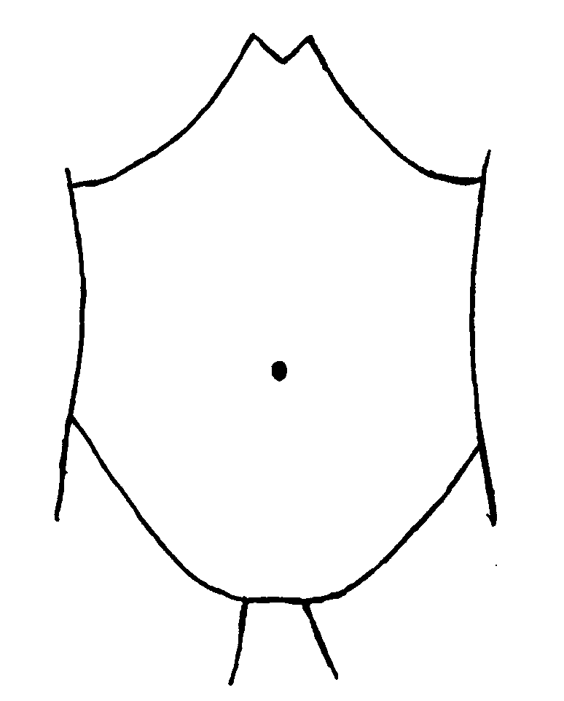.....................................................................................................................................................................................................................

17 | Does the patient have diarrhoea? | YES |  |  | NO
18 | Has the patient vomited? | YES |  |  | NO
 | If ‘yes’, specify:
a) When did the patient last vomit?........................................................................................................................................... GMT

b) If he is still vomiting, specify frequency and character: ..............................................................................................................

.....................................................................................................................................................................................................................

.....................................................................................................................................................................................................................

19 | Has he vomited blood?? | YES |  |  | NO
20 | Can the patient pass urine without difficulty? | YES |  |  | NO
21 | Is the urine clear  or blood stained 
22 | Is urinating painful? | YES |  |  | NO
23 | Is the abdomen soft to palpation? | YES |  |  | NO
 | If ‘no’, specify the site by writing 23 on chart
24 | Are there any swellings in the abdomen? | YES |  |  | NO
 | If ‘yes’, specify site (by writing 24 on chart), size and consistency:
.....................................................................................................................................................................................................................

.....................................................................................................................................................................................................................

.....................................................................................................................................................................................................................

25 Can you hear bowel sounds? YES NO
Part 3 – Section D
NERVOUS SYSTEM

26 Has he any visual disturbance? YES NO

If ‘yes’, specify: .........................................................................................................................................................................................

.....................................................................................................................................................................................................................

.....................................................................................................................................................................................................................

.....................................................................................................................................................................................................................

27 | Has he a headache? | YES |  |  | NO
28 | State of consciousness:
Fully alert and orientated

Confused

Drowsy

Unconscious but responds to stimuli

Unconscious and unresponsive

29 Are pupils equal and normal in response to light? YES NO

If ‘no’, amplify: ..........................................................................................................................................................................................

.....................................................................................................................................................................................................................

.....................................................................................................................................................................................................................

30 Is the corneal (blink) reflex normal? YES NO

31 Does the patient have vertigo (dizziness)? YES NO

32 Does the patient have nystagmus (eye flickering)? YES NO

33 Is hearing equal and normal in both ears? YES NO

If ‘no’, specify: ..........................................................................................................................................................................................

.....................................................................................................................................................................................................................

.....................................................................................................................................................................................................................

.....................................................................................................................................................................................................................

34 Are the remainder of the cranial nerves normal?

Eye movements | YES |  |  | NO | Swallowing reflex | YES |  | NO
Facial sensation | YES |  |  | NO | Tongue movement | YES |  | NO

Facial movements YES NO Soft palate movement
YES NO

Shrugging of shoulders

YES NO
35 Can the patient voluntarily move his:

 | R. Shoulder | YES |  |  | NO | L. Shoulder |  | YES |  |  | NO
 | R. Elbow | YES |  |  | NO | L. Elbow |  | YES |  |  | NO
 | R. Wrist | YES |  |  | NO | L. Wrist |  | YES |  |  | NO
 | R. Fingers | YES |  |  | NO | L. Fingers |  | YES |  |  | NO
 | R. Hip | YES |  |  | NO | L. Hip |  | YES |  |  | NO
 | R. Knee | YES |  |  | NO | L. Knee |  | YES |  |  | NO
 | R. Ankle | YES |  |  | NO | L. Ankle |  | YES |  |  | NO
 | R. Toes | YES |  |  | NO | L. Toes |  | YES |  |  | NO
36 | Has he any weakness? |  |  |  |  |  |  | YES |  |  | NO

If ‘yes’, specify: .........................................................................................................................................................................................

.....................................................................................................................................................................................................................

.....................................................................................................................................................................................................................

.....................................................................................................................................................................................................................

37 Are reflexes (tendon jerks) Normal Increased Absent ?

Triceps: R.

L. Biceps: R.
L. Knee R.
L. Ankle: R.
L.

38 Is the plantar response: ↑ R. ↑ L.
OR ↓ R. ↓ L. or not clear R. L.

39 Does he have ‘pins and needles’? YES NO

If ‘yes’, specify: .........................................................................................................................................................................................

.....................................................................................................................................................................................................................

40 Is there a normal sensory response to pinprick? YES NO

If ‘no’, specify: ..........................................................................................................................................................................................

.....................................................................................................................................................................................................................

 | Can you detect a level of sensory change? | YES |  |  | NO
41 | Can he pass urine? | YES |  |  | NO

Part 3 – Section E
ANY OTHER RELEVANT FINDINGS NOT LISTED ABOVE

.....................................................................................................................................................................................................................................

.....................................................................................................................................................................................................................................

.....................................................................................................................................................................................................................................

.....................................................................................................................................................................................................................................

.....................................................................................................................................................................................................................................

.....................................................................................................................................................................................................................................

.....................................................................................................................................................................................................................................

