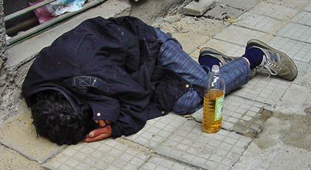
Management and Assessment of Unconsciousness

Contents
- Definition

- Management Strategy
3. Glasgow Coma Scale
4. Causes and effects
5. Case study
6. Transportation / Evacuation

Introduction

In the offshore environment loss of consciousness is most likely to occur in association with accidents or seizures. Experience shows that seizures are likely to be brought on by acute alcohol withdrawal and are quite common offshore.

The aims of this unit are to cover systems of management for any case of unconsciousness that you might encounter in your offshore environment and therefore we will not discuss all causes in depth.

- We will discuss a system of management for any case of unconsciousness
- Offshore causes and effects
- Difficulties associated with transportation of your injured or sick crew member

We will the put everything into perspective in the case study in section 5.

Preparation

Using an up dated first aid reference book you should familiarise yourself with the treatment of unconsciousness. Then take a little time to read up on the following:

- Diabetes
- Epilepsy
- Brain structure
- Stroke
- Cerebral circulation

Warm up

For this warm up exercise we have attached two tables with causes and effects of unconsciousness. Have a go at putting the correct cause with the correct effect. We have completed the first one for you.

Answers on page 5

Cause | Effect
Haemorrhage | Hypotension
Head Injury
Nitrazepam
Insulin
Asphyxia
Table 1

Definition

As you will have read in your text books the brain is a very sensitive organ. Its normal function can easily be disturbed resulting in many different effects, one of them being unconsciousness.

One definition of unconsciousness is:

‘A condition in which the ability of the brain to receive information and to initiate purposeful activity is seriously impaired’.
Q1
Think back to what you have read in you first aid manual and then list the most important actions you would take in your immediate response to an unconscious patient?

Cause | Effect
Haemorrhage | Hypoxia
Head Injury | Hypoglycaemia
Nitrazepam | Hypotension
Insulin | Concussion
Asphyxia | Sedation
Table 2

2 Management strategies

It can often be difficult to determine the cause of unconsciousness; therefore it is very important that you learn to use a strategy of management. Once you have developed this you must keep to it and avoid taking short cuts. You will need to review and revise this system on a regular basis so make allowances for this.

It is important as the HSE Offshore Medic and only medical person on board that you use your common sense along with your system/strategy. If you do this you will do the best for your patient.

There are three main steps to follow:

- 1. Your immediate response
- 2. Obtaining a history
- 3. Examination

Answer1
Your immediate response should follow the basic rules below:

- Ensure your own safety
- Ensure patient’s safety
- Ensure your team’s safety
- Attend to the ABC’s
- Oxygenate with highest percentage possible
- Prevent heat loss

Step 1 - Immediate response

Remember once you are at the scene you must make a decision as to whether you or your patient’s safety is compromised. If so you must make a critical decision about moving the patient before you have evaluated the extent of their injuries.

In the first instance you should follow your BLS routine and commence a standard CPR response. If you are alone at this point there is nothing else you can do. Once help arrives at the scene you can attend to the patient’s airway using a suction device to clear the airway, mouth and pharynx. If this causes a gag reflex then the patient has an intact protective reflex.

A patient with an intact protective reflex and spontaneous respiration will still require their upper airway to be protected; you can do this by using adequate suction to remove mucus, saliva and blood whilst maintaining a good chin lift.

If however your patient is not breathing for themselves, you will have to assist them further by using one of the following techniques:

- Mouth to mouth
- Mouth to face mask
- Bag valve – face mask
- Bag valve – to – nasopharyngeal airway
- Bag valve – to – oropharyngeal airway

Remember:
- Your patient may vomit at any time
- Adequate oxygenation of the brain is essential
- Patient must continue to have unobstructed spontaneous breathing or effective ventilation

You need to oxygenate at the highest percentage available. This can be achieved on free flow for the breathing patient, or running through a ventilating device. You need also to check the patient’s circulation with the carotid pulse, or the perfusion by pressure on the lips or nail-bed.

2.2 Step 2 Obtain a History

Try to obtain some sort of history from the patient’s work colleagues as to how they have become unconscious and /or the nature, mechanism of injury. In the absence of information you will need to become a detective and look for clues at the scene. The patient might have a medical file on board containing relevant medical information, or their colleagues might have information to give you that the patient has withheld.

Any containers found at the scene containing food, alcohol, drugs or poisons must be examined and saved for chemical analysis, and as possible legal evidence.
It is worth noting that although everyone working offshore is required to have a medical, some people withhold medical information from the examining Doctor to gain employment.

2.3 Step 3 – Examination

You will now need to carry out comprehensive physical examination following guidance from the table below. Make sure you make a clear concise record of your findings, this will assist in you diagnosis and following discussion with your Topside Doctor.

Assessment

Assess
- Pulse rate force and volume
- Blood pressure
- Respiration rate
- Spinal reflexes and plantar responses
- Oral or anal body temperature
- Glasgow Coma Score
- Blood Glucose

Observe

Facial appearance:

- Pale due to shock
- Cold and sweaty – due to shock
- Flushed- due to fever
- Hot and sweaty – due to fever
- Cyanosis - due to lack of oxygen
- Abrasions, lacerations and swelling – due to injury/trauma

You then need to look at:

- Pupil size and reaction to light
- Scalp wounds
- Swelling
- Bony injuries
- Neck rigidity
- Blood or fluid loss from nose ears or mouth
- Mouth injuries, bitten tongue, broken teeth, smell of breath (alcohol etc)
- Haemorrhage
- Fractures
- Urinary incontinence
- Erection (in male patients) sign of spinal injury
- Muscular rigidity or flaccidity
- Involuntary movements
- Twitching and/or convulsions

3. Glasgow Coma Score

This is a method of assessing the consciousness level of a patient.
The score has two advantages over other methods:

- It's simple to perform
- It's easy to remember

The method consists of rating patient responses as shown in the table below

The lower the rating, the deeper the level of unconsciousness. Continuous assessment of your patient using the score will give a strong indication of any changes in consciousness level.

Results can be noted on a chart (if provided by your company) or on the patient's records.
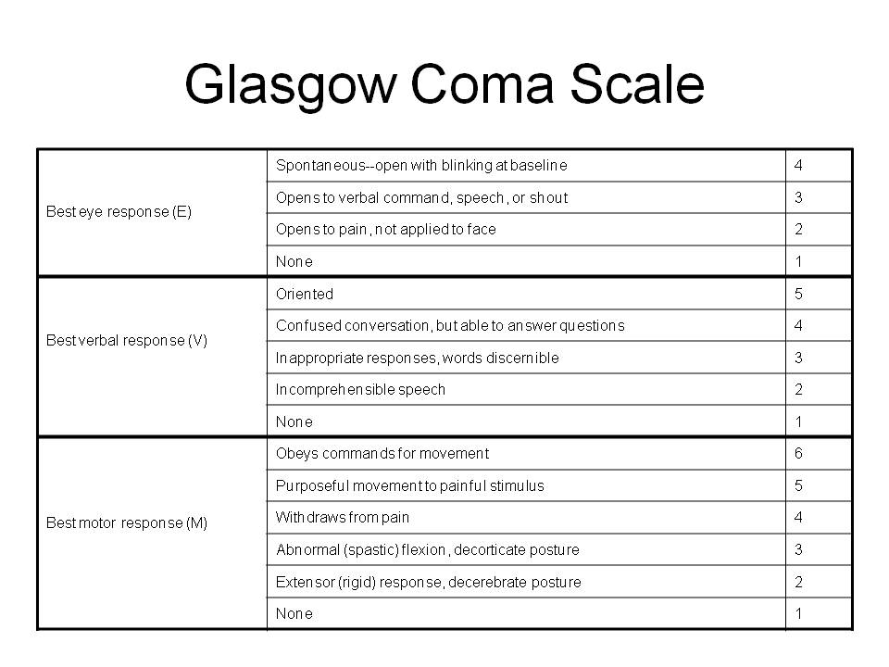

Now try the exercise below?

Question 2
A crew member has been rescued from a smoke filled room, his eyes are watering and stinging and when asked to open them he tries to but finds it too uncomfortable. When asked to breathe in deeply he tries but immediately starts coughing. You then ask him what happened but he cannot reply due to the cough.

Using the Glasgow Coma Scale provided, assess his level of consciousness
Check your answer on the next page

Question 3
A Rigger strikes his forehead against a container, you see a large haematoma on his forehead and so you do a five minute quick neurological status check on him. His eyes are shut but he opens them on verbal command. You then ask him to stick his tongue out with no response. You ask a second time and he responds. You then ask him his name and what day it is and he has no idea.

Using the Glasgow score what is your assessment of his level of consciousness?
Check this answer on the next page

Answer 2
The score should be 15
Eyes – 4
Motor – 6
Verbal – 5
In short he has made the best response in each category therefore there is no brain injury and his complaints are probably due to smoke inhalation.

Answer to question 3
The patient has a Glasgow Coma Score of 13
Eyes – 3
Motor – 6
Verbal – 4

4. Causes and Effects

We have listed below some of the more specific conditions which might cause a state of altered consciousness offshore, this list is not exhaustive. Having some level of understanding of these conditions will help you manage your patients more effectively.

Diabetes Hypothermia < 35˚C
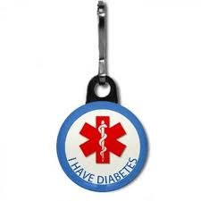
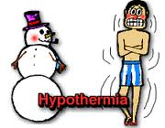

Asphyxia
Shock BP Hg mm↓ Hb
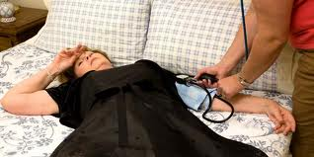

Faint (lack of 0₂)
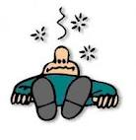

Stroke (Brain Attack)
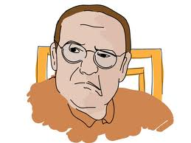

Head injury
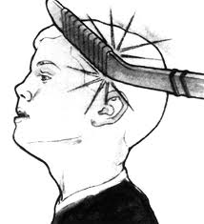

Epilepsy

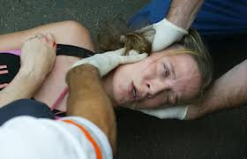

Alcohol and drugs
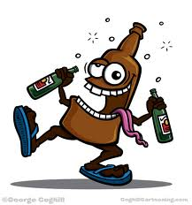

Diabetes mellitus

Glucose is utilised by the brain as an energy source and is taken up from the blood in large amounts. In an individual who is non diabetic a period without food can lead to relative hypoglycaemia, causing minor symptoms such as light headedness and lack of concentration.

Diabetics can work offshore under certain rigidly controlled circumstances, they will normally be young, insulin dependant and well stabilised.
You must remember that they are as healthy as anybody else offshore.

It is very unlikely that you will have to treat a case of diabetic hypoglycaemic coma; the reason for this is two fold:

- Offshore workers with insulin- dependant Diabetes mellitus are very few in number
- Hypoglycaemia is more common in an unstable diabetic

You must discuss any condition that you suspect may be due to a hypoglycaemic attack with your Topside Doctor at the earliest convenience. If the Topside Doctor confirms your suspicions you will then have to reverse the hypoglycaemic state.

Treatment of hypoglycaemic coma

- Ensure you have a 5 ampoule box of 50% dextrose in your drug cupboard (Dextrose provides a sugar load for a diabetic in a hypoglycaemic coma. Up to 50mls of 50% glucose solution should be injected intravenously, after consultation with Topside Doctor.
- You should also have a glucagon injection pack available. Glucagon increases plasma glucose by mobilising glycogen from the liver. The advantage of this method is that the solution can be injected subcutaneous, intramuscular or intravenously depending on the medics skill. The disadvantages of this method of treatment are that it is sometimes ineffective.

If your patient does not respond to IM, Sub Cut injection after a period of 20 minutes you will have to revert to gaining IV access so you can administer IV glucose.

Once the blood sugar has been raised your patient will quickly regain consciousness. You can then give oral glucose. They will have been disorientated and amnesic for the whole episode so allow them at least an hour to recover before discussing the likely causes and further management.

Please take note:
Hyperglycaemia is a very rare condition; it is slow in onset and the body can tolerate it for a short period of time. It is very unlikely that you will ever have to treat this condition offshore.

Hypothermia

If you have already completed the module Cold Water Immersion you will be aware of the differences between unconsciousness and hyperthermia/hypothermia. If you have not completed this module please refer to it or refresh yourself on the above.

Asphyxia

When the mechanism of breathing is disturbed there is either a relative or absolute deficiency of oxygen. An absolute deficiency of oxygen will result in unconsciousness in 10 seconds and death within 5 minutes.

Your treatment offshore would be to immediately re-oxygenate the brain. Use the highest percentage available for example 15lires per minute (100%). It is also worth mentioning at this point that someone suffering from a head injury will be more susceptible to lack of oxygen.

Shock

A lowering of the systemic blood pressure will result in a reduction of cerebral blood flow. The brain requires continuous perfusion with well oxygenated blood as mentioned above under the title asphyxia. The main difference between the two conditions is:

- Asphyxia = primary 0₂ deficiency
- Shock = secondary oxygen deficiency due to lack of transport medium (blood)

Question 4:
Name the procedure that can be used to relieve an obstructed airway – the procedure is named after its inventor.

Check your answer on page 16

Question 5:
Define shock in your own words?

Check your answer on page 17

Faint

You can think of a faint as a type of temporary shock, we have listed some common causes below:

- Lack of food
- Sight of blood (often ones own)
- Fear of pain
- ‘micturition syncope’ Getting out of bed at night to pass urine
- Sudden changes of posture, often associated with febrile illness
- Standing for long periods (for example on a parade ground)

Treatment
Remember your basic first aid skills. Keep the injured person horizontal, head cushioned with feet elevated, they should recover briskly. Once they have regained consciousness you should keep them in the sickbay for a minimum of 2 hours for observation and find out what happened. You will need to consult with your Topside Doctor as to the management of your patient. As a general rule anyone who has collapsed, lost consciousness or who has a suspected head injury must be Medivaced at the first instance once they are stabilised.
Note:
Some patient’s produce convulsive movements while they are in a faint. It is very important that this is not diagnosed as Epilepsy. Epilepsy in itself is a very specific condition which if diagnosed has important implications and consequences to the sufferer. This could mean the loss of a livelihood for one of your crewmembers.

So, avoid the term Epilepsy and use the term convulsions.

Answer Q4:
Name the procedure that can be used to relieve an obstructed airway – the procedure is named after its inventor.

Answer
‘The Heimlich manoeuvre’. We will discuss this further and you will have time to practice this method during your visit to DDRC. Please note the above is now commonly discussed as the abdominal thrust.

Head Injury

A blow to the head can cause several effects including:

- Shaking of the brain inside the skull
- A fractured skull, uncomplicated
- Bleeding within the scalp leading to a soft tissue swelling
- A split scalp resulting often in profuse bleeding
- A fractured skull, complicated by:
- Exposure of the brain tissue
- Increased intracranial pressure (pressure within the skull)
- Damage to underlying structures
- Formation of a blood clot
- Leakage of CSF (cerebral spinal fluid)
- Injury to the neck bones

Answer Q5:
Define shock in your own words?

Check your answer in the module ‘Shock Mechanisms and Management’
The body can bring into play a number of mechanisms to help maintain the systolic blood pressure.

When someone receives a blow to the head this causes the brain to shake inside the skull. As a result of this a shearing force is applied to the nerve fibres in the brain which leads to a variable level of cerebral dysfunction. The effects can be temporary or prolonged unconsciousness. You will remember from reading through your anatomy text books that the brain fits neatly inside the skull and is cushioned by a thin layer of cerebral spinal fluid. Damage to structures within the skull can result in swelling of brain tissue and the formation of blood clots. Swelling inside the skull will compress brain tissue further, leading to an increase in intracranial pressure.

Treatment
- Protect airway and give 0₂ as discussed earlier
- Maintain a good blood pressure
- Apply a protective neck collar
- Control haemorrhage. Scalp wounds bleed profusely but direct pressure using a decent size pad will normally bring the bleeding under control
- Dress any scalp wounds with attached bandages. Shell or ambulance dressings are ideal
- Continue to check vital signs every 5-10 minutes and periodically access GCS (Glasgow coma scale)

Any crewmember with a head injury will require a full evaluation in a hospital environment, discuss with Topside as a matter of priority. In the event of a Medivac the patient should be escorted by a skilled medical practitioner, preferably the Topside Doctor. During evacuation of a comatose patient the airway should be protected by an endotracheal tube

Be aware that the insertion of an endotracheal tube is a difficult and dangerous procedure unless you do this on a regular basis, you might be advised to use an LMA or I-Gel, which is safer and quicker to put in situ.

Question 6
What is the effect of pressure increasing inside the skull?

Answer on next page

Question 7
How can the body improve arterial perfusion pressure?

Answer on the next page

Answer Q6
What is the effect of pressure increasing inside the skull?

A reduction in cerebral perfusion pressure. The pressure of blood perfusing the brain tissue will be countered by the raising of intracranial pressure

Answer Q7
How can the body improve arterial perfusion pressure?

By increasing the systemic blood pressure. This would be associated with a reflex drop in the pulse rate.

A head injury associated with intracranial swelling will result in coma, a rise in blood pressure and fall in pulse rate. If unchecked, intracranial pressure will become higher than systolic pressure, cerebral perfusion will fall and the brain will die.

Epilepsy

Epilepsy is not a cause of unconsciousness as such but more of a condition that can be associated with it.
‘Epilepsy (from Ancient Greek ἐπιληψία), is a common and diverse set of chronic neurological disorders characterized by seizures. Some definitions of epilepsy require that seizures be recurrent and unprovoked but others require only a single seizure combined with brain alterations which increase the chance of future seizures.
Epileptic seizures result from abnormal, excessive or hypersynchronous neuronal activity in the brain. About 50 million people worldwide have epilepsy and nearly 90% of epilepsy occurs in developing countries. Epilepsy becomes more common as people age. Onset of new cases occurs most frequently in infants and the elderly. As a consequence of brain surgery, epileptic seizures may occur in recovering patients’ Wikipedia 2012
It might be worth noting that 1 in 30 of the population have some kind of single seizure once within their lifetime. If someone is suggested to be suffering from Epilepsy then it must be presumed that they have a tendency toward having seizures and are currently being treated for such with some kind of medication.

These single seizures can occur at any time and the sufferer will normally deny any recollection or knowledge of having a fit. It is important to remember that a fit can occur at any time.

Any individual who has suffered from a fit at work offshore will be automatically regarded as unfit to return to work, please refer to the UKOOA Guidelines: Standards of fitness, to understand why this measure should be taken.

Grand mal fit

Tonic–clonic seizures (formerly known as grand mal seizures or gran mal seizures) are a type of generalized seizure that affects the entire brain. Tonic–clonic seizures are the seizure type most commonly associated with epilepsy and seizures in general, though it is a misconception that they are the only type. For further information go to http://en.wikipedia.org/wiki/Tonic-clonic_seizure

Treatment

- Protect patient from harm
- Monitor for however long required
- Don’t leave unattended as might be confused
- Allow to sleep it off
- Medivac with appropriate escort
- Refer to Onshore Medical Practitioner for further investigations and treatment

Status Epilepticus

As an offshore medic your initial treatment would be to administer intravenous Diazepam (as Diazemuls) 10mg in 2 ml over a period of 5 minutes via a butterfly needle in the back of the hand. If it is going to waste time getting IV access then 10-20mg of rectal diazepam may be used as an alternative. If you don’t get any response then repeat the procedure, don’t forget to discuss with your Topside Doctor as soon as it is possible.

If the patient fails to respond, only partially responds or their condition deteriates it will be necessary to administer Diazepam by intravenous infusion. For example you will need to set up an intravenous infusion of 1 litre of 5% dextrose solution containing 200mg Diazepam and run it in fast enough to control the convulsions. Once again contact Topside as a matter of urgency as soon as you get time.

Stroke

The likelihood of you seeing a stroke offshore is very unlikely due to the age range involved. However the incidence of strokes start to rise over the age of 50 and the average offshore worker seems to be 50 these days, some crew members are still working well into their 70’s. In general:

- About 80% of strokes are due to the sudden loss of blood supply to an area of the brain due to vascular disease.
- Around 10% are due to primary haemorrhage into the substance of the brain
- About 10% are due to a subarachnoid haemorrhage

As very useful tool is FAST – Face Arm Speech Test

Facial Movements

Ask the patient to smile or show their teeth.

- Look for new lack of symmetry – tick the yes box if there is an unequal smile, grimace or obvious facial asymmetry
- Make a note of which side does not move so well, then mark down on the form whether it’s the left side or the right side

Arm movements

- Lift the patient’s arms together to 90˚ if sitting, 45˚ if supine and ask them to hold the position for 5 seconds then let go.
- Does one arm drift down or fall rapidly?
- If one arm drifts down or rapidly falls, note whether it is the left or right arm.

Speech
If the patient is able to speak:
- Look for new speech disturbance
- Look for slurred speech
- Look for word finding difficulties, ask them to name nearby objects such as a window, door, teapot, chair etc

If you suspect a stroke or TIA contact your Topside Doctor immediately or as soon as it is safe to do so. Think basic fist aid, ABCD, Protect the airway, give oxygen and give IV fluids (not glucose). Be alert for the decline in neurological observations.

The blood pressure should not be actively managed in acute strokes

Do not give Aspirin- this is contraindicated within the first 24hrs

Priority should be given to transporting the patient to a hospital for consideration of Thrombolysis. The window of opportunity for this is from onset to 4.5 hours and there is no proven benefit after this.

Useful check list:

Speech impairment Yes No?
Facial Palsy Yes No?
Affected side L R
Arm Weakness Yes No?
Affected side L R

Remember

A subarachnoid haemorrhage is a rare cause of a stroke in a young man. The condition is characterised by the sudden onset of a crippling headache. It has been likened to being struck on the head with a hammer. The headache remains severe, the neck becomes stiff and the patient may lapse into a coma. Again approach in an ABCD manner and contact the Topside Doctor.

Drugs and Alcohol

Many drugs interfere with the ‘chemistry’ of the brain, often in ways that are not fully understood. Usually the effects are measured physiologically and,for example, how it alters the bodily functions. Be aware that many of your crew will be on prescription medications from their local GP who in turn might be unaware of what job they do. It is the responsibility of your crew/patients to inform you of any prescription medication they may be taking; it is a good idea to promote this during your health presentations.

When someone is found in a coma and the cause is not obvious, a drug overdose must be considered as an option. Acute alcohol withdrawal can also cause a seizure, some offshore and maritime workers spend 3-8 weeks on a dry Rig or Vessel then go home and drink to excess. Subsequently they then return to work and are denied alcohol, which leads to withdrawal symptoms. These symptoms start around 3 – 6 hours after the last alcoholic drink and can last for as long as 7 days. A seizure is possible 10-60 hours after the last alcoholic drink.

Warm up answers

A + 3
B + 4
C + 5
D + 2
E + 1

We have now studied systems of management, the Glasgow Coma Score and various other issues along with the more common causes of unconsciousness offshore. If you are going to use these systems then you will need to practice them. Many of the elements will be able to be rehearsed during your day to day activities and routine consultations on board.

To fully complete rehearsals it is recommended that you run casualty simulation exercises, this will help iron out any shortfalls in your system and also allow you to test the response of your first aid teams. The management of a seriously injured crewmember will be enhanced if you have a well-trained and well-rehearsed first aid team to assist you.

We will now run through two case studies, both are based on real events and illustrate what you should be able to do.

Try to work your way through these two case studies, you will find that sometimes you are asked a question and the answer will be on the following page.

Remember this is primarily a learning exercise and not necessarily a definitive treatment.

5. 1 Case study number 1 – Has your crewmember been drinking?

It is 23.00 hours. You are called to visit a man found to be unrousable, lying face down on the floor of his room. He is alone in the room, but as you arrive on the scene, his roommate enters.

His mate says they are both unskilled labourers working for an agency. They both arrived on the platform earlier the same day. Both felt fine when they left the beach.

You shout his name several times into his ear. He opens his eyes and closes them again. You tell him to put out his tongue but get no response. You pinch his ear lobe. He moans and moves his head.

The mate is not very forthcoming, saying they had 'one or two drinks' in town the previous night. Your patient remains unrousable but is breathing and has a good colour.

You find that he is breathing in a regular fashion; radial pulse is full and regular.

Now answer the questions below. You will find the answers on page 27.

Question 1: Which of the following are vital signs?

a. Temperature, e. Pulse rate
b. Reflexes f. Verbal response
c. Blood pressure g. Breathing rate
d. Pupil reactions

Question 3: What is your calculation for his coma score?

Question 4: What aspects of your patient's medical history would be of most use to you at this point?

a. Number of cigarettes smoked per day.
b. Family history of high blood pressure.
c. Past history of head injury.
d. Daily alcohol consumption.
e. Past history of epilepsy.
f. Medication being taken by the individual.
g. Recent lack of sleep.

Question 5: What next?

Question 6: What are your first impressions?

Question 7: What next?

Question 8: Which of the following would you tell him to do? Please tick.

a. Check the pupil reactions every minute.
b. Check the blood pressure every five minutes.
c. Ensure that your patient's airway remains clear at all times
d. Call you if he has any concerns.
e. All of the above.

Question 9: What are you going to do now?

Question 10: What management plan would you decide upon at this point?

Before you can carry out your plan, you receive a call from the Fist Aider. Your patient has regained consciousness, got up from the floor, climbed into his bunk and 'gone to sleep'.

Question 11: What provisional diagnosis do you think that you and the Topside Doctor would come to?

a. Head injury of unknown cause. Possibly assault
b. Sub-arachnoid haemorrhage
c. Diabetic coma
d. Seizure induced by acute alcohol withdrawal
e. Poisoning

It's now 5 o'clock in the morning. Your patient has recovered consciousness and is fully alert and orientated. His head injury seems to be superficial. If you want to Medevac him immediately, a special night flight helicopter evacuation will have to be arranged. You will also have to arrange for an escort for your patient into hospital. His condition continues to improve.

Question 12: What do you want to do now?

However, the OIM has other ideas and wants your patient evacuated immediately.

Question 13: What do you do next?

The OIM is not convinced and orders you to send your patient straight to hospital

Question 14: What do you do now?

ANSWERS

Answer 1
Answers: c, e, g.
If these signs are present you can at least assume that the patient is alive.

Answer 2
Check the level of unconsciousness. Use the Glasgow Coma Score.

Answer 3
The answer is a Glasgow Coma Score = 10
Eyes = 3, Verbal = 2, Motor = 5.

Answer 4
Answers: c,d,e,f,g.
The individual may have primary epilepsy, or epilepsy secondary to head injury in the past. He may be taking medication for epilepsy. Heavy alcohol consumption combined with sleeplessness can induce a seizure.

Answer 5
You carry out a quick but thorough general examination.
Findings: Abrasion on forehead, bloody sputum in mouth, trouser crotch damp. No other injuries are apparent.

Answer 6
You should have considered a seizure of unknown cause. The abrasion could have been caused from striking his head on the floor.

Answer 7
Send for help.
OK. A First Aider is found.

Answer 8
Answers: c, d.
Ensure the patient continues to breathe normally. To call you immediately if he has any concerns.

Answer 9
Go to the OIM. Explain you have a sick man who will need to be sent in to the beach. The OIM asks you what is wrong. Your answer is that you think your patient has had a fit.

Answer 10
To move your patient to the sick bay and tuck him up in bed. Start a neurological observations chart. Call the Topside Doctor and discuss further management of the patient.

Answer 11
Answer: d.
None of the other diagnoses are likely.

Answer 12
You would put him on the next routine flight.

Answer 13
You advise the OIM that there is no urgent need for Medevac and that your patient is recovering well. You don’t suspect any complications from his head injury and his condition doesn’t warrant medevac.

Answer 14
You do as you are told!
What happened next?

The helicopter arrives an hour later. Your patient is quiet and co-operative. A First Aider escort is detailed to accompany the man, who is taken straight to the local hospital.

The following morning the patient discharges himself from hospital and heads for the nearest pub!

Summary
- Alcohol withdrawal seizures can occur within 10 to 60 hrs after a heavy drinking session.
- Even if not witnessed the injured person will show signs they suffered a fit.
- Collapse is sudden and profound; the patient may injure themselves, though this would rarely be serious.
- Your patient may suddenly awaken and appear normal, they are far from that and should be escorted away to a quiet, darkened room and encouraged to sleep.
- Once recovered they will have no knowledge of the event.
- They will have lost their job but probably find another and could soon be working offshore for another company. That’s life and there’s nothing we can do about that.

5.2 The Pump man

You are working on a Jack Up (Drilling Rig) and drilling is in progress. Its 22:00hrs and there is a strong cold wind blowing. You are called by the Tool Pusher to attend an injured man located at the base of the derrick; you put on your boots and other PPE, grab your emergency bag and hurry to the scene.

As usual in these circumstances you find a group of oil covered men standing round a crumpled heap of a man, who is lying motionless at the base of the derrick. The supervisor tells you that he is the pump man and he was on his way down for his tea break when he fell. The fall was about fifteen feet and he didn’t get up or move after landing. The area is very cold and exposed.

Question 1: What are your immediate actions?

a. Examine the patient
b. Call for help
c. Run to the sickbay for your medical kit.
d. Ensure the safety of both you and your patient

OK. You both appear to be safe.

Question 2: What is your next step?

Question 3: What do you do next?

The injured man is lying on his back, with his head turned to the right. His right arm is under his body and his left arm is beside his body. Both legs are bent at the knees in a natural way, to the right. He is wearing a waterproof jacket and trousers, beneath which he has several layers of thick, warm clothing. He is wearing a safety helmet which has ear flaps. The helmet is fastened under his chin. He is also wearing steel-capped boots, gloves and a scarf. His outer clothing is filthy with drilling mud.

Question 4: How will you check his vital signs?

The patient's ABCs are satisfactory.

Question 5: What next?

Question 6: Why is he unconscious?

Question 7: What next?

Question 8: What other injuries might you suspect in view of the history?

a. Fractured cervical spine
b. Fractured limb
c. Ruptured spleen
d. Fractured ribs
e. Fractured pelvis
f. All of the above

Question 9: What are your next important steps?

Question 10: Which of these IV infusion solutions would you NOT use at this stage? (you may select more than one answer)

a. 5% dextrose
b. Normal saline
c. Hartmann's solution
d. Mannitol
e. Haemaccel

Question 11: What do you do next?

Question 12: What are you going to do? What should you consider now?

Question 13: List the practical steps that you need to take to move your patient to the sick bay.

Once in the sick bay you are in a better position to appraise the situation and you carry out a more general examination.

Question 14: What should be one of your first actions on arriving at the sick bay?

Answers

Answer l
Answer: d.

Answer 2
Send a runner for a stretcher party and blankets.

Answer 3
Check your patient’s vital signs

Answer 4
Gently, but quickly, remove his safety helmet, ensuring that you do not disturb the position of his head any more than necessary. Check his airway, breathing and circulation using the standard ABC method
For the carotid pulse to be palpable, the systolic pressure must be 60 mmHg.
For the radial pulse to be palpable, the systolic pressure must be >80 mmHg.
For the femoral pulse to be palpable, the systolic pressure must be > 70 mmHg.

Answer 5
Check level of consciousness using the Glasgow Coma Score.
There is no spontaneous movement, he neither responds to verbal commands nor to pain.

Answer 6
Presumably his unconsciousness is due to a head injury.

Answer 7
Check his head for signs of injury. Remember the possibility of a neck injury, so take care

There are no external signs of head injury.

Answer 8
Answer: f. All of these.

Answer 9
Administer oxygen, undiluted, by full face mask, remember the effects of wind-chill; cover him with a foil or other blanket until you are ready to move him. Expose both arms by cutting away clothing to the shoulders. Provided both arms are uninjured, use one for blood pressure monitoring and the other to set up an Intravenous line.

It is better to start an infusion early as it may become more and more difficult to find a vein if the patient becomes shocked.

Answer 10
Answer: d and a. Mannitol is a specific treatment for the correction of acute cerebral oedema. Glucose should be avoided in cases of head injury.

You find the patient's blood pressure is 120/80; pulse 72, full and regular; respiration 18 per minute. There is no evidence of internal haemorrhage at this stage.

Answer 11
You will need to carry out a general examination.

However, your patient is heavily clothed and it is very cold.

Answer 12
You should consider moving your patient to the sick bay where an examination can be carried out in more favourable surroundings. You should consider the possibility of other injuries and fractures, particularly of the spine and pelvis, prior to any move.

Answer 13:
Your list should have covered the following:

Carefully apply a neck splint, moving the head to a forward facing position. Check that the airway remains unobstructed.
Splint the feet together and carefully straighten the legs, checking that there are no obvious fractures of either leg. Whilst doing this, get help to support the pelvis, ensuring that the spine is not being twisted.
Splint the legs together as for a fractured pelvis.
Utilising blankets, or a scoop stretcher if available, move your patient from the floor into a basket stretcher.
Carefully transfer your patient to the sick bay.

Answer l4
Arrange contact with the Topside Doctor for further help.

What happened next?

You find no gross abnormality on examination. After discussing the situation with you, the Topside Doctor decides to fly out to the installation and escort your patient to hospital.

Your patient made an uneventful recovery.

6. Transportation

The civilian helicopters that are routinely used for carrying personnel are far from ideal vehicles in which to transport a seriously ill individual. You should note that, once airborne, your access to your patient will be limited.

How does this fact affect your actions prior to transportation?

Transportation should only be undertaken once the patient has been stabilised. Do not be forced into using a helicopter that is in the field. It is far better to await the arrival of medical assistance from onshore.

Finally, you will be aware that all forms of unnecessary movement can be traumatic for the patient and produce a certain degree of deterioration in his condition.

Key Points

- It can be very difficult to determine the cause of unconsciousness

- Immediate response should follow established first aid principle

- During transport to the hospital, the patient must be accompanied by a competent and suitably qualified escort

- Measurements of pulse, blood pressure, respiration rate, pupillary reaction and coma level should be made frequently. Send these recordings to hospital with your patient

- As soon as possible, correct hypoxia and low blood pressure

- A patient unconscious from a head injury may have other injuries

Summary

- The effects of a head injury can be severe despite the absence of external signs of damage
- A patient with a depressed level of consciousness should have circulation and respiration stabilised as a matter of priority
- Low blood pressure and hypoxia will lead to further deterioration, these conditions should be corrected
- Continuous assessment should be employed. Regularly check pulse, blood pressure, respiration, pupil reaction and level of consciousness (coma score). Remember some Doctors will prefer to use AVPU which is a simpler method or scoring as used by first aiders.
- Ensure your notes and recordings arrive at the hospital with your patient
- Head injury patients might also have neck injuries, so splint the neck to stabilise.

Objectives

You should be able to: | Your test:
- Define the term ‘unconsciousness’ | Q1
- State the main causes of unconsciousness offshore?

