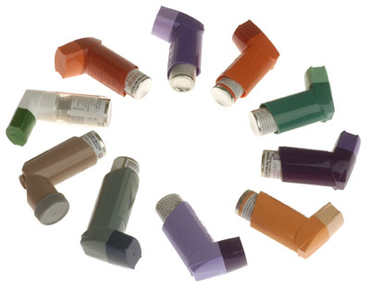

**Asthma in the Offshore Environment**



**Contents:**

1. **Causes and effects of asthma**

* Factors in asthma
* Asthma symptoms

1. **Assessment**

* How to use a peak flow meter

1. **Management of asthma – clinical**

* Case study – Eric
* Acute severe asthma attack
* Ongoing asthma management

**4 Fitness to work offshore**

**Introduction**

“Asthma is thought to be produced by an inflammatory reaction affecting the airways of the lung and is increasingly common in the general population for reasons that are not yet fully understood.”

**The main focus of this unit is to provide you with a plan for managing an acute asthma attack offshore.**

Asthma attacks offshore are more frequent than you may think! It is essential that as the Offshore Medic you are confident in the management and treatment of acute asthma attacks.

The average age of the offshore worker is about 50 years of age; many of these people suffer from a plethora of illnesses including mild asthma which is not considered a risk factor for offshore work. Sometimes these people with mild asthma suffer an exacerbation of their condition. There are also many sensitisers in the offshore environment which may precipitate asthma in a previously unaffected worker.

Preparation prior to commencing this module

It is recommended that you use a standard textbook to remind yourself of the anatomy and physiology of the airways, including the microscopic structure.

You should also read through the British Thoracic Society’s “British Guideline on the Management of Asthma, May 2008”

Before you continue, consider which of the following features could be typical of asthma and mark with an x, see example in top row?

|  |  |
| --- | --- |
| Coughing | x |
| **Purulent sputum** |  |
| **Bacterial infection** |  |
| **Tightness in the chest** |  |
| **Insomnia** |  |

1. Causes and Effects of Asthma

Asthma is an inflammatory condition of the airways. Refer to a textbook of your choice and revise this condition to ensure that you are fully aware of the causes and effects of this condition.

*Question 1*

*Can you list the three main physiological events that occur during an asthma Attack?*

*Check your answer on page 5*

Remember

Asthma triggered by a sensitising agent might only require a small amount to trigger such a reaction. Asthma is very unpredictable and therefore a dangerous disorder.

These three main events lead to a narrowing of the airways. As a result the affected individual has great difficulty moving air in and out of their lungs.

We will now go on to discuss the main factors of asthma:

1.1 Factors of Asthma

Age

People who develop asthma in adulthood often have the condition for life.

Some are born with a condition which leads them to suffer with eczema, hay fever and asthma. These individuals are said to have Atopy. The condition itself normally regresses in late childhood although still normally have a tendency towards it.

Asthma can develop at any age.

It is even possible for elderly people to develop the condition at a late stage in life.

Physical factors

Irritants

Irritants upset the lining of the airways by a direct physical effect, they are also numerous and commonplace. We have listed some types of irritants below:

* Dust
* Smoke and fumes of all types can be inhaled and so cause a reaction. The severity of the attack also depends on the concentration of the irritant inhaled. Remember a non asthmatic will have a similar reaction to exposure; however this condition will normally subside, whereas an asthmatic will progress.
* Forceful inhalation of cold air, perhaps from forced air during exercise or working in a cold environment, is a very potent irritant.

Sensitising agents

A sensitising agent is something that will have previously sensitised the person and on second exposure, may lead to an allergic response.

Here are some examples of sensitising agents and materials

* Paints containing isocyanate
* Dust from bedding
* Faeces from dust mite
* Drugs such as Aspirin
* NSAIDS (non steroidal anti-inflammatory drugs ) such as Ibuprofen
* Formaldehyde which is often found in drilling mud (drilling mud is a heavy substance that is used to put down the drill hole to keep oil and gases from escaping into the atmosphere during drilling ops).
* Vapours from welding and cutting operations. In particular cadmium, chromium(from plated metals)and stainless steel, cause problems offshore.

Remember there are many more sensitising agents around and it is up to you as the Occupational Health representative on board to keep track of what chemicals and substances are being used and stored on board. You can do this by liaising with the store man, OIM, Engineers etc.

1.2 Diagnosis of Asthma in Primary Care

Initial Assessment

The main key to reaching a diagnosis of asthma is in the recognition of a characteristic pattern of signs and symptoms and the absence of an alterative explanation for them. A careful clinical history and assessment along with measurements of spirometry is the key to a good sound diagnosis.This will also make the Topside Doctor’s input and decision making much easier.

* Patients with a **high probability** of asthma are started on a trial of treatment; further testing is only required if they do not respond to this treatment.
* Patients with a **low probability** of asthma, whose symptoms are thought to be caused by an alternate diagnosis, are investigated and managed accordingly. Remember when you are offshore you need to reconsider your diagnosis and treatment in any crew member that is not responding.
* The preferred management of patients with an **intermediate probability** of having asthma is to carry out further investigations, including an explicit trial of treatments for a specific period, prior to confirming a diagnosis and initiating a fixed treatment regime.

**Spirometry is the preferred (and best) initial test to assess the presence and severity of airflow obstruction (make sure you have the correct equipment on board when you first arrive on the installation).**

*Answer to Question1*

*The following features could be typical of asthma*

* Coughing
* Insomnia
* Tightness of the chest

*If you listed purulent sputum and bacterial infection, remember asthma is primarily an inflammatory condition and so should be treated with anti-inflammatory drugs and not antibiotics, unless it has been triggered by an infection of the respiratory tract (URTI)*

Clinical features that increase the probability of Asthma

* Prominent dizziness, tingling in hands and fingers
* Light headedness
* Chronic productive cough
* Absence of wheeze or breathlessness with a cough
* Voice disturbance
* Symptoms with cold only?
* Repeated normal physical examination of chest when

symptomatic

* Significant smoking history (20 per day for many years)
* Cardiac disease
* Normal PEF or Spirometry when symptomatic*

*A normal spirogram/spirometry when the patient is not

symptomatic does not exclude the diagnosis of asthma.

Remember repeated measurements of lung function are often

more informative than a single assessment.

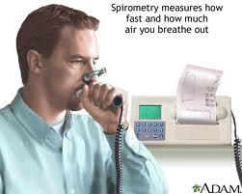

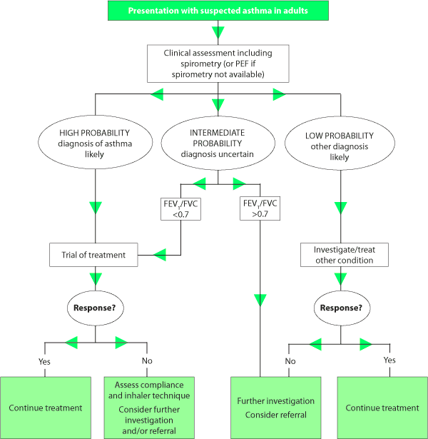

See diagram below of another simple chart to remind you of initial management of asthma You will find many similar versions in various textbooks and company procedures:

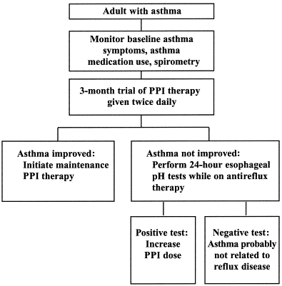

2. Method of Assessment

The peak flow meter is a very simple device that exploits the fact that, with forced expiration, the velocity of the air passing out of the mouth rises to a peak then falls away.

The meter itself measures the peak flow rate (PFR) and this gives you a useful piece of diagnostic information to feed back to your Topside Doctor and the crewmembers GP.

Peak flow meters are now available on prescription and therefore known asthmatics are encouraged to measure their peak flow on a regular basis. They will often be able to tell you what their best and worst readings are and what they have been recently, this can be very helpful in your ongoing management strategy.

Have a look at the diagram below and think how you would demonstrate a peak flow meter’s use to your patients?



This graph shows a series of readings taken from an asthmatic over a period of seventy two hours and demonstrates clearly the gradual deterioration of lung function that is associated with an asthma attack.

This type of graph will have more impact than anything else when explaining your patient’s condition to them.

2.1 The use of a peak flow meter

The peak flow meter measures forced expiration. The patient is requested to inhale as deeply as possible, forming a seal around the mouthpiece of the meter. Ensure they are holding the device correctly so as not to obstruct the moving parts. Failure to explain this initially may result in them having to repeat the test. This can be very difficult and extremely stressful to an asthmatic. They are then encouraged to empty the lungs as fast as possible. This will then cause the pointer of the device to move along to the far end, providing you have reminded them to keep their fingers clear.

You measure the reading from wherever the pointer stops.

Give them three attempts at this and then note down the best measurement.

Peak flow measurements can be taken at regular intervals and as often as you like.



This picture shows the correct method of taking a peak flow reading

A pictorial reminder of the basic anatomy and physiology of asthma

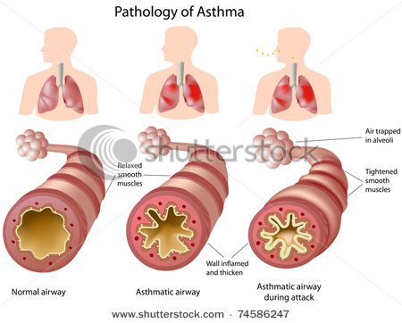

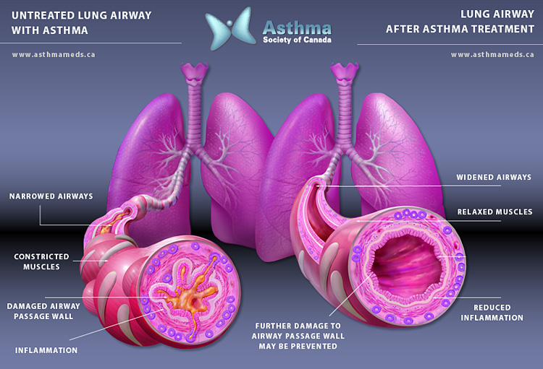

3. The Management of Asthma- -Clinical

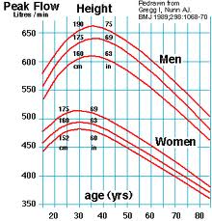3.1 Case study - Jonathon

*Jonathon is a mild asthmatic whose asthma is getting worse.*

*He has presented at your sickbay complaining of a*

*severe cough that has being getting progressively worse,*

*particularly at night. He has asked you for some cough*

*medicine.*

What you need to do first of all is find out more about

Jonathon’s condition and past medical history (PMH).

On doing so you find out that he is also:

* Starting to wheeze
* Becoming breathless when climbing steps

and carrying out his routine daily duties

It looks very likely to you that Jonathon’s asthma is

worsening. Your next step is to find out about his asthma

history and to make a provisional diagnosis. You ask

Jonathon about:

* Past episodes of “chestiness”, pneumonia, bronchitis

etc

* Visits to his family doctor
* Hospital visits and any admissions with asthma
* Regular prescriptions from his GP
* Current treatment

Now you have managed to get some information from Jonathon you then begin to ask more detailed questions and you gain more detailed information from him:

* What is his work?
* Where does he work? Outside on the deck? In an office? etc.
* What products or chemicals is he normally exposed to?
* Is he exposed to cold weather and the elements for long periods of time?
* What PPE (personal protective equipment) is required for his job?
* Does he get wheezy under certain circumstances? Cold winds?, exercise?, etc.
* Does he use an asthma inhaler and has he been using it more than normal lately?
* How often has he been using the routine medication on a day to day basis?
* What type of medication is it?
* What sort of device is it?
* Has he ever measured his peak flow? and if so what is an average measurement?
* What is his best measurement?

Your final step is a physical examination of Jonathon.

You check his pulse rate, respiratory rate, listen to his chest and measure his peak flow. These form your baseline observations and you must record them in his notes. Note the peak flow table on page 11 shows a healthy male and female’s peak flow.

We will now discuss the treatment of Jonathon in his offshore environment.

Treatment

**Mild to moderate exacerbation in a patient with normally minor symptoms**

Contact the Topside Doctor. Following your discussions with Topside you will then decide upon a course of action. It might be the case that it is felt appropriate for him to continue working offshore whilst he is receiving treatment for his condition or his condition may be such that he needs to be medivaced.

Treatment offshore may initially be simply to ensure that your patient is using their prescribed medication appropriately. Some very mild asthmatics might only use a beta antagonist such as Salbutamol when symptomatic and require no other medications. Others however may be prescribed a steroid inhaler such as Beclomethasone (Becotide 100mcg) or Budesonide (Pulmicort 200mcg) – 400 mcg twice daily to reduce frequent acute attacks. With salbutamol for symptomatic relief where necessary. Patients often fail to take all of their prescribed medication as directed by their physician and some get confused as to when they should take steroids and salbutamol, so it is very important that you clarify what they are actually taking and when they are taking it.

*Using the chart on page 11 work out your own predicted peak flow rate?*

*You could then get hold of a peak flow meter and test your actual flow rate and compare the result.*

1. *What is your predicted expiratory rate?*
2. *What is your actual expiratory rate?*

*If you can’t do this now you will be able to do this on your practical week.*

Examples of some types of inhaler:

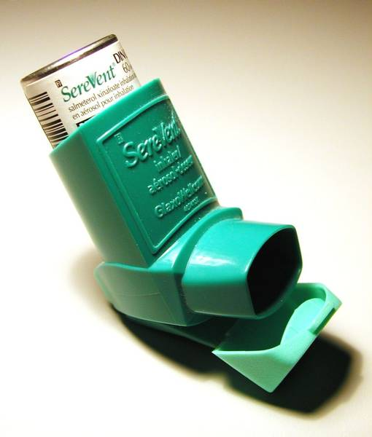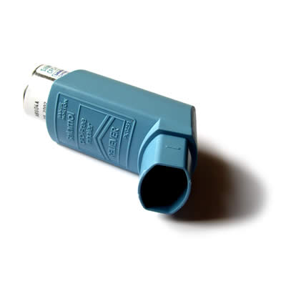

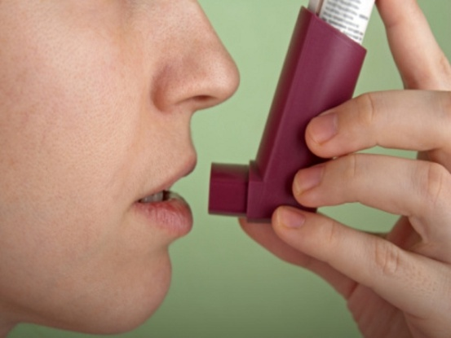

For someone who uses a salbutamol inhaler only but who has increasing symptoms, you might be advised by your Topside Doctor to initiate treatment with a steroid inhaler twice a day (BD). Over the course of a week you should notice that your patient’s symptoms improve, however you should endeavour to see him every day at the end of his shift.

Check his symptoms and take regular peak flow readings. If the recordings remain stable or indeed improve, then continue the treatment regime as discussed to the end of your patient’s trip on board. Give them a letter to take to their GP and advise them to go and see their Doctor as soon as they return home, you should include all the relevant information in the referral letter, including a clear concise account of your findings and subsequent management.

If the peak flow readings are worsening then you should get in contact with your Topside Doctor immediately as they will probably advise a Medivac.

3.2 The acute severe asthma attack

Some individuals can enter into a life threatening form of asthma without any warning.

Others will gradually deteriorate over a period of time because they have failed to appreciate the severity of their situation.

The severity of the asthma attack can be easily underestimated.

Question number 3

Think of at least 4 possible points that would indicate this individual was suffering from an acute severe asthma attack? Write them below.

You can check your answers on page 18

Example of the assessment of acute moderate to severe asthma in O/P

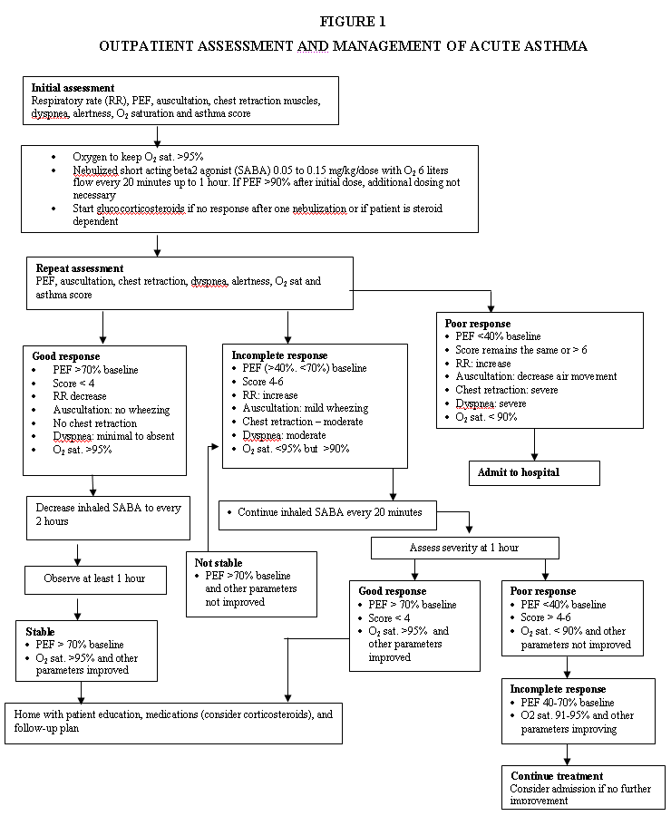

Example of Management of acute severe asthma in E/D

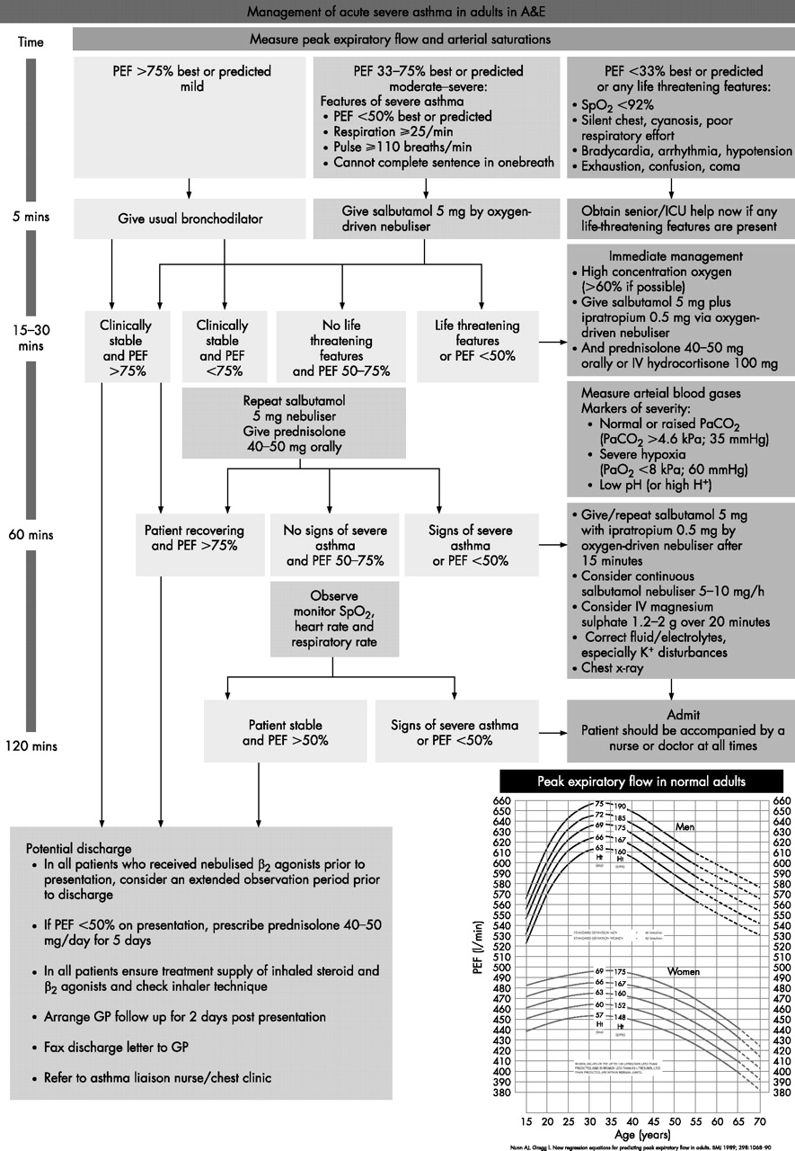

**Asthma Management**

* Needs to be rapid and aggressive
* Monitor the patient’s response to treatment, observing any changes in appearance and vital signs
* Obtain PEFR readings before and after treatment

|  |  |
| --- | --- |
| Oxygen | β2 Agonist Bronchodilator |
| * Give high flow oxygen to all patients with acute severe asthma * Nebulise **β2** agonist bronchodilators should be driven by oxygen * The absence of supplementary oxygen should not prevent nebulised therapy being given if indicated | * Use high dose of inhaled **β2** agonists as first line agents in acute asthma and administer as early as possible. Reserve intravenous  **β2** agonists for those patients in whom inhaled therapy cannot be used reliably * In acute asthma with life threatening features the nebulised route (oxygen-driven) is recommended. * In severe asthma (PEF or FEV 1<50% best or predicted) and asthma that is poorly responsive to an initial bolus of  **β2** agonist, consider continuous nebulisation |

|  |  |
| --- | --- |
| Steroid Therapy | Ipratropium Bromide |
| * Give steroids in adequaste doses in all cases of acute asthma * Continue prednisilone 40-50 mg daily for at least five days or until recovered | * Add nebulised Ipratropium bromide (0.5mg 4-6hrly) to  **β2** agonist treatment for patients with severe or life threatening asthma or those with poor initial response to  **β2** agonist therapy |

|  |  |
| --- | --- |
| Other Therapies |  |
| * Routine prescription of antibiotics is not indicated for acute asthma * **IV** Terbutalene (Bricanle 250 mcg) over **ten minutes.** NB: This should only be administered in acceptional circumstances without a Doctor being present. |  |

**Moderate exacerbation of Asthma**

1. Administer inhaled bronchodilator: Salbutamol (Ventolin) Inhaler 2 puffs or Salbutamol 5mg via nebuliser (oxygen driven nebuliser if possible). If no response in 10 minutes can then repeat.
2. Repeat PEFR 15 minutes after treatment and chart every 4 hours

1. Call Topside ASAP

**Acute severe / life threatening asthma**

1. **Administer oxygen at 15 litres per minute**
2. **Maintain Sp0₂ of 94 – 98 (lack of pulse oximetry should not prevent the use of 0₂)**
3. **Administer salbutamol 5mg via nebuliser (oxygen driven nebuliser if possible) If no response in 10 minutes can repeat**
4. **Establish IV Access**
5. **Call Topside Doctor**
6. **Administer Hydrocortisone (Solu – Cortef) 200mg IV**
7. **If no response, administer nebuliser Ipatropium (Atrovent) 0.5mg 4-6hourly in addition to salbutamol**
8. **If patient not responding to treatment consider IV Terbutaline (Bricanyl) 250mcg over 10 minutes NB: THIS SHOULD ONLY BE ADMINISTERED IN EXCEPTIONAL CIRCUMSTANCES WITHOUT A DR PRESENT.**
9. **Measure PEF 165 minutes after treatment and chart every 4 hours**

Possible problems

Patients are totally absorbed by the need to breathe and may find themselves unable to assist in their treatment.

For example,

* They may not be able to carry out a peak flow for you
* They might not be able to tolerate any form of mask on their face
* They cannot relax and straighten their arm to give you IV access
* They will be unable to walk or lie down
* They will be unable to talk to you and answer questions

3.3 Management of ongoing asthma

We are now going to give you some understanding of the chronic management of asthma as it is carried out in GP surgeries. Treatment should normally be instigated by the person’s own GP; however you may need to temporarily alter treatment (in conjunction with your Topside Doctor)

*Answer to Question number 3:*

*Any of the following might indicate an individual is suffering from an acute severe asthma attack*

* Inability to speak
* Tachycardia
* Chest silent on auscultation
* Peak flow less than 40% predicted or 200 1/minute

*Remember*

*Persistant coughing and lack of sleep over a 24hr period can lead to a state of total exhaustion*

Pharmacological Management of Asthma

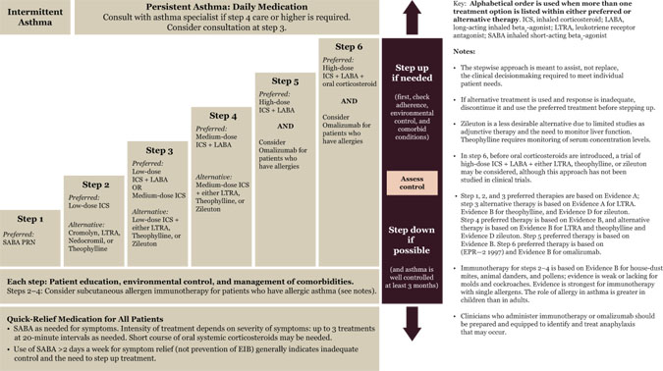

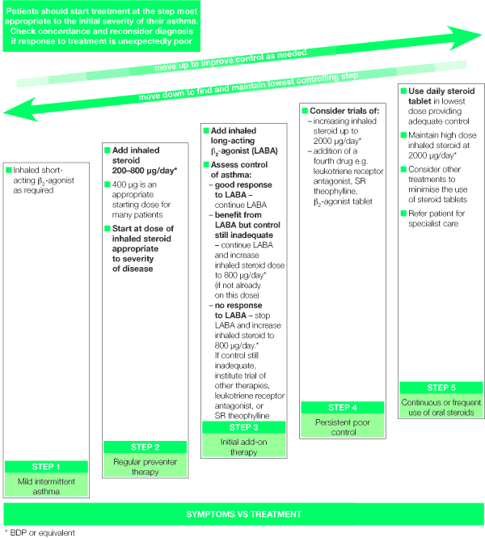

4. Fitness to work offshore

Following a severe asthma attack and hospital admission the individual should be assessed by a Doctor, with knowledge of the offshore industry, before a decision is made about their fitness to return to work offshore. Make sure that they are aware of this prior to you sending them off as there have been occasions whereby crew members have been medivaced, treated and recovered enough to return to work, unfortunately for them they returned back offshore without clearance from an Offshore Doctor due to poor advice.

A diagnosis of occupationally induced asthma is made by establishing a relationship between the patient’s asthma and their work environment. There are over 200 organic and inorganic compounds associated with asthma. Unfortunately this list is increasing and occupational asthma is often unrecognised with consequent delay in diagnosis.

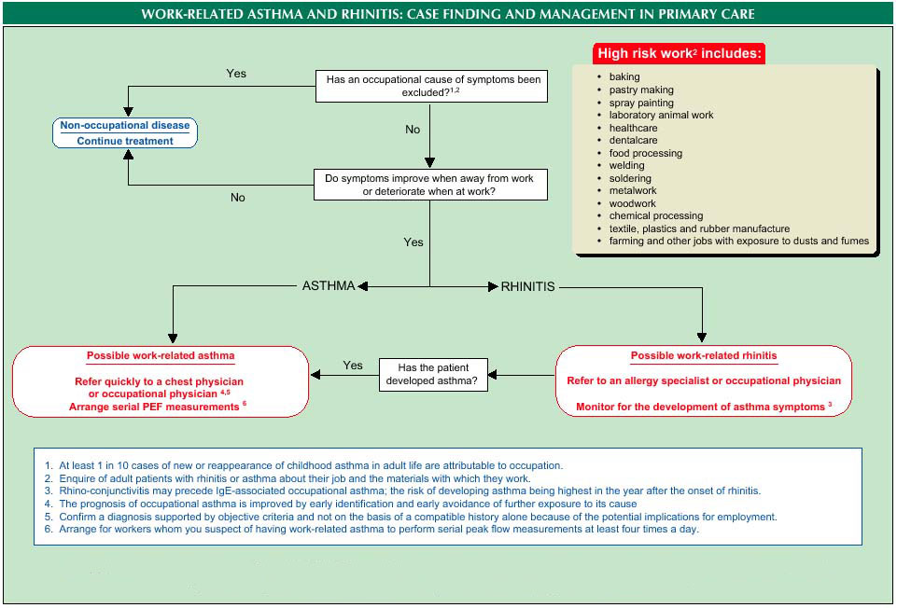

**Notes**

**Questions for your tutor**